LC-MS/MS Analysis of crude Flavonoid Compounds from Justicia secunda from Democratic Republic of the Congo and evaluation of their antisickling Activity
Benjamin Z. GBOLO^{1,2*}, Amandine NACHTERGAEL², K. N. NGBOLUA¹, Bobette N. CIALA³, Irène SEMAY⁴, Pius T. MPIANA⁵, Pascal GERBAUX⁴, Pierre DUEZ²

- Methods
  - Isolation and purification of flavonoids
The dry methanolic extract (3.7943 g) was combined with 10 g of silica (40-63 µm diameter) to create the Dryload, which was then subjected to flash chromatography using a PURIFLASH COLUMN 30 SILICA HP (12.0 g) with an Interchim Puriflash 215 system. A binary gradient was applied at a flow rate of 5 mL/min, with the mobile phase consisting of heptane (Solvent A) and a mixture of ethyl acetate and methanol in a 1:7 ratio (Solvent B). The gradient program was as follows: A = 30%, B = 70% at 0 min; A = 25%, B = 75% at 5.5 min; A = 20%, B = 80% at 10.5 min; A = 15%, B = 85% at 15.5 min; A = 10%, B = 90% at 20.5 min; A = 5%, B = 95% at 25.5 min; A = 0%, B = 100% at 30.5 min; and A = 0%, B = 100% at 45.5 min. Two fractions were collected, designated FA and FP, with their weights recorded as FA (1.4318 g) and FP (1.5377 g).
Fraction FP was further processed by mixing with silica gel and subjected to a second round of flash chromatography using a PURIFLASH COLUMN 30 SILICA HP (12.0 g) and the Interchim Puriflash 215 system. The elution was performed with a gradient solvent system consisting of ethyl acetate (Solvent A), methylethylketone (Solvent B), and an isopropanol-water mixture (Solvent D), at a flow rate of 5 mL/min over 135 minutes to yield sub-fractions FP1-FP30. The gradient program was as follows: A = 100%, B = 0%, D = 0% at 0 min; A = 0%, B = 0%, D = 0% at 45 min; A = 0%, B = 68%, D = 32% at 61 min; A = 0%, B = 30%, D = 70% at 105 min; A = 0%, B = 10%, D = 90% at 115 min; A = 0%, B = 0%, D = 100% at 120 min; A = 0%, B = 0%, D = 100% at 135 min.
After vacuum concentration, sub-fractions FP2-FP9, which were identified as crude flavonoids extracted from Justicia secunda, were pooled based on their similarity profiles on HPTLC and then weighed (0.0586 g).

  - In vitro antisickling activities

    - Hemolytic assay

Many plant compounds, such as saponins, may present a risk of hemolysis due to their strong hemolytic activity. The hemolysis of red blood cells (RBCs) was evaluated by measuring absorbance at 540 nm after contact with crude flavonoid extracts from J. secunda and disodium cromoglycate. A suspension of RBCs in 9 ‰ NaCl was considered to be at 0% hemolysis (negative control), while the suspension in distilled water was considered to be at 100% hemolysis (positive control).
To conduct the experiment, 200 µL of a 2.5% erythrocyte suspension in 9 ‰ NaCl was incubated with 200 µL of either crude flavonoid extracts from J. secunda or disodium cromoglycate in 9 ‰ NaCl (1 mg/mL) at 37 °C for 30 minutes, resulting in a final concentration of 0.5 mg/mL for both the crude flavonoid extracts and disodium cromoglycate. After incubation, the samples were centrifuged at 380 g for 5 minutes. The hemoglobin content in the supernatant was measured at 540 nm using a spectrophotometer (Jenway 7315, Laboratoires Humeau, France) in triplicate. The absorbance of the crude flavonoid extracts and RBCs suspended in 9 ‰ NaCl was also measured as controls. These absorbance values were compared to those of erythrocytes in distilled water, used as the positive control.
(Haddad et al., 2004).
The potential hemolytic activities of the crude flavonoid extracts were evaluated at a high concentration of 1 mg/mL. The hemolysis rate was determined using the following formula:
$$\%hemolysis=\frac{A Crude flavonoid-A NaCl 0,9 \%}{A disodium cromoglycate-A NaCl 0,9 \%}x100$$

    - Hypoxia creating and sickling induction
Hypoxia and sickling were induced using 2% Na₂S₂O₅ and clear varnish. Specifically, 950 µL of the diluted whole blood was combined with 50 µL of 2% Na₂S₂O₅ and thoroughly mixed. A 5 µL aliquot of this mixture was placed on a slide, covered with a coverslip, and then smeared with clear varnish. The sickling of red blood cells, caused by the reducing effect of Na₂S₂O₅, was observed under a light microscope at zero and sixty minutes. Microscopic images of the erythrocytes were captured using a digital camera (LEICA ICC50 W). The counts of sickle cells and total cells were performed in five different microscopic fields. The percentage of sickled cells was calculated using the following formula:
$$F \left(\%\right)=\frac{SRB}{TRB}x100$$
Where F : Sickling Cells Rate ; SRB : Sickled Red Blood Cells Count and TRB : Total Red Blood Cell Count.
    - Inhibition of falciformation
The Emmel test was conducted following the method described by Gbolo Zoawe et al. (2023). Briefly, a mixture of diluted whole blood and 2% Na₂S₂O₅ in a 20:1 (v/v) ratio was prepared, and to this mixture, 10 µL of each solution of crude flavonoid extracts from J. secunda, disodium cromoglycate, or NaCl 9 ‰ was added and homogenized. A 5 µL aliquot of the resulting mixture was placed on a slide, covered with a coverslip, and then sealed with clear varnish. The effects of the various extracts on sickling were observed using light microscopy at the initial time and after 60 minutes. Microscopic images of the erythrocytes were captured with a digital camera (LEICA ICC50 W). Sickle cells and total cells were counted in five different microscopic fields. The percentage of sickle cell inhibition was calculated using the following formula:
(Kotue et al., 2019):
$$SI=\frac{F_{0}-F_{n}}{F_{0}} x 100$$
Where SI is the percentage of sickling inhibition, $F_{0}$ is the % of sickling of the mixture SS blood and Na₂S₂O₅, 2% and $F_{n}$ is the % of sickling of the mixture SS blood, Na₂S₂O₅, 2% and each extract sample.

    - Determination of the Minimum Reversibility Concentrations (MRC)
For the determination of the MRC, the proportions of sickle cell inhibition (i.e., reversibility rate) were assessed by varying the concentrations of crude flavonoid extracts from J. secunda and disodium cromoglycate between 5 and 1000 µg/mL, as previously described. For each concentration, the sickle cell inhibition (SI) was calculated according to the method outlined above to determine the reversibility rate (R) using the following formula:
$$R =\frac{{SI}_{0}-{SI}_{n}}{{SI}_{0}} x 100$$
Where R is the reversibility rate (%) and ${SI}_{0}$ and ${SI}_{n}$ are the proportions of sickling inhibition for the control (NaCl 9 ‰) and the tested concentration, respectively.
Dose-effect curves were obtained by fitting data to the equation $y=\frac{A_{1}-A_{2}}{1+({x/{x_{0}})}^{p}}+A_{2}$ using the Origin 8.5 software (OriginLab, Northampton, MA, United States).

    - Inhibition of sickle hemoglobin (HbS) polymerization

Following the original method described by Noguchi and Schechter (1978), HbS polymerization was evaluated by measuring the turbidity of a polymerizing mixture at 700 nm. A 200 µL volume of red blood cell pellet was hemolyzed by adding an equal volume of distilled water. The supernatant was then incubated for 30 minutes with or without the plant extract (400 µL). To induce hemoglobin S polymerization, 3000 µL of a 2% sodium metabisulfite solution was added to deoxygenate the mixture. After centrifugation at 3500 rpm for 5 minutes, the absorbance was measured, and the difference in absorbance indicated the level of turbidity. The rate of polymerization inhibition was estimated by the tangent of the absorbance versus time graph. Relative polymerization and relative inhibition were calculated with respect to the control (Gbolo Zoawe et al., 2023; Mishra et al., 2022) as:

$$R_{p}=\frac{A_{t}-A_{i}}{t}$$

Where $R_{p}$ = rate of polymerization, $A_{t}$= Absorbance at time t, $A_{i}$= initial Absorbance, t=time

    - Erythrocyte membrane stability
Osmotic fragility of erythrocytes was used to measure the membrane-stabilizing effect of extracts under osmotic stress or hypotonic lysis after a 60-minute incubation period. A 10 µL aliquot of washed red blood cells was diluted in 1990 µL of a series of buffered hypotonic saline solutions with varying concentrations (0.2-0.8% NaCl). To each solution, 10 µL of flavonoid extracts, disodium cromoglycate, or NaCl 9 ‰ was added and thoroughly mixed. The impact of the different extracts on hemolysis at each concentration was observed using light microscopy. Microscopic images of the erythrocytes were captured with a digital camera (LEICA ICC50 W). Total cells were counted in five different fields of view on the slide at both zero and sixty minutes. The percentage of hemolyzed cells was calculated using the following formula:
$$\% Hemolysis=\frac{{N_{0}-N}_{60}}{N_{0}} x 100$$
where $N_{0}$ is the number of red blood cells at time t=0 and $N_{60}$ is the number of red blood cells at time t=60 minutes. The median corpuscular fragility (MCF) which is the NaCl concentration that causes 50% erythrocyte hemolysis is calculated on the basis of linear regression analysis of the pairs NaCl concentration -% hemolysis using ORIGIN 8.5 software (OriginLab, Northampton, MA, United States).

    - Determination of methemoglobin concentration
The supernatant from hemolyzed and centrifuged (1500 g, 10 min) red blood cells was incubated at room temperature, with or without the addition of flavonoid extracts or disodium cromoglycate. The changes in absorbance were measured at 540 nm for hemoglobin (Fe²⁺) and 630 nm for methemoglobin (Fe³⁺), using a spectrophotometer (Jenway 7315, Laboratoires Humeau, France).
The proportion of methemoglobin was calculated at each time as:
$${Fe}^{3+}=\frac{{(A_{630})}^{2}}{{(A_{540})}^{2}+{(A_{630})}^{2}}x100$$

Where ${Fe}^{3+},$ $A_{540}$ and $A_{630}$ are the proportion of methemoglobin and the absorbances at 540 and 630 nm, respectively.
To appreciate the kinetics of the reaction in the presence or absence of extract, ${Fe}^{3+}$ time curves were obtained by fitting data to the equation $y=\frac{A_{1}-A_{2}}{1+({x/{x_{0}})}^{p}}+A_{2}$ using the Origin 8.5 software.
- CID spectra of identified flavonoids in Justicia secunda Vahl.
All the CID spectra in ESI - mode were recorded on the Waters Synapt G2-Si and were preceded by an HPLC separation on the Waters Acquity UPLC H-Class.
All the CID spectra in ESI + mode were recorded on the Waters Q-ToF US and were preceded by an HPLC separation on the Waters Alliance 2695.

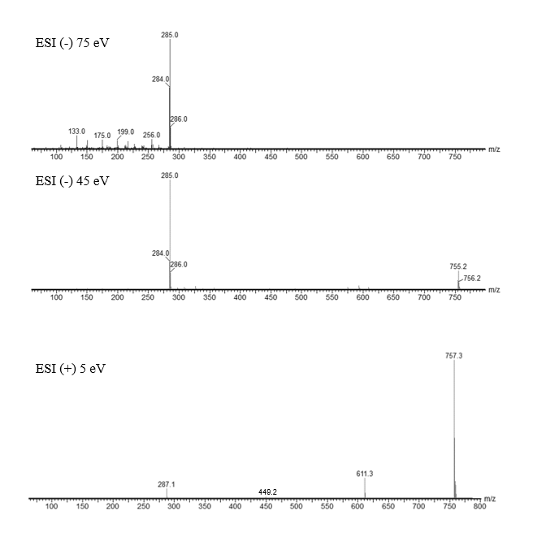
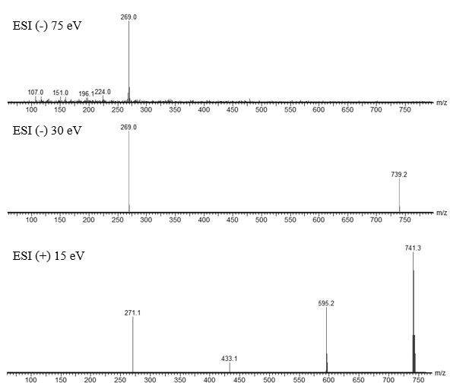
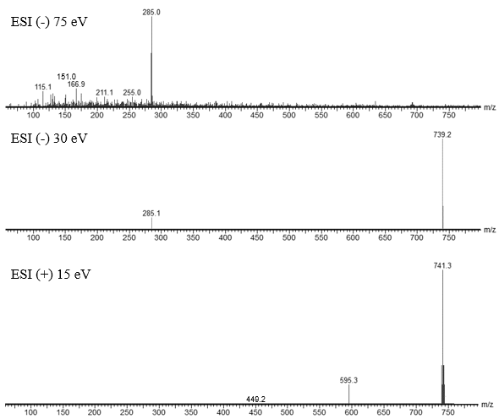
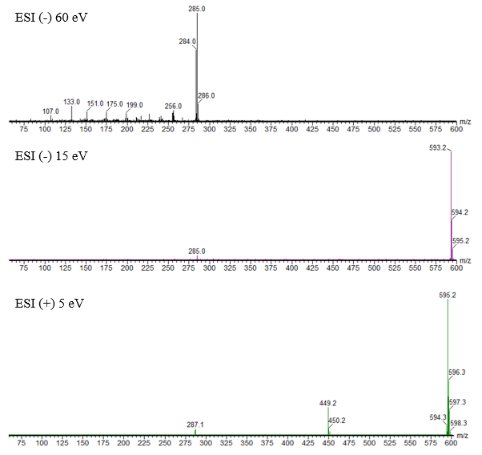
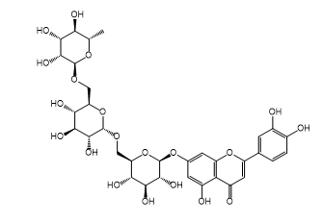
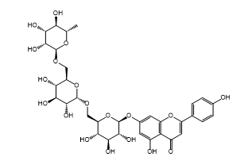
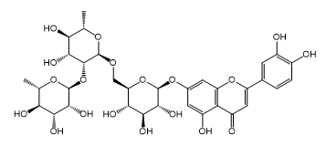
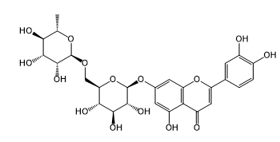
1.Luteolin-7-O-hexosylhexosylrhamnoside

2. Apigenin-7-O-hexosylhexosylrhamnoside

3. Luteolin-7-O-hexosylrhamnosylrhamnoside

4. Luteolin-7-O-hexosylrhamnoside

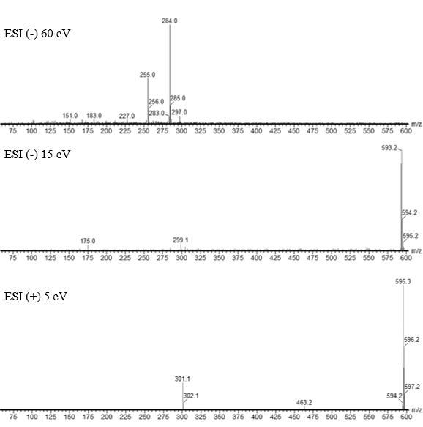
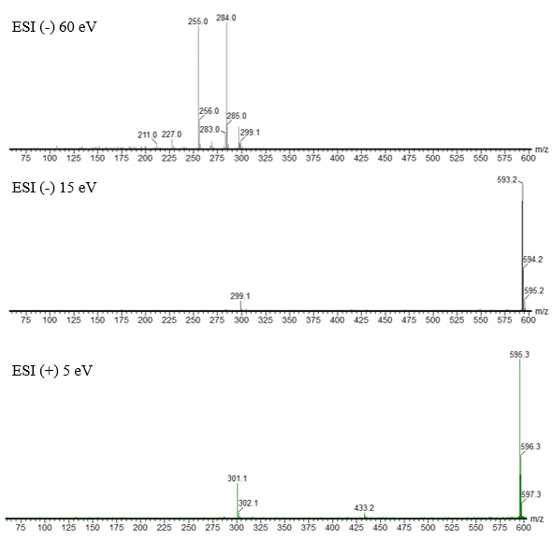
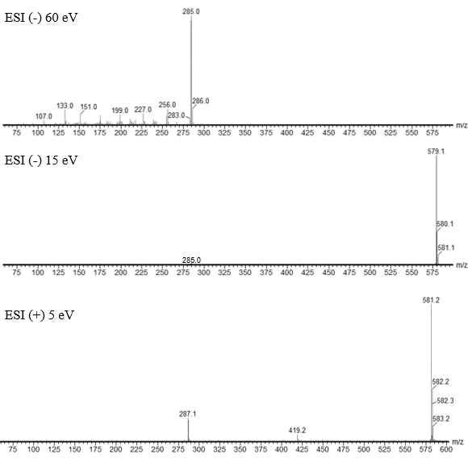
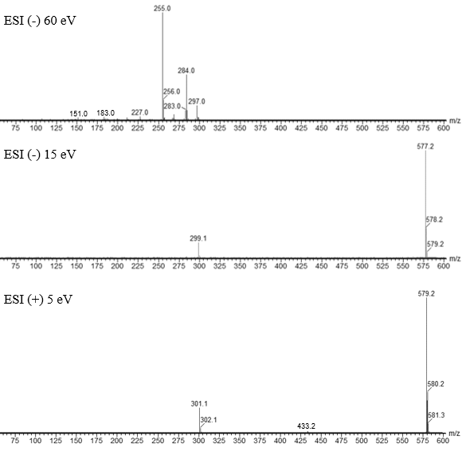
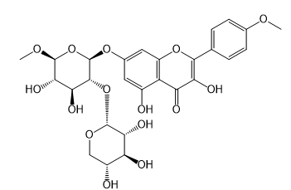
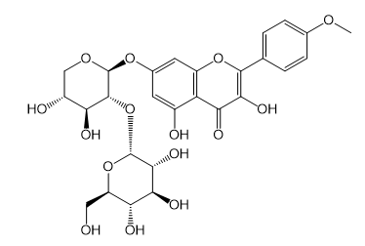
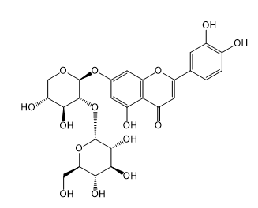
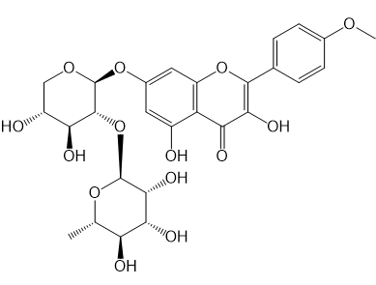
5. Kaempferide-7-O-hexosylpentoside

6. Kaempferide-7-O-pentosylhexoside

7. Luteolin-7-O-pentosylhexoside

8. Kaempferide-7-O-pentosylrhamnoside

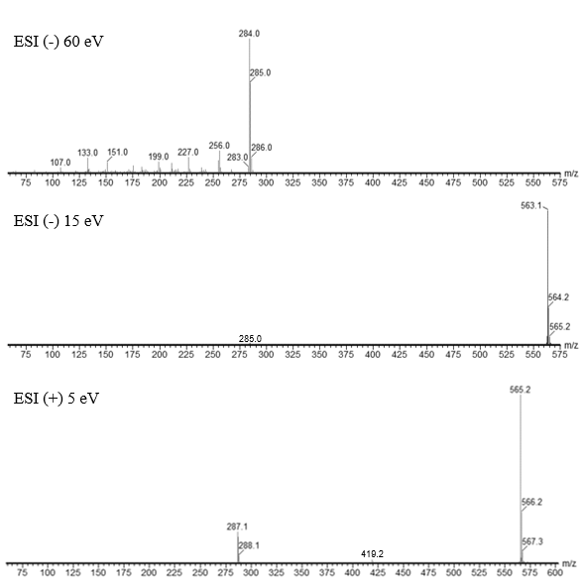
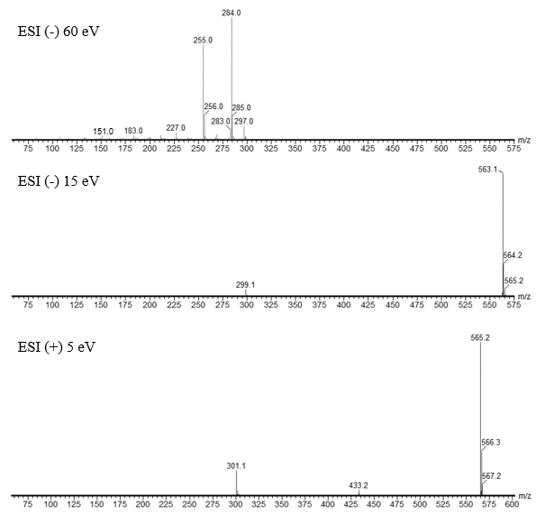
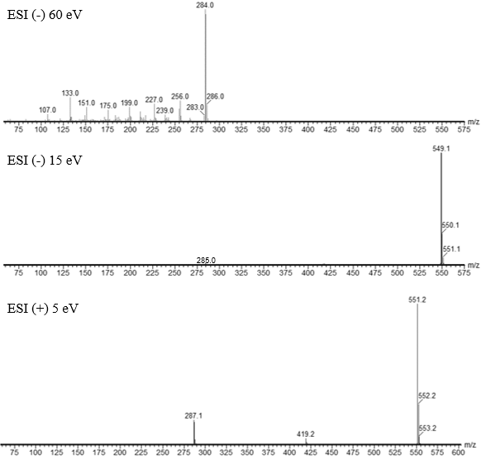
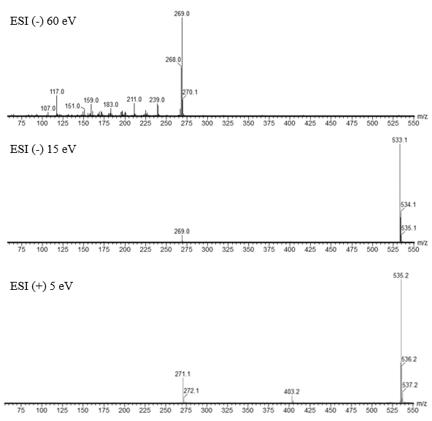
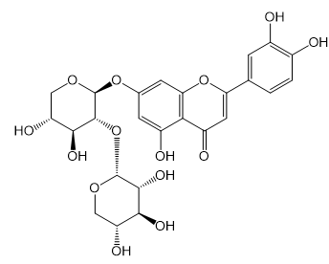
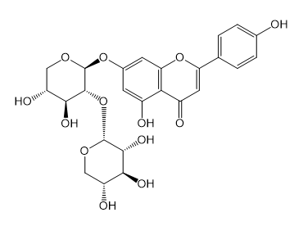
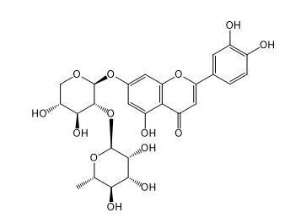
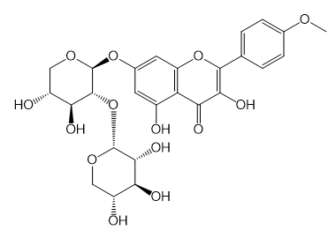
9. Luteolin-7-O-pentosylrhamnoside

10. Kaempferide-7-O-dipentoside
11. Luteolin-7-O-dipentoside
12. Apigenin-7-O-dipentoside

Figure 1: LC-MS/MS spectra with the main fragments obtained for compounds 1-12 in negative and positive modes. The fragmentation scheme illustrated below is taken from the model proposed by Fabre al. (2001) for flavones (compounds 1, 2, 3,4,7,9,11 and 12); the fragmentation of luteolin is given as an example and flavonols (compounds 5,6,8 and 9); the fragmentation of quercetin is given as an example.

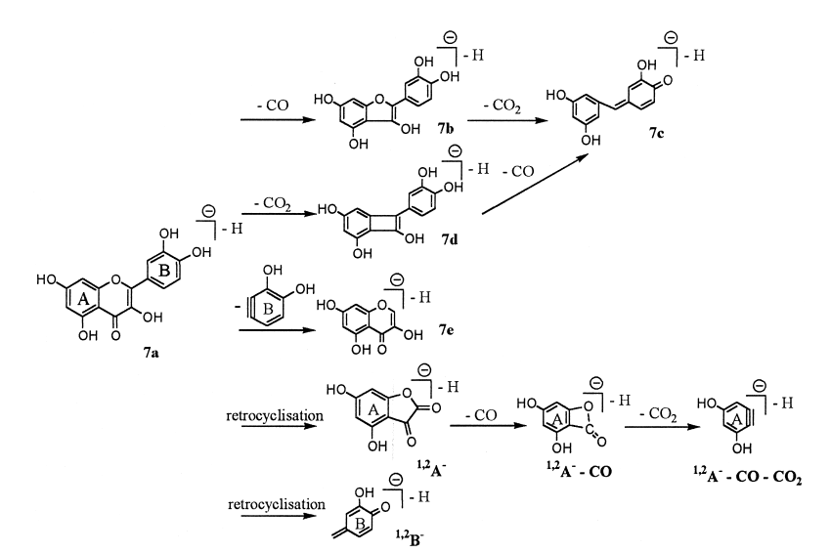
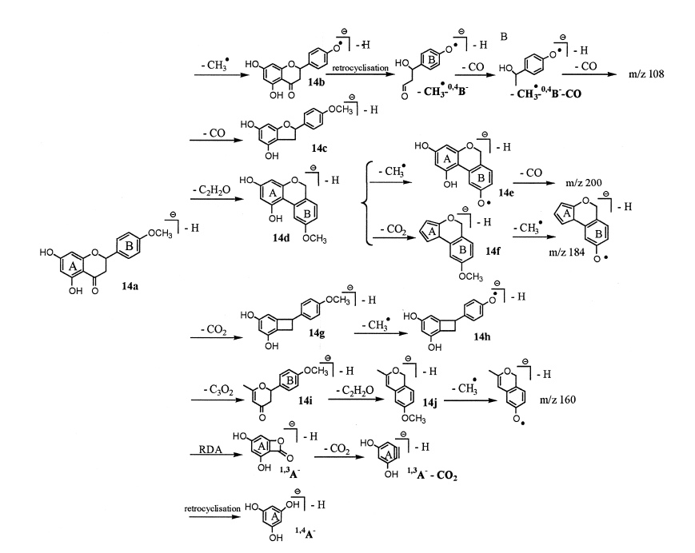
(a)
(b)
227
271
243
199
285
256
199
227
217
175

Figure 2: Fragmenting scheme proposed by Fabre et al. (2001) for the quasi-molecular anions (a) flavonol (case of quercetin following losses of CO and CO₂) and (b) flavone (case of luteolin following losses of CH₃, CO, C₂H₂O, CO₂ and C₃O₂).

