Supplementary Information 1: Structure Elucidation of Compound 2 (DNW-9-4-2-3) (Dischidia bengalensis water extract fraction no: 9-4-2-3)

Phytochemical Analysis and Bioactivity of Nepalese Medicinal Plants, with Compound Isolation from Dischidia bengalensis Colebr.
Nista Gurung¹, Manoj Sharma¹, Ashma Gurung¹, Santosh Chaudhary¹, Hari Prasad Devkota², Sushil Panta¹, Hem Raj Paudel³, Atisammodavardhana Kaundinnyayana¹, Khem Raj Joshi^{1,*}
¹Faculty of Health Sciences, School of Health and Allied Sciences, Pokhara University, 33700, Nepal
²Graduate School of Pharmaceutical Sciences, Kumamoto University, 5-1 Oehonmachi, Chuo-ku, Kumamoto, 862-0973, Japan
³Department of Plant Resources, National Herbarium and Plant Laboratories, 44600, Nepal

¹H NMR
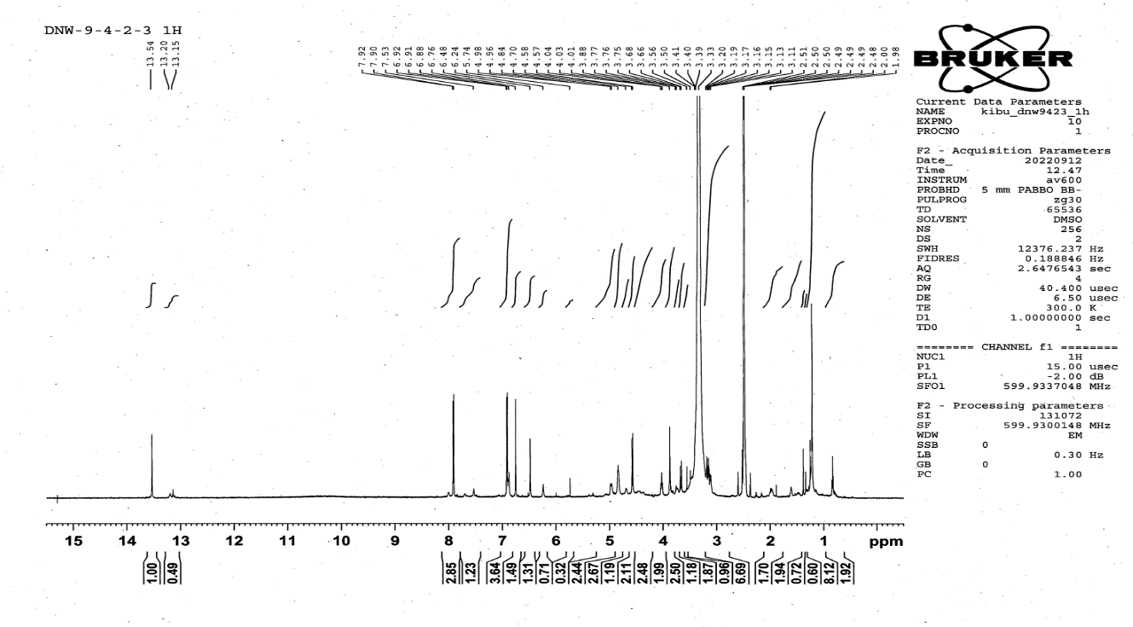
Figure: ¹H NMR spectrum of DNW-9-4-2-3

DEPT
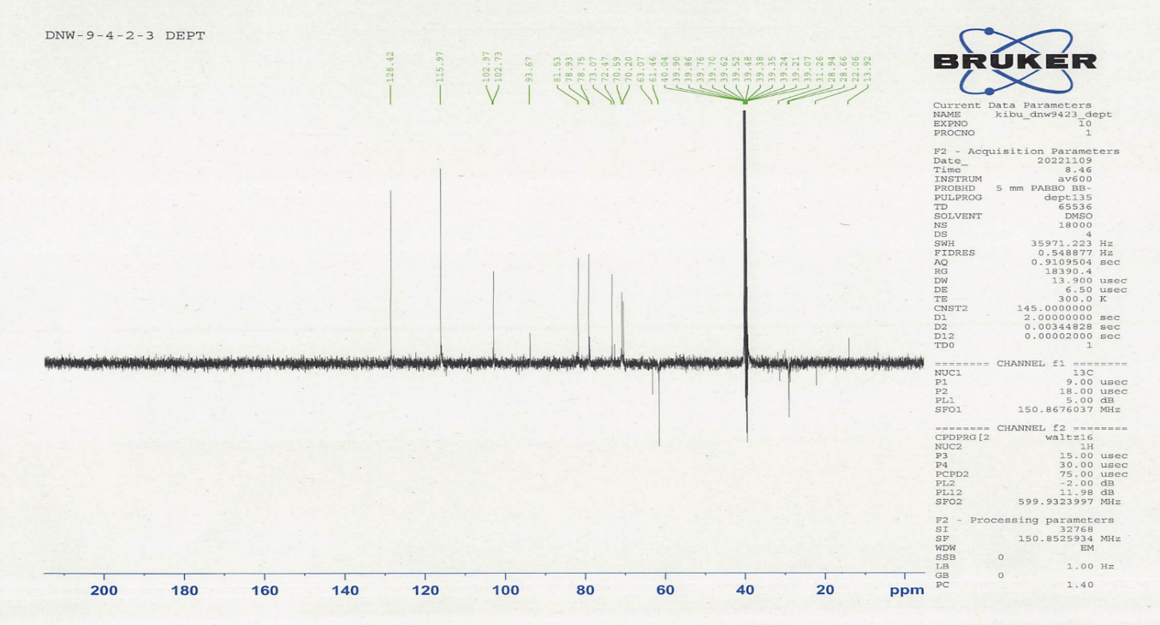

Figure: DEPT spectrum of DNW-9-4-2-3
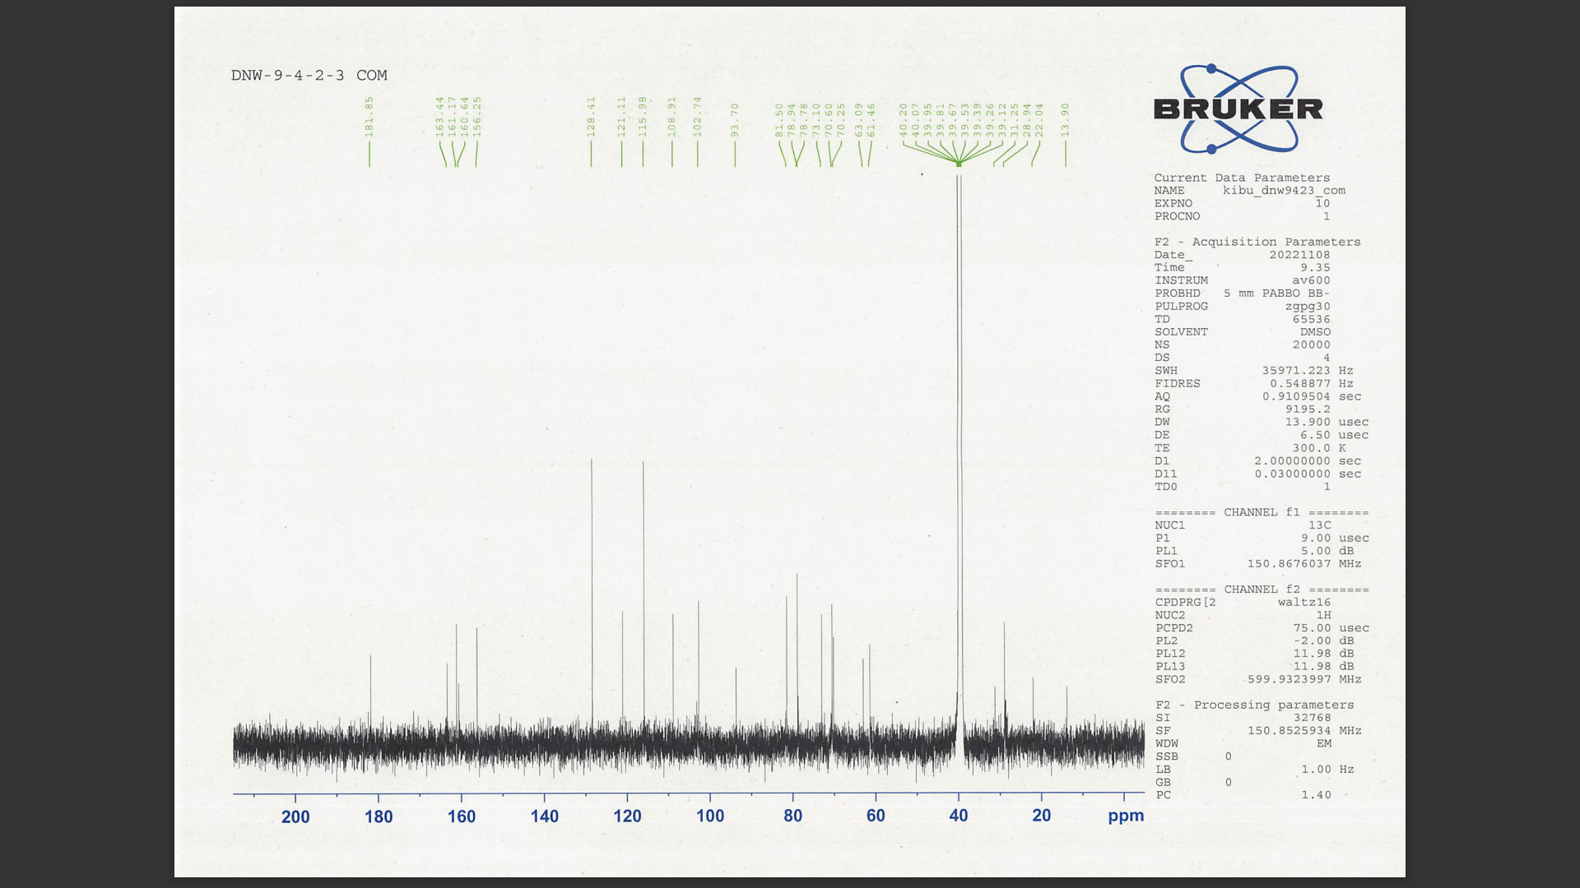
¹³C NMR
DNW-9-4-2-3
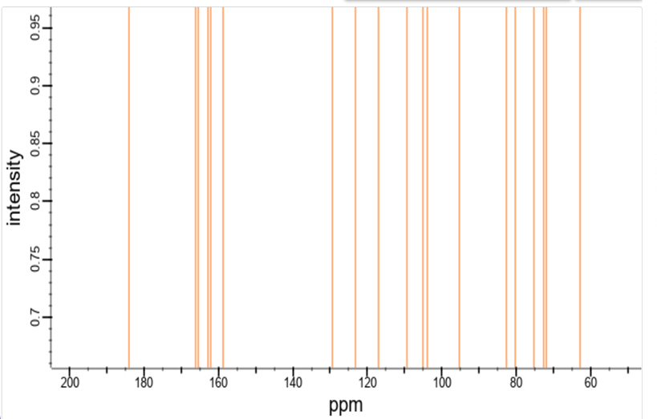
isovitexin

Figure: ¹³C NMR spectrum of DNW-9-4-2-3 and isovitexin

Table: ¹H NMR and ¹³C NMR spectral data of DNW-9-4-2-3

Position | Isolated Compound  (DNWP 9-4-2-3) |  | Reference  (isovitexin)  (Joshi et al., 2013)
Position | ¹³C NMR (δ ppm)  (DMSO) | ¹H NMR  (δ ppm, J in Hz) | ¹³C NMR (δ ppm) | ¹H NMR  (δ ppm, J in Hz)
δ | 13.54 (s) |  | -
2 | 163.4 | - | 163.9 | -
3 | 102.97 | 6.76 (1H, s) | 102,9 | 6.75 (s)
4 | 181.6 | - | 181.9 | -
5 | 160.6 | - | 160.7 | -
6 | 108.9 | - | 109.0 | -
7 | 163.4 | - | 163.6 | -
8 | 93.70 | 6.48 (s) | 93.9 | 6.50 (s)
9 | 156.3 | - | 155.0 | -
10 | 102.7 | - | 103.3 | -
1' | 121.1 | - | 121.2 | -
2' | 128.4 | 7.90 (d, 8.82) | 128.5 | 7.91 (d, 8.8)
3' | 115.9 | 6.92 (d, 8.82) | 116.1 | 6.92 (d, 8.8)
4' | 161.2 | - | 161.6 | -
5' | 115.9 | 6.92 (d, 8.82) | 116.1 | 6.92 (d, 8.8)
6' | 128.4 | 7.90 (d, 8.82) | 128.6 | 7.91 (d, 8.8)
6-C-Glc
Glc-1 | 73.1 | 4.58 (d, 9.78) | 73.0 | 4.60 (d, 9.8)
Glc-2 | 70.6 | 4.04-3.5 | 70.6
Glc-3 | 78.9 | 4.04-3.5 | 79.0
Glc-4 | 70.3 | 4.04-3.5 | 70.3
Glc-5 | 81.5 | 4.04-3.5 | 81.6
Glc-6 | 61.5 | 3.68 (brd., 10.26) | 61.6

