Supplementary Information 1: Structure Elucidation of Compound 1 (DNW-6-4-2-4) (Dischidia bengalensis water extract fraction no: 6-4-2-4)

Phytochemical Analysis and Bioactivity of Nepalese Medicinal Plants, with Compound Isolation from Dischidia bengalensis Colebr.
Nista Gurung¹, Manoj Sharma¹, Ashma Gurung¹, Santosh Chaudhary¹, Hari Prasad Devkota², Sushil Panta¹, Hem Raj Paudel³, Atisammodavardhana Kaundinnyayana¹, Khem Raj Joshi^{1,*}
¹Faculty of Health Sciences, School of Health and Allied Sciences, Pokhara University, 33700, Nepal
²Graduate School of Pharmaceutical Sciences, Kumamoto University, 5-1 Oehonmachi, Chuo-ku, Kumamoto, 862-0973, Japan
³Department of Plant Resources, National Herbarium and Plant Laboratories, 44600, Nepal

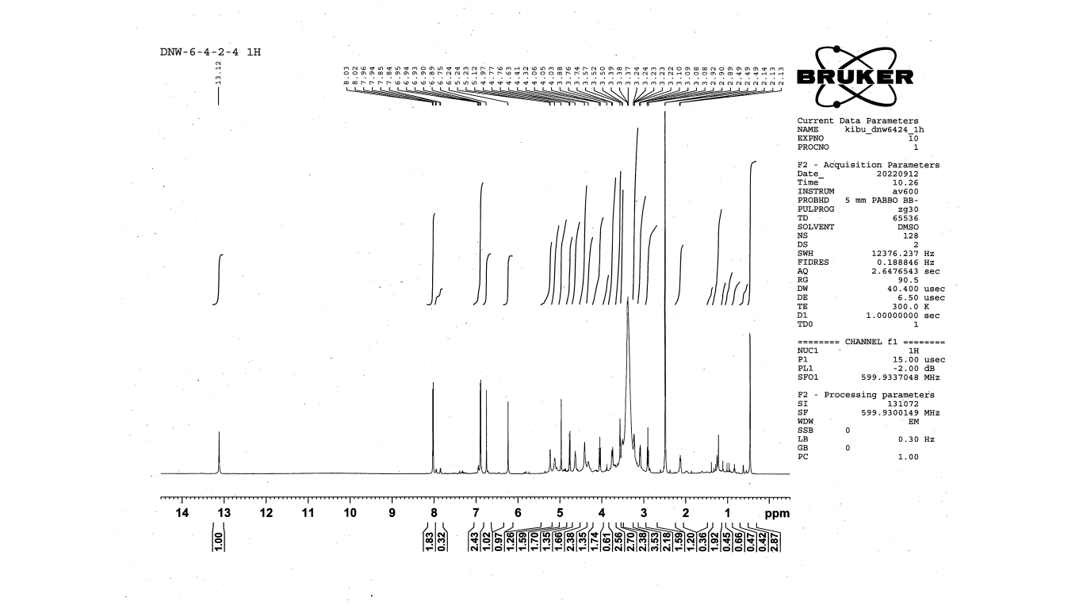
¹H NMR
Figure: ¹H NMR spectrum of DNW-6-4-2-4

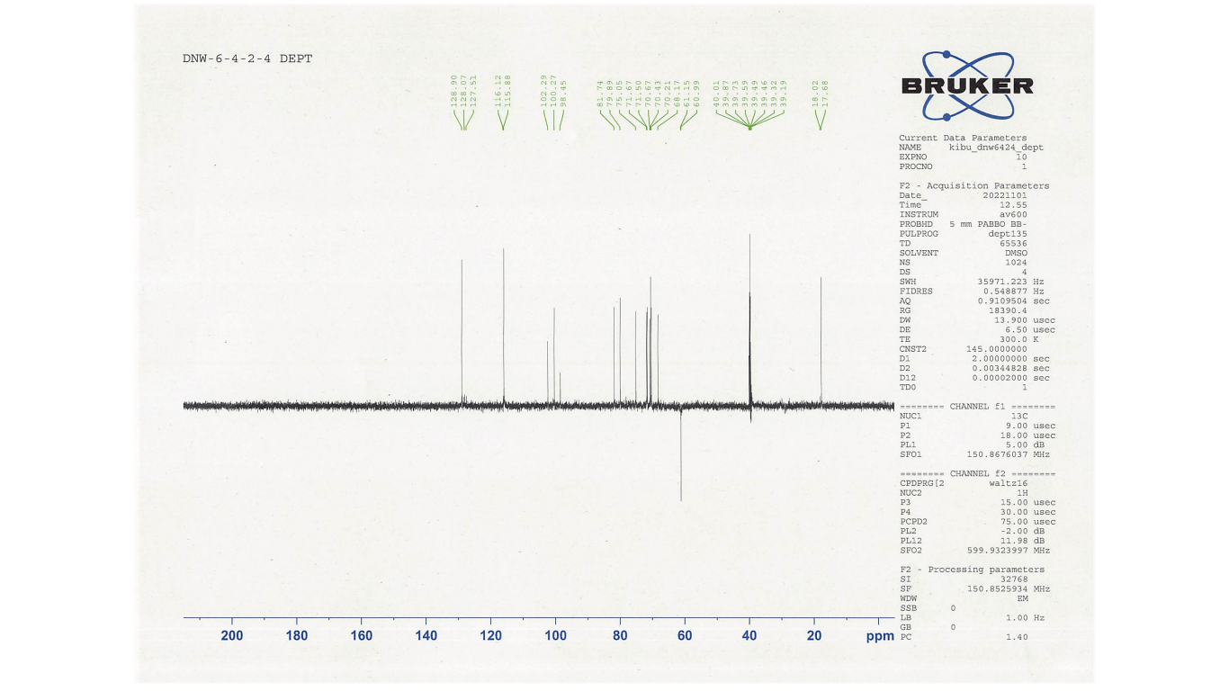
DEPT
Figure: DEPT spectrum of DNW-6-4-2-4
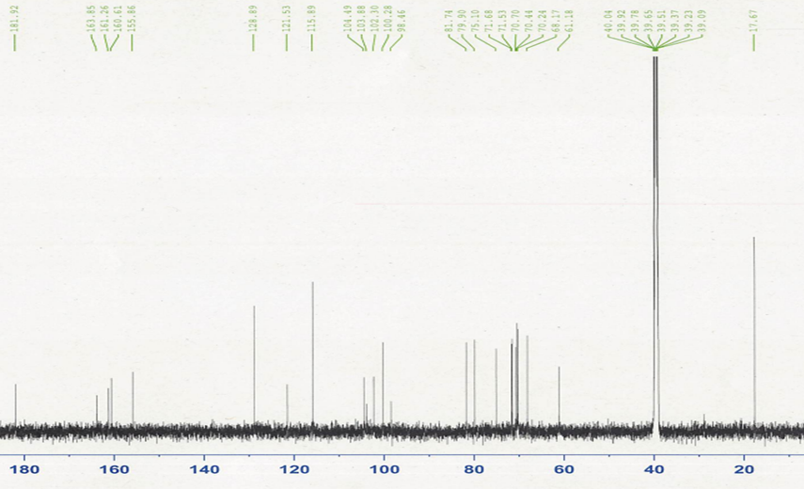
DNW-6-4-2-4
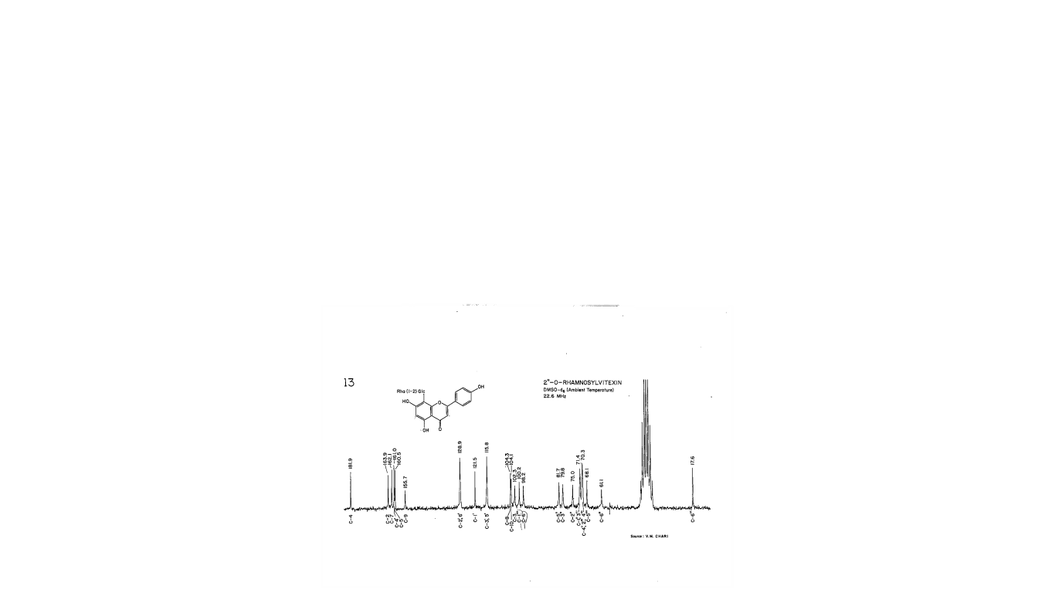
Figure: ¹³C NMR spectrum of DNW-6-4-2-4 and 2"-O-rhamnosylvitexin

¹³C NMR
Table: ¹H NMR and ¹³C NMR data of DNW-6-4-2-4
Position | DNW-6-4-2-4 |  | Reference-1  (Kim Thoa et al., 2019) |  | Reference -2  (Lei et al., 2017)
Position | ¹³C NMR (δ ppm) (DMSO) | ¹H NMR  (δ ppm, J in Hz) | ¹³C NMR (δ ppm) | ¹H NMR  (δ ppm, J in Hz) | ¹³C NMR (δ ppm) | ¹H NMR  (δ ppm, J in Hz)
δ | - | 13.12 (s) | - | - | - | 13.15 (1H, s, 5-OH)
2 | 163.8 | - | 166.5 | - | 164.4 | -
3 | 102.3 | 6.75 (1H, s) | 103.5 | 6.62 (s) | 103.0 | 6.79 (1H, s)
4 | 181.9 | - | 184.0 | - | 182.5 | -
5 | 160.6 | - | 162.6 | - | 161.5 | -
6 | 98.5 | 6.23 (1H, s) | 99.8 | 6.26 (s) | 98.7 | 6.28 (1H, s)
7 | 163.8 | - | 164.0 | - | 162.7 | -
8 | 104.5 | - | 105.5 | - | 104.7 | -
9 | 155.9 | - | 157.8 | - | 156.3 | -
10 | 103.9 | - | 105.9 | - | 104.9 | -
1' | 121.5 | - | 123.4 | - | 122.1 | -
2' | 128.9 | 8.03 (2H, d, 8.82) | 130.0 | 8.01 (d, 8.5) | 129.1 | 8.05 (2H, d, 8.8)
3' | 115.9 | 6.95 (2H, d, 8.75) | 117.0 | 6.97 (d, 8.5) | 116.3 | 6.91 (2H, d, 8.8)
4' | 161.3 | - | 162.6 | - | 161.1 | -
5' | 115.9 | 6.95 (2H, d, 8.75) | 117.0 | 6.97 (d, 8.5) | 116.5 | 6.91 (2H, d, 8.8)
6' | 128.9 | 8.03 (2H, d, 8.82) | 130.0 | 8.01 (d, 8.5) | 129.4 | 8.05 (2H, d, 8.8)
8-C-Glc
Glc-1 | 71.7 | 4.77 (1H, d, 9.96) | 73.6 | 5.06 (d, 10) | 72.1 | 4.77 (1H, d, 10)
Glc-2 | 75.1 | - | 78.0 | 4.28 (d, 8.0) | 75.5 | -
Glc-3 | 79.9 | - | 81.5 | 3.66 (m) | 80.2 | -
Glc-4 | 70.7 | 3.87 (1H, s) | 72.1 | 3.87 (m) | 70.6 | -
Glc-5 | 81.7 | - | 82.7 | 3.34 (m) | 82.2 | -
Glc-6 | 61.1 | 3.76 (d, 11.52) | 63.0 | 3.80 (dd, 5.5, 12)  3.97 (d, 12) | 61.5 | -
2"-O-Rha
Rha-1 | 102.2 | 4.97 (1H, s) | 102.4 | 5.11 (Overlapped) | 100.8 | 4.98 (1H, s)
Rha-2 | 70.7 | 3.56 (s) | 72.4 | 3.65 (m) | 71.0 | -
Rha-3 | 70.4 | 3.38 (s) | 71.8 | 3.42 (m) | 70.8 | -
Rha-4 | 71.7 | - | 73.4 | 3.13 (m) | 71.8 | -
Rha-5 | 68.2 | 2.14 (t, 6.3) | 69.8 | 2.50 (t, 6.0) | 68.7 | -
Rha-6 | 17.67 | 0.63 (d, 6.12) | 18.0 | 0.67 (d, 6.0) | 18.2 | 0.48 (3H, d, 6.0)

