Supplementary Information 1: Compound Isolation of Dischidia bengalensis Whole Plant

Phytochemical Analysis and Bioactivity of Nepalese Medicinal Plants, with Compound Isolation from Dischidia bengalensis Colebr.
Nista Gurung¹, Manoj Sharma¹, Ashma Gurung¹, Santosh Chaudhary¹, Hari Prasad Devkota², Sushil Panta¹, Hem Raj Paudel³, Atisammodavardhana Kaundinnyayana¹, Khem Raj Joshi^{1,*}
¹Faculty of Health Sciences, School of Health and Allied Sciences, Pokhara University, 33700, Nepal
²Graduate School of Pharmaceutical Sciences, Kumamoto University, 5-1 Oehonmachi, Chuo-ku, Kumamoto, 862-0973, Japan
³Department of Plant Resources, National Herbarium and Plant Laboratories, 44600, Nepal

- Extraction
Figure 1: Extraction procedure of D. bengalensis Whole Plant
Dischidia bengalensis Whole Plant, shade dried (550 g)
First maceration with 70% MeOH (24 hr. at room temperature)
Residue
Filtrate I
Second maceration with 70% MeOH (24 hr. at room temperature)
Residue
Filtrate II
Mixed
Evaporate (40°C, 70-80 rpm)
- MCI Column
Volume of column = 𝜋𝑟²h
Where, 𝜋 = 22/7
r = radius of the column
h = height of the MCI in column
V = 𝜋𝑟²h = 22/7 x (2.5)²x 23= 451.78 cm³
Dischidia bengalensis Whole Plant Extract (76.2 g)
Dissolved in distilled water
Water soluble portion (66.19 g)
Insoluble portion (10.01 g)
Applied to MCI Column
H₂O
40% MeOH
60% MeOH
80% MeOH
MeOH
CHCl₃
Fraction
(1-5)
Fraction
(6-35)
Fraction
(36-65)
Fraction
(66-74)
Discarded
Figure 2: Separation through MCI Column
Table 1: Fractions obtained from MCI Column
Solvent | Sample Code | Fraction | Net Weight (g)
H₂O  (1.5 L) | DNW-1 | 1 | Discarded
H₂O  (1.5 L) | DNW-2 | 2 | 2.41 g
H₂O  (1.5 L) | DNW-3 | 3-5 | 1.42 g
40% MeOH  (1.5 L) | DNW-4 | 6-11 | Discarded
40% MeOH  (1.5 L) | DNW-5 | 12-13 | 2.06 g
40% MeOH  (1.5 L) | DNW-6 | 14-24 | 3.72 g
40% MeOH  (1.5 L) | DNW-7 | 25-35 | 0.67 g
60% MeOH  (1.5 L) | DNW-8 | 36-42 | Discarded
60% MeOH  (1.5 L) | DNW-9 | 43-48 | 2.03 g
60% MeOH  (1.5 L) | DNW-10 | 49-65 | Discarded
80% MeOH  (1 L) | DNW-11 | 66-74 | 0.84 g
MeOH  (1 L) | DNW-12 | 75-105 | Discarded
CHCl₃  (1 L) | Discarded

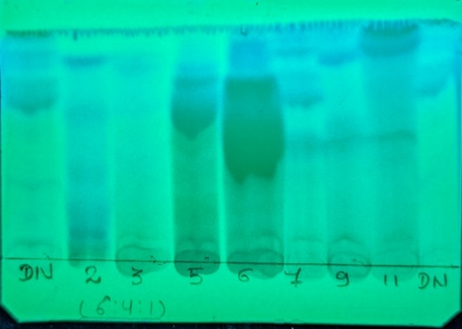  254 nm | 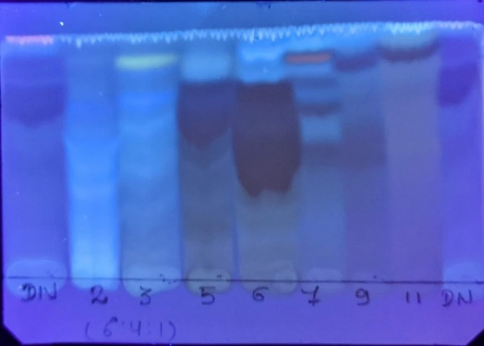  365 nm
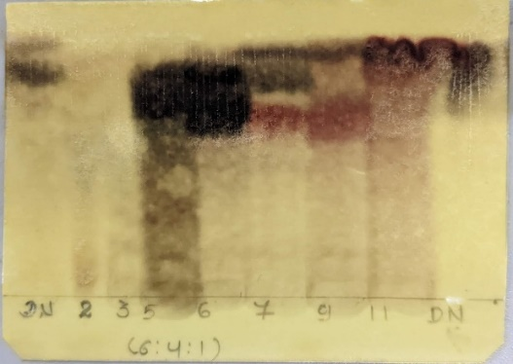  10% FeCl₃ Spray | 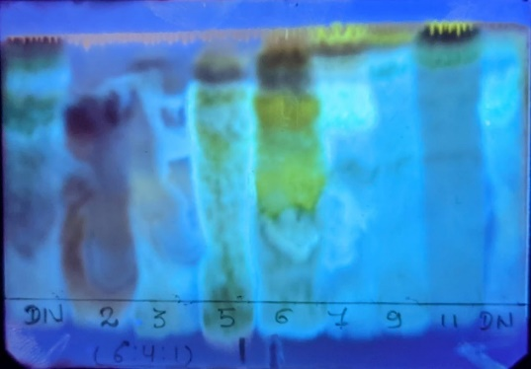  10% H₂SO₄/Heat/365 nm
Solvent system CHCl₃: MeOH: H₂O (6:4:1)

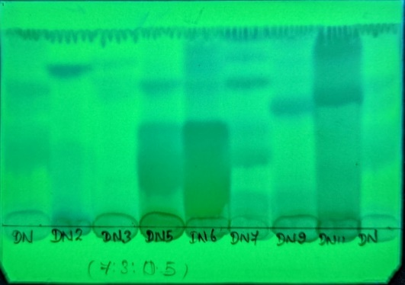  254 nm | 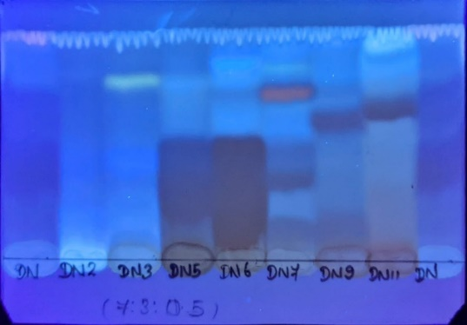  365 nm
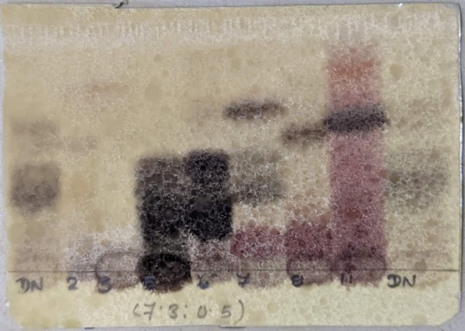  10% FeCl₃ Spray | 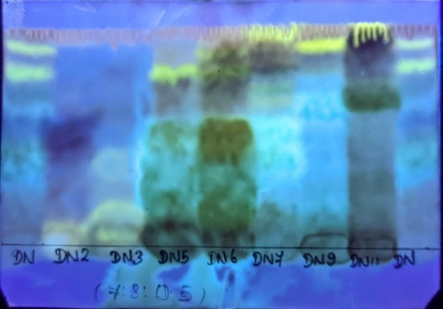  10% H₂SO₄/Heat/ 365 nm
Solvent system CHCl₃: MeOH: H₂O (7:3:0.5)
Figure 3: TLC pattern of fractions obtained from MCI Column
- Sephadex Column
Volume of column = 𝜋𝑟²h
Where, 𝜋 = 22/7
r = radius of the column
h = height of the Sephadex in column
V = 𝜋𝑟²h = 22/7 x (2)²x 26 = 326.85 cm³
For DNW-6
The fraction DNW-6 obtained from the MCI column was selected to apply in the Sephadex column based on its TLC result.
DNW-6 (3.72 g)
Dissolved in 100% MeOH
Applied to Sephadex LH-20 Column
DNW-6-2
DNW-6-3
DNW-6-4
DNW-6-5
DNW-6-1
Figure 4: Fractionation process of DNW-6 through Sephadex Column

Table 2: Fractions of DNW-6 obtained from Sephadex Column
Solvent | Sample Code | Fractions | Net Weight (mg)
100% MeOH | DNW-6-1 | 1-11 | Discarded
100% MeOH | DNW-6-2 | 12-15 | 380 mg
100% MeOH | DNW-6-3 | 16-18 | 360 mg
100% MeOH | DNW-6-4 | 19-30 | 1760 mg
100% MeOH | DNW-6-5 | 31-48 | Discarded

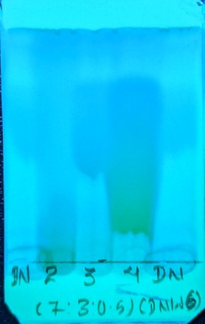  254 nm | 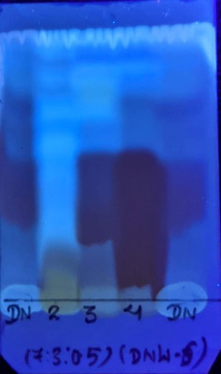  365 nm | 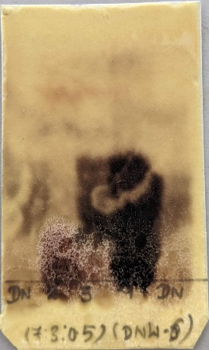  10% FeCl₃ | 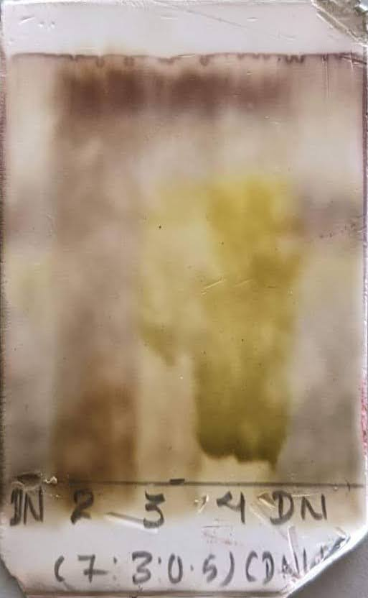  10% H₂SO₄/Heat
Figure 5: TLC pattern of fractions of DNW-6 obtained from Sephadex Column

For DNW-9
The fraction DNW-9 obtained from the MCI column was selected to apply in the Sephadex column based on its TLC result.
DNW-9 (2.03 g)
Dissolved in 70% MeOH
Applied to Sephadex LH-20 Column
DNW-9-2
DNW-9-3
DNW-9-4
DNW-9-5
DNW-9-1
Figure 6: Fractionation process of DNW-9 through Sephadex Column
Table 3: Fractions of DNW-9 obtained from Sephadex Column
Solvent | Sample Code | Fractions | Net Weight (mg)
70 % MeOH | DNW-9-1 | 1-16 | Discarded
70 % MeOH | DNW-9-2 | 17-28 | 550 mg
70 % MeOH | DNW-9-3 | 29-36 | Discarded
70 % MeOH | DNW-9-4 | 37-43 | 60 mg
70 % MeOH | DNW-9-5 | 44-45 | Discarded

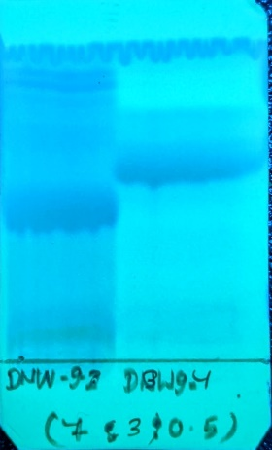  254 nm | 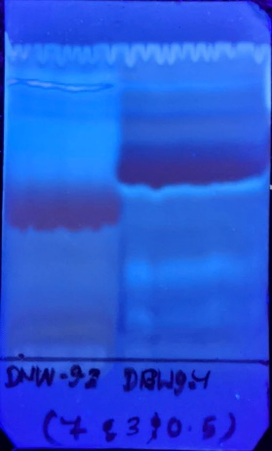  365 nm | 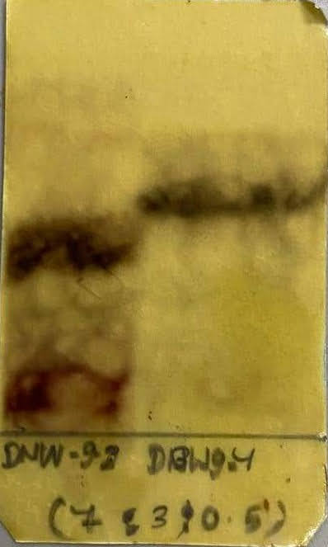  10% FeCl₃ Spray | 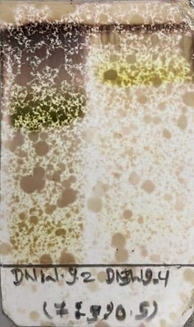  10% H₂SO₄/Heat
Figure 7: TLC pattern of DNW-9 fractions obtained from Sephadex Column
- ODS Column
Volume of column = 𝜋𝑟²h
Where, 𝜋 = 22/7
r = radius of the column
h = height of the ODS in column
V = 𝜋𝑟²h = 22/7 x (2)²x 17.5 = 220 cm³
For DNW-6-4
The fraction DNW-6-4 obtained from the Sephadex column was selected to apply in the ODS column based on its TLC result.
DNW-6-4 (1760 mg)
Dissolved in 40% MeOH
Applied to ODS Column
DNW-6-4-2
DNW-6-4-3
DNW-6-4-4
DNW-6-4-1
Figure 8: Fractionation process of DNW-6-4 through ODS Column
Table 4: Fractions of DNW-6-4 obtained from ODS Column
Solvent | Sample Code | Fractions | Net Weight (mg)
40 % MeOH | DNW-6-4-1 | 1-2 | Discarded
40 % MeOH | DNW-6-4-2 | 3-12 | 1550 mg
40 % MeOH | DNW-6-4-3 | 13-28 | 18 mg
40 % MeOH | DNW-6-4-4 | 29-36 | 30 mg

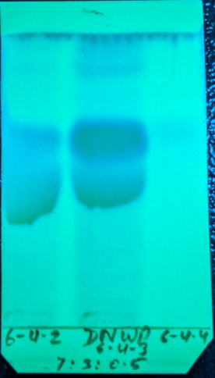  254 nm | 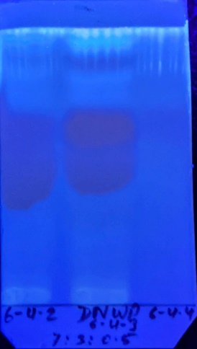  365 nm | 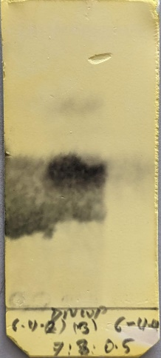  10% FeCl₃ | 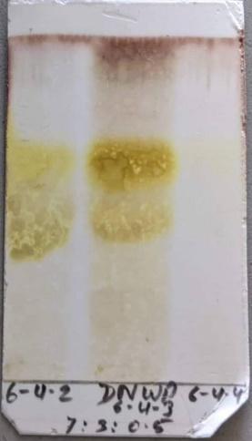  10% H₂SO₄/Heat
Figure 9: TLC pattern of fractions of DNW-6-4 obtained from ODS Column

For DNW-9-4
The fraction DNW-9-4 obtained from the Sephadex column was selected to apply in the ODS column based on its TLC result.
DNW-9-4 (60 mg)
Dissolved in 35% MeOH
Applied to ODS Column
DNW-9-4-2
DNW-9-4-3
DNW-9-4-1
DNW-9-4-2/3
Mixed
Figure 10: Fractionation process of DNW-9-4 through ODS Column
Table 5: Fractions of DNW-9-4 obtained from ODS Column
Solvent | Sample Code | Fractions | Net Weight (mg)
35 % MeOH | DNW-9-4-1 | 1-7 | Discarded
35 % MeOH | DNW-9-4-2 | 8-16 | 9.4 mg
35 % MeOH | DNW-9-4-3 | 17-49 | 15.6 mg

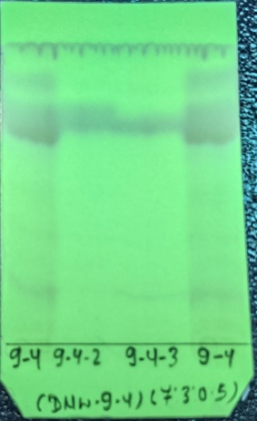  254 nm | 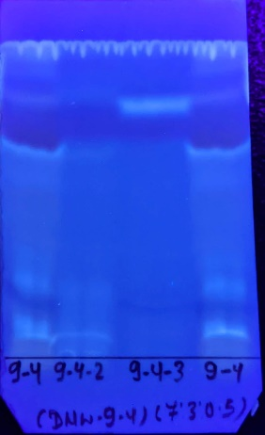  365 nm | 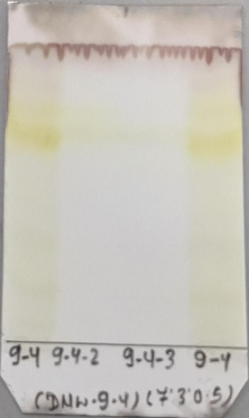  10% H₂SO₄/Heat
Figure 11: TLC pattern of fractions of DNW-9-4 obtained from ODS Column
- Silica Column
For DNW-6-4-2
Volume of column = 𝜋𝑟²h
Where, 𝜋 = 22/7
r = radius of the column
h = height of the Silica in column
V = 𝜋𝑟²h = 22/7 x (1.5)²x 37 = 261.5 cm³
The fraction DNW-6-4-2 obtained from the ODS column was selected to apply in the Silica column based on its TLC result.
DNW-6-4-2 (1550 mg)
Dissolved in CHCl₃:MeOH:H2O (8:2.5:0.2)
Applied to Silica Column
CHCl₃: MeOH: H2O
(8:2.5:0.2)
CHCl₃: MeOH: H2O (7:3:0.5)
- DNW-6-4-2-1 (Discard)
- DNW-6-4-2-2 (70 mg)
- DNW-6-4-2-3 (90 mg)
- DNW-6-4-2-4 (60 mg)
- DNW-6-4-2-5 (500 mg)
- DNW-6-4-2-6 (180 mg)
- DNW-6-4-2-7 (70 mg)
- DNW-6-4-2-8 (Discard)
- DNW-6-4-2-9 (70 mg)
- DNW-6-4-2-10 (110 mg)
- DNW-6-4-2-11 (30 mg)
- DNW-6-4-2-12 (10 mg)
- DNW-6-4-2-13 (140 mg)
- DNW-6-4-2-14 (40 mg)
Figure 12: Fractionation process of DNW-6-4-2 through Silica Column
Table 6: Fractions of DNW-6-4-2 obtained from Silica Column
Solvent | Sample Code | Fractions | Net Weight (mg)
CHCl₃: MeOH: H2O  (8:2.5:0.2) | DNW-6-4-2-1 | 1-60 | Discarded
CHCl₃: MeOH: H2O  (8:2.5:0.2) | DNW-6-4-2-2 | 61-92 | 70 mg
CHCl₃: MeOH: H2O  (8:2.5:0.2) | DNW-6-4-2-3 | 93-112 | 90 mg
CHCl₃: MeOH: H2O  (8:2.5:0.2) | DNW-6-4-2-4 | 113-123 | 60 mg
CHCl₃: MeOH: H2O  (8:2.5:0.2) | DNW-6-4-2-5 | 124-195 | 500 mg
CHCl₃: MeOH: H2O  (8:2.5:0.2) | DNW-6-4-2-6 | 196-212 | 180 mg
CHCl₃: MeOH: H2O  (8:2.5:0.2) | DNW-6-4-2-7 | 213-230 | 70 mg
CHCl₃: MeOH: H2O  (8:2.5:0.2) | DNW-6-4-2-8 | 231-233 | Discarded
CHCl₃: MeOH: H2O  (8:2.5:0.2) | DNW-6-4-2-9 | 234-241 | 70 mg
CHCl₃: MeOH: H2O  (8:2.5:0.2) | DNW-6-4-2-10 | 242-272 | 110 mg
CHCl₃: MeOH: H2O  (8:2.5:0.2) | DNW-6-4-2-11 | 273-300 | 30 mg
CHCl₃: MeOH: H₂O  (7:3:0.5) | DNW-6-4-2-12 | 301-330 | 10 mg
CHCl₃: MeOH: H₂O  (7:3:0.5) | DNW-6-4-2-13 | 331-334 | 140 mg
CHCl₃: MeOH: H₂O  (7:3:0.5) | DNW-6-4-2-14 | 335-355 | 40 mg

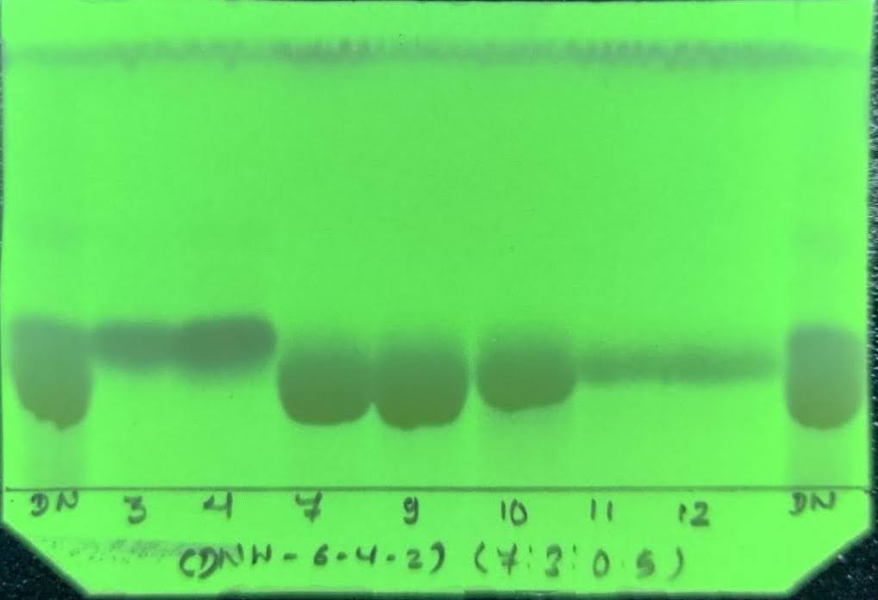  254 nm | 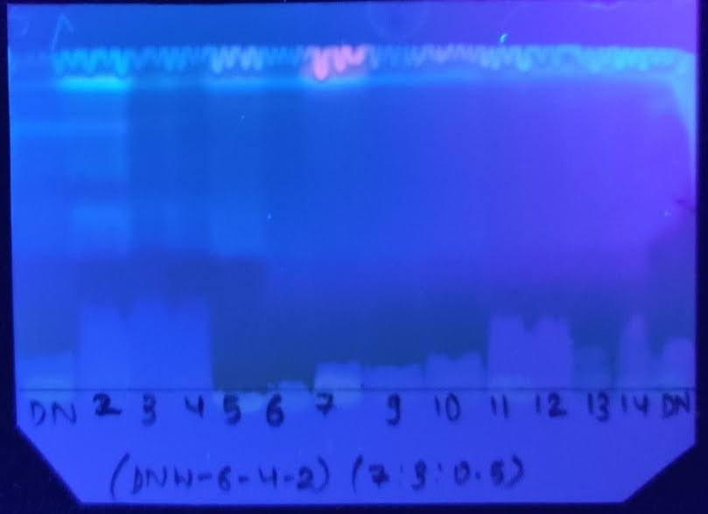  365 nm
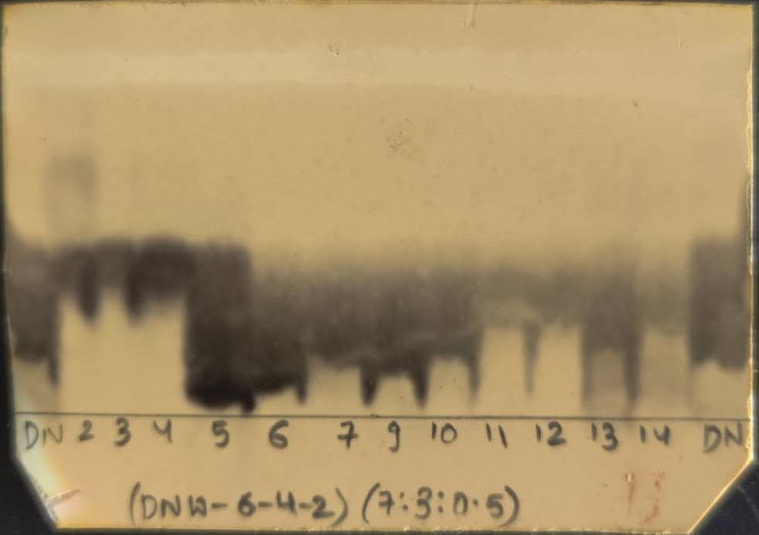  10% FeCl₃ Spray | 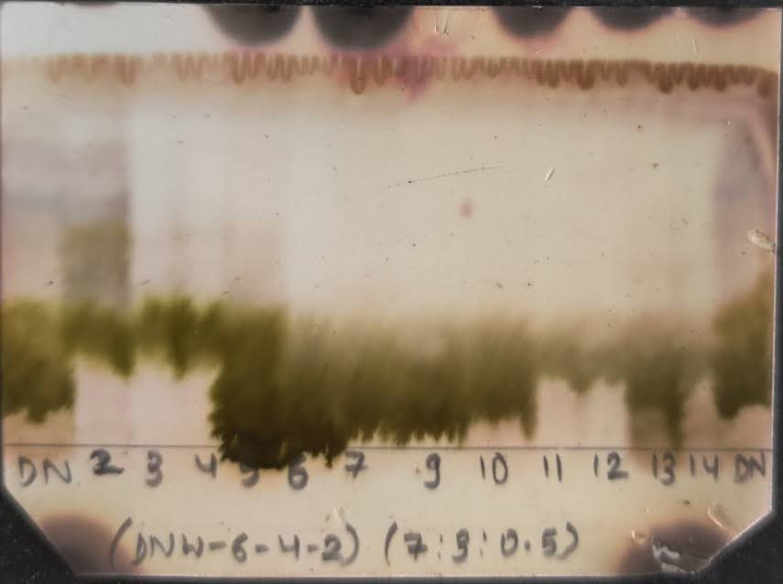  10% H₂SO₄/Heat
Figure 13: TLC pattern of fractions of DNW-6-4-2 obtained from Silica Column
For DNW-9-4-2/3 (i.e. DNW-9-4-2)
Volume of column = 𝜋𝑟²h
Where, 𝜋 = 22/7
r = radius of the column
h = height of the Silica in column
V = 𝜋𝑟²h = 22/7 x (1.5)²x 37= 261.5 cm³
The fraction DNW-9-4-2 and DNW-9-4-3 obtained from the ODS column were mixed to obtain the fraction DNW-9-4-2/3, as they showed similar spots on TLC. Thus, the mixed fraction was coded as DNW-9-4-2/3 (i.e. DNW-9-4-2). It was then applied to the Silica column.
Figure 14: Fractionation process of DNW-9-4-2 through Silica Column
DNW-9-4-2/3 (i.e. DNW-9-4-2) (25 mg)
Dissolved in CHCl₃: MeOH: H₂O (9:3:0.1)
Applied to ODS Column
DNW-9-4-2-2
DNW-9-4-2-3
DNW-9-4-2-1
Table 7: Fractions of DNW-9-4-2 obtained from Silica Column
Solvent | Sample Code | Fractions | Net Weight (mg)
CHCl₃: MeOH: H₂O (9:3:0.1) | DNW-9-4-2-1 | 1-9 | Discarded
CHCl₃: MeOH: H₂O (9:3:0.1) | DNW-9-4-2-2 | 10-14 | 3.3 mg
CHCl₃: MeOH: H₂O (9:3:0.1) | DNW-9-4-2-3 | 15-43 | 2.6 mg

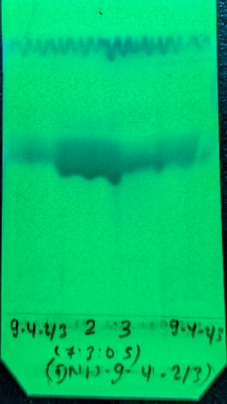  254 nm | 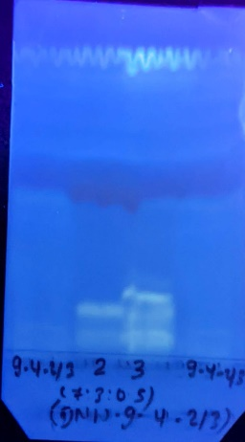  365 nm | 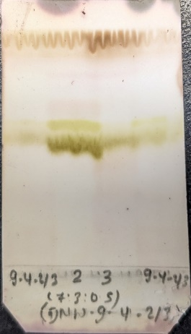  10% H₂SO₄/Heat
Figure 15: TLC pattern of fractions of DNW-9-4-2 obtained from Silica Column

