SUPPLEMENTARY MATERIAL

Antimicrobial and cytotoxic chemical constituents from Ficus sycomorus L. (Moraceae) and their chemophenetic significance
Vanini Samiyatou Michiren Mandou¹, Willifred Dongmo Tekapi Tsopgni¹, Mohamed Foundikou Nsangou¹, Gervais Mouthe Happi², Alain François Kamdem Waﬀo¹, Emmanuel Ngeufa Happi¹*
¹Department of Chemistry, University of Douala, Faculty of Sciences, P.O. Box 24157 Douala, Cameroon
²Department of Chemistry, Higher Teacher Training College Bambili, The University of Bamenda,
P.O Box 39 Bambili, Cameroon
Corresponding author : ngeufa@yahoo.fr (Emmanuel Ngeufa Happi)

- General instrumentation
EI-MS and ESI-MS were recorded on a Finnigan MAT 95 spectrometer (70 eV) with perfluorokerosene as a reference substance for EI–HR–MS. The spectrometer operated in positive and negative modes (m/z: 50‒1500, with a scan rate of 1.00 Hz) with automatic gain control to provide high-accuracy mass measurements within 1 ppm deviation using Na formate as calibrant. The following parameters were used for experiments: spray voltage of 4.5 kV, the capillary temperature of 200 °C. Nitrogen was used as sheath gas (4 l/min). The ¹H- and ¹³C-NMR spectra were recorded at 500 MHz and 125 MHz, respectively on Bruker AMX 500 NMR spectrometers chemical shifts are reported in δ (ppm) using TMS as internal standard and coupling constants (J) were measured in Hz. Column chromatography was carried out on silica gel (70‒230 mesh, Merck). Thin-layer chromatography (TLC) was performed on Merck precoated silica gel 60 F₂₅₄ aluminium foil, and spots were detected using ceric sulphate spray reagent.

- Antibacterial assay
The broth microdilution method was used for susceptibility testing of bacteria species in 96 well-microtiter sterile plates as described by Newton et al (Newton et al., 2002). For this, the crude extracts were dissolved in 5% dimethylsulfoxide (DMSO) solution and diluted with Mueller Hinton broth to obtain a stock concentration of 2000 µg/ml for the extracts, 1000 µg/ml for fractions, and 500 µg/ml for the isolated compounds. Serial two-fold dilutions of the test substances were made with Mueller Hinton broth to yield a volume of 100 µl/well. This gave a concentration range of 1000-0.96 µg/ml, 500-0.96 µg/ml and 250 to 0.96 µg/ml respectively. One hundred microlitres of each bacterial suspension (containing about 1.5×10⁶ CFU/mL) was added to respective wells containing the test samples and mixed thoroughly to give final concentrations ranging from 500-0.48 µg/ml for extract, 250-0.48µg/ml for fraction and 125 to 0.48µg/ml for isolated compounds. The solvent control, 5% DMSO did not show inhibitory effects on the growth of the bacteria. Ciprofloxacin® (Bayer, Germany) at concentration of 125 to 0.48µg/ml were used as the standard reference The assay microtitre plates were incubated at 37 °C for 24 hrs. Inhibitory concentrations of the extracts were detected after addition of 50 µl of 0.2 mg/ml p-iodonitrotetrazolium chloride (INT) (Sigma–Aldrich, South Africa) and incubated at 37 °C for 30 min (Mativandlela et al., 2006). Viable bacteria change the yellow dye of p-iodonitrotetrazolium chloride to a pink color. The assay is based on living cells’ capacity to transform the INT dye tetrazolium ring into a pinkcoloured formazan structure due to the action of mitochondrial and other dehydrogenases inside the cell. The lowest concentration at which no visible colour changes was observed was considered as the MIC (Minimum Inhibitory Concentration). The bactericidal concentrations were determined by adding 50 µl aliquots of the preparations (without INT), which did not show any visible colour change after subculture from MIC assays, into 150 µl of extract-free Mueller Hinton broth. These preparations were further incubated at 37 °C for 48 hrs and bacterial growth was revealed by the addition of INT as above. The smallest concentration at which no colour changes was observed was considered as the MBC. The tests were performed in duplicates. The ratio MBC/MIC was calculated to determine the bactericidal (MBC/MIC ≤ 4) and bacteriostatic (MBC/MIC > 4) effects.

- Antifungal assay
- Preparation of yeast inocula
The inocula of yeasts were prepared from 48h old cultures by picking numerous colonies and suspending them in sterile saline (NaCl) solution (0.9%). Absorbance was read at 530 nm and adjusted with the saline solution to match that of a 0.5 McFarland standard solution, corresponding to about 10⁶ yeast cells/ml.

- Preparation of dermatophyte inocula
Conidia suspensions of dermatophyte species were prepared from 10 days old cultures. The number of conidia was determined using a spectrophotometer and adjusted with sterile saline (NaCl) solution (0.9%) to an absorbance of 0.600 at 450 nm corresponding to a final concentration of about 1 x 104 spores/ml.
Minimum Inhibitory Concentration (MIC) of each extract was determined by using broth microdilution techniques according to the guidelines of the Clinical and Laboratory Standards Institute (CLSI, formerly National Committee for Clinical and Laboratory Standards, NCCLS) for yeasts (M27-A2). Stock solutions of the test extracts were prepared in 5% aqueous dimethylsulfoxide (DMSO) solution and diluted with Sabouraud Dextrose Broth (SDB) to give a concentration of 1 mg/ml. This was serially diluted two-fold to obtain a concentration range 500 to 0.24 μg /ml for extracts and 125 to 0.24 µg/ml for compounds.
The final concentration of DMSO in the well was less than 1% (preliminary analysis with 1% DMSO did not inhibit the growth of the test organisms). Negative control well consisted of 195 µl of SDB and 5 µl (containing about 10⁶ cells/ml for yeast and 1 x 10⁴ spores/ml for filamentous fungi) of the inoculum. The plates were covered with a sterile lid, and incubated on the shaker at 37 °C for 48 hours (for yeasts) or at 28 °C for 7 days (for dermatophytes). MICs were assessed visually after the corresponding incubation period and were taken as the lowest product concentration at which there was no growth or virtually no growth. The assay was repeated three times. For the MFCs determination, 5 µl aliquots from each well that showed no growth of microorganism were replicated into 195 µl of SDB and incubated at 37 °C for 48 hours (yeasts) and at 28 °C for 7 days (dermatophytes). The lowest concentration that yielded no growth after the subculturing was taken as the MFC. Nystatin (for yeasts) and griseofulvin (for dermatophytes) were used as positive controls.

- Cytotoxicity assay of the plant extract
Cytotoxicity effects of the crude extracts was investigated on Vero cell line ATCC CRT-1586 using rezasurin-based assay as previously described by Mosmann (Mosmann, 1983). The cells were cultured in Dulbecco’s Minimal Essential Medium (DMEM) (Sigma-aldrich-Germany), supplemented with 5% Fetal Bovine Serum (Sigma-aldrich-Germany) and 1% gentamicin (Sigma-aldrich-Germany). Monolayer culture reaching a confluence between 80-90% was detached using trypsin solution (1x) (Sigma-aldrich-Germany) and calibrated with a cell counter (Newbeaur). Calibrated cell suspension was seeded into 96-well tissue culture microtitre plates at a density of 1 × 10⁴ cells / well and incubated overnight at 37°C in a 5% CO2 incubator for cell adhesion. Following incubation, 100µl of medium was removed from cells and replaced by 100µl of the fresh one followed by the addition of gradual concentration of extracts at 100, 20, 4, 0.80, and 0.16 µg/mL. Positive control (Podophyllotoxin (10µmol/l (Sigma-aldrich-Germany) and negative control (0.5% DMSO) were added. Then, plates were incubated for 48h in the same culture conditions as above described. At the end of the incubation period, cell proliferation and viability were quantified by addition of 10 μl of 0.015 mg/ml solution of rezasurin in PBS and incubate at 37°C for 4 h. Fluorescence was measured at excitation of 530 nm and emission of 590 nm using Infinite M200 (TECAM, Swiss) microtitre plate reader. The results were expressed as a percentage of viability of the control cells and IC50 values were calculated based on the following equation:
% inhibition = (1-absorbancy of treated cells/absorbancy of untreated cells) x100.
The CC₅₀ values were calculated as a sigmoidal dose response curve using GraphPad Prism 4.03 software using the nonlinear regression log (inhibitor) vs. response algorithm.

Table 1S: NMR Data for Compound 1 (500 and 125 MHz in CDCl₃, J in Hz)

Position | δ_{H} [mult, J (Hz)] | δ_{C}
1 | 1.93 (m, 1H)  1.90 (m, 1H) | 39.7
2 | 2.49 (ddd, J = 15.7, 9.6, 7.6 Hz, 1H)  2.42 (ddd, J = 15.7, 7.8, 4.5 Hz, 1H) | 33.9
3 | - | 218.1
4 | - | 47.6
5 | 1.36 (dd, J = 5.5, 2.9 Hz, 1H) | 54.8
6 | 1.48 (m, 2H) | 19.9
7 | 1.46 (m, 2H) | 34.3
8 | - | 41.5
9 | 1.32 (m, 1H) | 49.1
10 | - | 36.8
11 | 1.51 (m, 2H) | 22.3
12 | 1.06 (m, 2H) | 26.7
13 | 1.80 (brt, 1H) | 39.2
14 | - | 43.4
15 | 1.79 (m, 2H) | 29.5
16 | 1.15 (m, 2H) | 37.9
17 | - | 35.3
18 | 1.24 (brdd, 1H) | 47.4
19 | 1.36 (dq, J = 6.7, 5.6, 1H) | 38.9
20 | - | 73.8
21 | 1.34 (m, 2H) | 38.2
22 | 1.48 (m, 2H) | 35.6
23 | 1.07 (s, 3H) | 26.9
24 | 1.02 (s, 3H) | 21.2
25 | 0.93 (s, 3H) | 16.2
26 | 1.08 (s, 3H) | 16.3
27 | 0.96 (s, 3H) | 14.8
28 | 0.84 (s, 3H) | 17.9
29 | 1,06 (d, J = 6.7, 3H) | 18.1
30 | 1.18 (s, 3H) | 30.5

Table 2S: NMR Data for Compound 2 (500 and 125 MHz in CDCl₃, J in Hz)
Position | δ_{H} [mult, J (Hz)] | δ_{C}
1 | 1.08 (m, 1H)  1.66 (m, 1H) | 38.5
2 | 1.90 (m, 2H) | 23.6
3 | 4.52 (m, 1H) | 80.9
4 | - | 37.7
5 | 0.85 (d, J = 3.3, 1H) | 55.3
6 | 1.39 (m, 2H) | 18.3
7 | 1.34 (m, 2H) | 32.9
8 | - | 41.6
9 | 1.56 (m, 2H) | 47.6
10 | - | 33.4
11 | 0.89 (m, 2H) | 23.6
12 | 5.14 (t, J = 3.7, 1H) | 124.3
13 | - | 139.6
14 | - | 42.1
15 | 0.83 (m, 2H) | 28.8
16 | 1.77 (m, 2H) | 26.6
17 | - | 33.8
18 | 1.34 (m, 1H) | 59.1
19 | 0 .69 (m, 1H) | 39.6
20 | 1.34 (m, 1H) | 39.7
21 | 1.49 (m, 2H) | 31.3
22 | 1.02 (m, 2H) | 41.7
23 | 0.90 (s, 3H) | 28.1
24 | 1.04 (s, 3H) | 16.8
25 | 0.98 (s, 3H) | 15.8
26 | 1.04 (s, 3H) | 16.8
27 | 0.89 (s, 3H) | 23.5
28 | 0.90 (s, 3H) | 28.1
29 | 1.09 (s, 3H) | 23.4
30 | 0.93 (s, 3H) | 21.4
1’ | - | 171.0
2’ | 2.04 (s, 3H) | 21.4

Table 3S: NMR Data for Compound 3 (500 and 125 MHz in CD₃OD, J in Hz)
Position | δ_{H} [mult, J (Hz)] | δ_{C}
1 | 1.06 (m, 1H)  1.62 (m, 1H) | 38.1
2 | 1.83 (m, 2H) | 28.8
3 | 3.15 (1H ; dd, J = 11.3; 4.6) | 79.7
4 | - | 39.9
5 | 0.74 (1H, m) | 56.7
6 | 1.42 (1H, m)  1.18 (1H, m) | 18.8
7 | 1.33 (2H, m) | 32.6
8 | - | 40.0
9 | 1.20 (1H, m) | 43.2
10 | - | 39.2
11 | 1.93 (2H, dd, J = 6.0, 3.0) | 24.4
12 | 5.23 (1H ; t ; J = 3.7) | 126.9
13 | - | 139.7
14 | - | 40.4
15 | 1.38 (2H, m) | 29.2
16 | 1,53 (2H, m) | 25.3
17 | - | 40.8
18 | 2.20 (1H ; dd, J = 11.4; 1.8) | 54.4
19 | 1.30 (1H, m) | 38.1
20 | 1.56 (1H, m) | 34.3
21 | 1.22 (2H, m) | 31.8
22 | 1.64 (2H, m) | 32.5
23 | 0.97 (3H, s) | 27.9
24 | 0.78 (3H, s) | 16.1
25 | 0.96 (3H, s) | 17.8
26 | 0.85 (3H, s) | 17.8
27 | 1.12 (3H, s) | 24.1
28 | - | 180.7
29 | 0.87 (3H, d. J = 6.5) | 17.7
30 | 0.94 (3H, d. J = 6.5) | 21.6

Table 4S: NMR Data for Compound 4 (500 and 125 MHz in CDCl₃, J in Hz)
Position | δ_{H} [mult, J (Hz)] | δ_{C}
1 | 1.08 (m, 1H)  1.7 (m, 1H) | 38.3
2 | 1.13 (m, 2H) | 26.0
3 | 4.52 (m, 1H) | 80.9
4 | - | 37.7
5 | 0.85 (d, J = 3.3, 1H) | 55.3
6 | 1.43 (m, 2H) | 18.3
7 | 1.34 (m, 2H) | 32.5
8 | - | 41.7
9 | 1.60 (m, 1H) | 47.7
10 | - | 37.2
11 | 1.65 (m, 2H) | 23.5
12 | 5.20 (t, J = 3.7, 1H) | 121.6
13 | - | 145.2
14 | - | 42.1
15 | 1.14 (brs, 2H) | 26.1
16 | 2.02 (m, 2H) | 26.9
17 | - | 32.5
18 | 1.58 (m, 1H) | 47.7
19 | 1.93 (m, 1H)  1.99 (m, 1H) | 47.2
20 | - | 31.1
21 | 1.11 (m, 1H)  1.35 (m, 1H) | 34.7
22 | 1.21 (m, 2H) | 36.8
23 | 0.81 (s, 3H) | 28.8
24 | 0.88 (s, 3H) | 16.7
25 | 0.98 (s, 3H) | 15.6
26 |  | 16.9
27 | 0.97 (s, 3H) | 26.2
28 | 0.86 (s, 3H) | 28.4
29 | 0.88 (s, 3H) | 33.6
30 | 0.89 (s, 3H) | 23.7
1’ | - | 171.0
2’ | 2.04 (s, 3H) | 21.4

Table 5S: NMR Data for Compound 5 (500 and 125 MHz Acetone-d₆, J in Hz)
Position | δ_{H} [mult, J (Hz)] | δ_{C}
1 | 1.17 (m, 1H)  1.41 (m, 1H) | 39.4
2 | 1.58 (m, 1H)  1.88 (m, 1H) | 28.7
3 | 3.25 (d, J = 10.0, 1H) | 78.6
4 | - | 39.2
5 | 0.77 (m, 1H) | 56.2
6 |  | 19.2
7 | 1.53 (m, 2H) | 32.6
8 | - | 41.0
9 | 1.11 (m, 1H) | 48.5
10 | - | 37.8
11 | 1.60 (m, 2H) | 23.8
12 | 5.23 (t, J = 3.7, 1H) | 123.1
13 | - | 145.0
14 | - | 39.5
15 | 1.12 (m, 2H) | 28.1
16 | 1.53 (m, 2H) | 23.9
17 | - | 46.9
18 | 2.81 (dd, J = 13.8, 4.6 ; 1H) | 40.2
19 | 1.58 (m, 2H) | 46.8
20 | - | 30.6
21 | 1.25 (m, 2H) | 33.4
22 | 1.56 (m, 2H) | 31.3
23 | 1.05 (s, 3H) | 28.5
24 | 0.86 (s, 3H) | 16.3
25 | 1.05 (s, 3H) | 15.8
26 | 0.78 (s, 3H) | 17.6
27 | 1.13 (s, 3H) | 26.3
28 | - | 178.9
29 | 0.87 (s, 3H) | 33.7
30 | 0.90 (s, 3H) | 24.1

Table 6S: NMR Data for Compound 6 (500 and 125 MHz in MeOD+CDCl₃, J in Hz)

Position | δ_{H} [mult, J (Hz)] | δ_{C}
1 | 1.10 (m, 1H)  1.60 (m, 1H) | 45.9
2 | 5.03 (dt, J = 10.0, 4.5 ; 1H) | 72.8
3 | 3.25 (d, J = 10.0, 1H) | 80.0
4 | - | 41.2
5 | 0.88 (m, 1H) | 55.2
6 | 1.48 (m, 2H) | 18.2
7 | 1.29 (m, 1H)  1.50 (m, 1H) | 32.6
8 | - | 44.0
9 | 1,61 (m ,1H) | 47.4
10 | - | 39.2
11 | 1.08 (m, 2H) | 23.4
12 | 5.23 (t, J = 3.6, 1H) | 122.0
13 | - | 144.0
14 | - | 39.8
15 | 1.16 (m, 2H) | 28.3
16 | 0,97 (m, 2H) | 23.1
17 | - | 46.3
18 | 2.81 (dd, J = 13.8, 4.6 ; 1H) | 41.2
19 | 1.63 (m, 2H) | 46.0
20 | - | 30.5
21 | 1.16 (m, 2H) | 33.8
22 | 1.35 (m, 2H) | 32.5
23 | 1.05 (s, 3H) | 27.5
24 | 0.86 (s, 3H) | 16.5
25 | 1.05 (s, 3H) | 16.1
26 | 0.78 (s, 3H) | 16.6
27 | 1.13 (s, 3H) | 25.7
28 | - | 180.7
29 | 0.87 (s, 3H) | 32.7
30 | 0.90 (s, 3H) | 23.2
1’ | - | 168.2
2’ | 6.27 (d, J = 15.9, 1H) | 114.6
3’ | 7.59 (d, J = 15.9, 1H) | 145.1
4’ | - | 126.0
5’. 9’ | 7.39 (d, J = 8.6, 2H) | 130.0
6’. 8’ | 6.79 (d, J = 8.6, 2H) | 115.7
7’ | - | 159.5

Table 7S: NMR Data for Compound 7 (500 and 125 MHz in CDCl₃. J in Hz)

Position | δ_{H} [mult, J (Hz)] | δ_{C}
1 | 2.10 (2H, m) | 24.7
2 | 2.39 (2H, ddd, J = 13.3, 4.6, 2.3) | 42.4
3 | - | 213.0
4 | 2. 54 (1H, q, 6.71) | 56.8
5 | - | 42.6
6 | 1.83 (2H, dt, J = 12.2, 3.1) | 42.0
7 | 1.48 (2H, m) | 17.9
8 | 1.53 (1H, m) | 52.6
9 | - | 36.9
10 | 2.25 (1H, m) | 58.5
11 | 1.40 (2H, m) | 35.0
12 | 1.99 (2H, dt, J = 13.9, 3.5) | 29.9
13 | - | 39.1
14 | - | 38.1
15 | 1.40 (2H, m) | 31.1
16 | 1.20 (2H, m) | 31.7
17 | - | 35.3
18 | 1.18 (1H, m) | 39.7
19 | 1.20 (2H, m) | 34.0
20 | - | 27.8
21 | 1.38 (2H, m) | 31.2
22 | 1.27 (2H, m) | 32.1
23 | 0.90 (3H, d, J = 6.71) | 7.0
24 | 0.84 (3H, s) | 14.1
25 | 0.96 (3H, s) | 18.6
26 | 1.02 (3H, s) | 18.7
27 | 1.08 (3H, s) | 20.1
28 | 3.89 (1H, d, J = 11.69)  3.99 (1H, d, J = 11.69) | 63.0
29 | 1.00 (3H, s) | 32.7
30 | 1.18 (3H, s) | 34.7

Table 8S: NMR Data for Compound 8 (500 and 125 MHz in CDCl₃, J in Hz)

Position | δ_{H} [mult, J (Hz)] | δ_{C}
1 | 0.91 (m, 1H)  1.66 (m, 1H) | 38.7
2 | 1.61 (m, 1H)  1.57 (m, 1H) | 27.5
3 | 3.18 (dd, J = 11.4, 5.3; 1H) | 79.1
4 | - | 38.9
5 | 0.70 (m, 1H) | 55.4
6 | 1.52 (m, 1H)  1.41 (m, 1H) | 18.3
7 | 1.40 (m, 2H) | 34.3
8 | - | 40.8
9 | 1.26 (m, 1H) | 50.4
10 | - | 37.2
11 | 1.42 (m, 1H)  1.22 (m, 1H) | 20.9
12 | 1.05 (m, 1H)  1.66 (m, 1H) | 25.2
13 | 1.65 (m, 1H) | 38.1
14 | - | 42.8
15 | 0.99 (m, 1H)  1.69 (m, 1H) | 27.5
16 | 1.37 (m, 1H)  1.46 (m, 1H) | 35.6
17 | - | 43.0
18 | 1.38 (m, 1H) | 48.0
19 | 2.39 (m, 1H) | 48.3
20 | - | 150.0
21 | 1.32 (m, 1H)  1.91 (m, 1H) | 29.9
22 | 1.19 (m, 1H)  1.37 (m, 1H) | 40.0
23 | 0.98 (s, 3H) | 28.0
24 | 0.77 (s, 3H) | 15.4
25 | 0.84 (s, 3H) | 16.0
26 | 1.05 (s, 3H) | 16.1
27 | 0.95 (s, 3H) | 14.5
28 | 0.8 (s, 3H) | 18.0
29 | 4.55 (d, J = 2.4, 1H)  4.70 (d, J = 2.4, 1H) | 109.1
30 | 1.70 (s, 3H) | 19.3

Table 9S: NMR Data for Compound 9 (500 and 125 MHz in CDCl₃, J in Hz)

Position | δ_{H} [mult, J (Hz)] | δ_{C}
1 | 0.92 (m, 1H)  1.68 (m, 1H) | 39.1
2 | 1.54 (m, 2H) | 27.6
3 | 3.11 (dd, J = 5.0, 10.9; 1H) | 79.2
4 | - | 38.9
5 | 0.70 (m, 1H) | 55.5
6 | 1.41 (m, 1H)  1.53 (m, 1H) | 18.4
7 | 1.39 (m, 2H) | 34.5
8 | - | 40.8
9 | 1.31 (m, 1H) | 50.7
10 | - | 37.2
11 | 1.42 (m, 1H)  1.25 (m, 1H) | 21.0
12 | 1.04 (m, 1H)  1.70 (m, 1H) | 25.6
13 | 2.34 (m, 1H) | 38.5
14 | - | 42.6
15 | 1.37 (m, 1H)  1.92 (m, 1H) | 30.7
16 | 1.40 (m, 1H)  2.22 (m, 1H) | 32.3
17 | - | 56.4
18 | 1.62 (m, 1H) | 49.
19 | 3.30 (ddd, J = 5.0, 16.9, 10.6; 1H) | 47.1
20 | - | 150.5
21 | - | 29.9
22 | - | 37.4
23 | 0.95 (s, 3H) | 28.1
24 | 0.75 (s, 3H) | 16.3
25 | 0.85 (s, 3H) | 15.5
26 | 0.97 (s, 3H) | 16.2
27 | 1.00 (s, 3H) | 14.8
28 | - | 179.7
29 | 4.71 (m, 1H)  4.58 (m, 1H) | 109.9
30 | 1.68 (s, 3H) | 19.52

Table 10S: NMR Data for Compound 10 (500 and 125 MHz in CDCl₃, J in Hz)

Position | δ_{H} [mult, J (Hz)] | δ_{C}
1 | 0.86 (1H, m)  1.53 (1H, m) | 38.4
2 | 1.50 (2H, m) | 23.7
3 | 4.32 (1H, dd, J = 10.6, 5.7) | 81.0
4 | - | 37.8
5 | 0.66 (1H, m) | 55.4
6 | 1.28 (1H, m)  1.39 (1H, m) | 18.2
7 | 1.28 (1H, m) | 34.2
8 | - | 40.9
9 | 1.15 (1H, m) | 50.4
10 | - | 37.1
11 | 1.89 (2H, m) | 21.0
12 | 0.95 (1H, m)  1.53 (1H, m) | 25.1
13 | 1.54 (1H, m) | 38.1
14 | - | 42.8
15 | 0.88 (1H, dt, J = 4.4, 2.3)  1.56 (1H, m) | 27.4
16 | 1.35 (2H, m) | 35.9
17 | - | 43.0
18 | 1.24 (1H, m) | 48.0
19 | 2.20 (2H, td, J = 11.0, 5.8) | 48.3
20 | - | 151.0
21 | 1.19 (1H, m)  1.78 (1H, m) | 29.9
22 | 1.06 (1H, m)  1.24 (1H, m) | 40.0
23 | 0.73 (3H. s) | 16.5
24 | 0.72 (3H. s) | 28.1
25 | 0.77 (3H. s) | 16.3
26 | 0.92 (3H. s) | 16.0
27 | 0.82 (3H. s) | 14.6
28 | 0.66 (3H. s) | 18.0
29 | 4.41 (1H. d. J = 2.5)  4.53 (1H. d. J = 2.5) | 109.4
30 | 1. 56 | 19.3
1’ | - | 171.0
2’ | 1.88 (3H. s) | 21.4

Table 11S: NMR Data for Compound 11 (500 and 125 MHz in CD₃OD, J in Hz)

Position | δ_{H} [mult, J (Hz)] | δ_{C}
1 | 2.1 (1H, dd, J = 12.5, 4.5)  1.9 (1H, dd, J = 11.4, 4.5) | 46.8
2 | 3.7 (1H, ddd, J = 11.4, 9.6, 4.5) | 68.2
3 | 2.88 (1H, d, J = 9.6) | 83.1
4 | - | 39.1
5 | 0.88 (1H, m) | 55.1
6 | 1.63 (2H, m) | 17.8
7 | 1.64 (2H, m) | 41.6
8 | - | 44.8
9 | 1.03 (1H, s) | 56.7
10 | - | 39.9
11 | 1.60 (2H, m) | 19.9
12 | 1.64 (2H, m) | 26.4
13 | 1.83 (1H, m) | 47.9
14 | 1.55 (12H, m) | 37.1
15 | 1.54 (2H, s) | 57.2
16 | - | 78.3
17 | 1.33 (3H, s) | 23.2
18 | 0. 99 (3H, s) | 28.1
19 | 0. 80 (3H, s) | 16.6
20 | 1. 11(3H, s) | 18.1

Table 12S: NMR Data for Compound 12 (500 and 125 MHz in CDCl₃, J in Hz)

Position | δ_{H} [mult, J (Hz)] | δ_{C}
1 | 1.15 (1H, m) | 37.3
2 | 1.44 (11H, m) | 31.7
3 | 3.52 (1H, m) | 71.8
4 | 1.98 (2H, m) | 42.4
5 | - | 140.8
6 | 5.35 (1H, m) | 121.7
7 | 1.85 (2H, m) | 32.0
8 | 1.44 (11H, m) | 31.9
9 | 1.44 (11H, m) | 50.2
10 | - | 36.6
11 | 1.44 (11H, m) | 21.1
12 | 1.44 (11H, m) | 39.8
13 | - | 42.4
14 | 1.44 (11H, m) | 56.9
15 | 1.54 (4H, m) | 24.4
16 | 1.54 (4H, m) | 28.9
17 | 1.53 (1H, m) | 56.9
18 | 0.68 (3H, s) | 12.2
19 | 1.02 (3H, s) | 19.4
20 | 2.27 (1H, m) | 40.5
21 | 0.87 (3H, d, J = 6.3) | 21.1
22 | 5.13 (1H, dd, J = 12.0, 8.0) | 138.3
23 | 5.03 (1H, dd, J = 12.0, 8.0) | 129.3
24 | 2.22 (1H, m) | 51.3
25 | 1.85 (1H, s) | 31.2
26 | 0.85 (3H, d, J = 6.8) | 21.2
27 | 0.82 (3H, d, J = 6.8) | 21.2
28 | 1.25 (3H, m) | 25.4
29 | 0.82 (3H, d, J = 6.9) | 12.2

Table 13S: NMR Data for Compound 13 (600 and 150 MHz in CDCl₃, J in Hz)
Position | δ_{H} [mult, J (Hz)] | δ_{C}
1 | 1.12 (m, 1H)  2.04 (m, 1H) | 37.1
2 | 1.39 (m, 2H) | 37.5
3 | - | 209.2
4 | 2.09 (m, 1H)  2.39 (m, 1H) | 38.1
5 | 2.60(t, J = 12.8, 1H) | 57.5
6 | - | 211.7
7 | 2.38 (m, 1H)  2.42 (m, 1H) | 46.7
8 | 1.45 (d, J = 3.39, 1H) | 37.1
9 | 1.01(dd, J = 12.3, 6.3; 1H) | 53.4
10 | - | 41.1
11 | 2.31(m, 1H)  2.62 (m, 1H) | 21.7
12 | 2.62 (m, 1H) | 39.5
13 | - | 42.5
14 | - | 56.1
15 | 1.25 (m, 2H) | 26.1
16 | 1.66 (m, 2H) | 29.1
17 | 1.21 (m, 1H) | 56.1
18 | 0.69 (s, 3H) | 12.1
19 | 0.70 (s, 3H) | 12.1
20 | 1.56 (m, 1H) | 40.4
21 | 0.87 (d, J = 8.68, 3H) | 21.2
22 | 5.14 (dd, J = 15.16, 8.68; 1H) | ,
23 | 5.03 (dd, J = 15.16, 8.66; 1H) | 129.8
24 | 2.09 (m, 1H) | 51.2
25 | 1.03 (m, 1H) | 31.9
26 | 0.94 (s, 3H) | 18.7
27 | 0.85 (s, 3H) | 21.4
28 | 1.56 (s, 2H) | 24.1
29 | 0.95 (d, J = 6.5, 3H) | 12.3

Table 14S: NMR Data for Compound 14 (500 and 125 MHz in CDCl₃, J in Hz)
Position | δ_{H} [mult, J (Hz)] | δ_{C}
1 | 1.12 (m, 1H)  2.13 (m, 1H) | 38.7
2 | 1.39 (m, 1H)  2.44 (m, 1H) | 38.1
3 | - | 213.0
4 | 2.23 (m, 1H)  2.34 ((m, 1H) | 44.2
5 | 1.24 (m, 1H) | 56.0
6 | 2.24 (m, 2H) | 39.4
7 | 5.18 (m, 1H) | 116.9
8 | - | 145.8
9 | 1.81 (m, 1H) | 42.8
10 | - | 34.3
11 | 2.23 (m, 1H)  2.6 (m, 1H) | 39.5
12 | 2.62 (m, 2H)
13 | - | 43. 4
14 | 1.54 (m, 1H) | 48.9
15 | 1.25 (m, 2H)
16 | 1.92 (m, 2H) | 27. 9
17 | 1.24 (m, 1H) | 56.1
18 | 0.56 (s, 3H) | 11.9
19 | 1.82 (s, 3H) | 12.8
20 | 1.36(m, 1H) | 36.6
21 | 0.98 (d, J =7.0, 3H) | 18.9
22 | 1.35 (m, 2H) | 33.9
23 | 1.19 (m, 2H) | 26.2
24 | 0.90 (m, 1H) | 45.9
25 | 1.66 (m, 1H) | 29.2
26 | 0.85 (d, J = 6.5, 3H) | 19.1
27 | 0.93 (d, J = 6.5, 3H) | 12.5
28 | 0.99 (s, 2H) | 21.1
29 | 0.82 (d, J = 7.5, 3H) | 19.0

Table 15S: NMR Data for Compound 15 (500 and 125 MHz in CDCl₃, J in Hz)
Position | δ_{H} [mult, J (Hz)] | δ_{C}
1 | 1.15 (m, 1H) | 37.3
2 | 1.44 (m, 1H) | 31.7
3 | 3.52 (m, 1H) | 71.8
4 | 1.98 (m, 2H) | 42.4
5 | - | 140.8
6 | 5.35 (m, 1H) | 121.7
7 | 1.85 (m, 2H) | 32.0
8 | 1.44 (m, 1H) | 31.9
9 | 1.44 (m, 1H) | 50.2
10 | - | 36.6
11 | 1.44 (m, 1H) | 21.1
12 | 1.44 (m, 1H) | 39.8
13 | - | 42.4
14 | 1.44 (m, 1H) | 56.9
15 | 1.54 (m, 2H) | 24.4
16 | 1.54 (m, 2H) | 28.9
17 | 1.53 (m, 1H) | 56.9
18 | 0.68 (s, 3H) | 12.2
19 | 1.02 (s, 3H) | 19.4
20 | 2.27 (m, 1H) | 40.5
21 | 0.87 (d, J = 6.3, 3H) | 21.1
22 | 5.13 (dd, J = 12.0, 8.0; 1H) | 138.3
23 | 5.03 (dd, J = 12.0, 8.0; 1H) | 129.3
24 | 2.22 (m, 1H) | 51.3
25 | 1.85 (s, 1H) | 31.2
26 | 0.85 (d, J = 6.8, 3H) | 21.2
27 | 0.82 (d, J = 6.8, 3H) | 21.2
28 | 1.25 (m, 3H) | 25.4
29 | 0.82 (d, J = 6.9, 3H) | 12.2

Table 16S: NMR Data for Compound 16 (500 and 125 MHz in MeOD+CDCl₃, J in Hz)

Position | δ_{H} [mult, J (Hz)] | δ_{C}
1 | 1.24 (m, 2H) | 37.5
2 | 1.39 (m, 2H) | 32.2
3 | 3.47 (m, 1H) | 78.6
4 | 1.93 (m, 2H) | 42.4
5 | - | 141.0
6 | 5.32 (m, 2H) | 121.9
7 | 1.80 (m, 2H) | 32.2
8 | 1.50 (m, 1H) | 32.1
9 | 1.50 (m, 1H) | 50.4
10 | - | 37.0
11 | 1.50 (m, 2H) | 19.5
12 | 1.50 (m, 2H) | 39.4
13 | - | 42.4
14 | 1.15 (m, 1H) | 57.0
15 | 1.80 (m, 2H) | 24.6
16 | 1.80 (m, 2H) | 29.3
17 | 1.24 (m, 1H) | 56.2
18 | 0.82 (s, 3H) | 12.2
19 | 0.95 (s, 3H) | 19.2
20 | 2.12 (m, 1H) | 40.8
21 | 0.90 (d, J = 6.4, 3H) | 21.3
22 | 5.16 (dd, J = 12.1, 8.2; 2H) | 138.8
23 | 5.03 (dd, J = 12.1, 8.2; 1H) | 129.6
24 | 1.50 (m, 1H) | 51.5
25 | 1.15 (m, 1H) | 32.1
26 | 1.50 (s, 3H) | 19.5
27 | 1.63 (s, 3H) | 19.3
28 | 0.76 (m, 3H) | 25.7
29 | 0.99 (d, J = 6.9, 3H) | 12.5
1’ | 4.22 (d, J = 6.5, 1H) | 102.6
2’ | 2.90 (t, J = 7.0, 1H) | 75.4
3’ | 3.12 (d, J = 7.5, 1H) | 78.4
4’ | 3.06 (m, 1H) | 71.8
5’ | 3.10 (m, 1H) | 78.2
6’ | 3.44 (m, 1H)  3.67 (m, 1H) | 63.0

Table 17S: NMR Data for Compound 17 (500 and 125 MHz in CDCl₃, J in Hz)

Position | δ_{H} [mult. J (Hz)] | δ_{C}
2 | 7.82 (s, 1H) | 152.5
3 | - | 122.9
4 | - | 181.9
4a | - | 106.0
5 | - | 157.3
5-OH | 13.02 (s, 1H) | -
6 | - | 105.6
7 | - | 159.5
8 | 6.34 (s, 1H) | 94.8
8a | - | 156.8
1’ | - | 123.5
2’, 6’ | 7.37 (d, J = 8.8, 2H) | 130.3
3’, 5’ | 6.83 (d, J = 8.8, 2H) | 115.6
4’ | - | 155.8
2’’ | - | 78.0
3’’ | 5.63 (d, J = 10.0, 1H) | 128.2
4’’ | 6.73 (d, J = 10.0, 1H) | 115.5
5’’ | 1.48 (s, 3H) | 28.2
6’’ | 1.48 (s, 3H) | 28.2

Table 18S: NMR Data for Compound 18 (500 and 125 MHz in CDCl₃+CD₃OD, J in Hz)

Position | δ_{H} [mult, J (Hz)] | δ_{C}
2 | 7.86 (s) | 152.4
3 | - | 124.1
4 | - | 181.3
5 | - | 161.8
6 | 6.25 (s) | 100.3
7 | - | 159.7
8 | - | 101.5
8a | - | 152.8
4a | - | 106.1
1’ | - | 121.8
2’ | 7.30 (d ; J = 8. 6) | 130.3
3’ | 6.91 (d ; J = 8.6) | 115.6
4’ | - | 157.5
5’ | 6.91 (d ; J = 8. 6) | 115.6
6’ | 7.30 (d ; J = 8. 6) | 130.3
2’’ | - | 78.3
3’’ | 5.56 (d ; J = 10.0) | 127.7
4’’ | 6.71 (d ; J = 10.0) | 114.6
5’’ | 1.45 (s) | 28.2
6’’ | 1.45 (s) | 28.2
5-OH | 12.81 (s) | /

Table 19S: NMR Data for Compound 19 (500 and 125 MHz in CDCl₃+CD₃OD, J in Hz)

Position | δ_{H} [mult, J (Hz)] | δ_{C}
2 | 7.70 (s, 1H) | 152.70
3 | - | 122.59
4 | - | 180.79
4a | - | 105.27
5 | - | 164.01
5-OH | 13.11 (s, 1H) | /
6 | 6.14 (dd ; J = 2.2, 1.0 ; 1H) | 99.15
7 | - | 162.07
8 | 6.22 (dd ; J = 2.2, 1.0 ; 1H) | 93.95
8a | - | 158.11
1’ | - | 124.59
2’ | 7.08 (d ; J = 2.3, 1H) | 130.20
3’ | - | 129.73
4’ | - | 157.4
4’-OMe | 3.72 (s, 3H) | 55.3
5’ | 6.78 (d, J = 8.4, 1H) | 110.2
6’ | 7.19 (dd ; J = 8.2, 2.3 ; 1H) | 127.6
1’’ | 3.21 (d ; J = 7.5, 2H) | 28.3
2’’ | 5.17 (ddq ; J = 8.7, 5.9, 1.4; 1H ) | 122.1
3’’ | - | 132.5
4’’ | 1.59 (s, 3H) | 17.5
5’’ | 1.57 (s, 3H) | 25.5

Table 20S: NMR Data for Compound 20 (500 and 125 MHz in Acetone-d₆, J in Hz)

Position | δ_{H} [mult. J (Hz)] | δ_{C}
2 | - | 164.1
3 | 6.69 (s, 1H) | 103.3
4 | - | 182.4
4a | -` | 105.0
5-OH | 13.12 (s, 1H) | 161.9
6 | 6.17 (s, 1H) | 99.5
7 | - | 159.3
8 | - | 101.3
8a | - | 151.9
1’ | - | 122.4
2’. 6’ | 8.00 (d, J = 8.8, 2H) | 128.5
3’. 5’ | 7.05 (d, J = 8.8, 2H) | 116.1
4’-OH | - | 161.2
1’’ | 6.92 (d, J = 10.0, 1H) | 114.6
2’’ | 5.78 (d, J = 10.0, 1H) | 127.8
3’’ | - | 78.0
4’’. 5’’ | 1.48 (s, 6H) | 27.4

Table 21S: NMR Data for Compound 21 (500 and 125 MHz in CDCl₃, J in Hz)

Position | δ_{H} [mult, J (Hz)] | δ_{C}
1 | - | 176.6
2 | - | 157.2
3 | 5.85 (brs, 1H) | 107.3
4 | - | 186.4
5 | 5.85 (brs, 1H) | 107.3
6 | - | 157.2
2-OCH₃ | 3.82 (s, 3H) | 56.4
6-OCH₃ | 3.82 (s, 3H) | 56.4

Table 22S: NMR Data for Compound 22 (600 and 150 MHz in Acetone-d₆+MeOD, J in Hz)
Position | δ_{H} [mult, J (Hz)] | δ_{C}
1 | 2.9 (t, J = 7.1, 2H) | 34.5
2 | 4.2 (t, J =7.1, 2H) | 65.1
1’ | - | 130.3
2’, 6’ | 7.1 (d, J = 8.4, 1H) | 130.2
3’, 5’ | 6.8 (d, J = 8.4, 1H) | 115.5
4’ | - | 154.3
4’-OH | 4.6 (brs, 1H) | -
1’’ | - | 174.0
2’’ | 2.3 (t, J = 7.1, 2H) | 34.4
3’’ | 1.6 (d, J = 7.1, 2H) | 25.1
4’’-28’’ | 1.2-1.3 (m, 56H) | 29.2-29.8
29’’ | 1.58 (m, 2H) | 25.1
30’’ | 0.9 (t, J = 7.0, 3H) | 14.3

Table 23S: NMR Data for Compound 23 (500 and 125 MHz in CDCl₃, J in Hz)

Position | δ_{H} [mult, J (Hz)] | δ_{C}
1 | 4.47 (1H ; dd ; J =11.3 ; 3.4 Hz);  3.97 (1H ; dd ; J = 11.3 ; 4.4 Hz) | 65.4
2 | 4.85 (1H ; q ; J = 6.7 Hz) | 50.3
3 | 3.23 (1H ; dd ; J = 13.9 ; 6.5 Hz);  3.14 (1H ; dd ; J =13.9 ; 7.0 Hz) | 37.3
4 | - | 137.2
5/9 | 7.59 (2H ; d ; J = 7.1 Hz) | 129.3
6/8 | 7.24 (2H ; d ; J = 7.1 Hz) | 129.2
7 | 7.26 (1H ; d ; J = 1.8 Hz) | 127.4
10 | - | 167.4
11 | - | 135.8
12/16 | 7.37 (2H ; t ; J = 9.9 Hz) | 128.4
13/15 | 7.25 (2H ; d ; J = 9.9 Hz) | 128.9
14 | 7.37 (1H ; t ; J = 7.4 Hz) | 133.3
N-Ha | 6.48 (1H ; d ; J = 6.6 Hz) | -
1’ | - | 171.9
2’ | 4.55 (1H ; dtd ; J = 12.0 ; 8.0 ; 3.9 Hz) | 54.4
3’ | 2.93 (1H ; dd ; J =13.7 ; 6.5 Hz);  2.82 (1H ; dd ; J =13.7 ; 8.4 Hz) | 37.6
4’ | - | 134.2
5’/9’ | 7.63 (2H ; d ; J = 7.1 Hz) | 128.7
6’/8’ | 7.22 (2H ; d ; J = 7.1 Hz) | 128.7
7’ | 7.44 (1H ; t ; J = 7.4 Hz) | 127.4
10’ | - | 167.4
11’ | - | 132.1
12’/16’ | 7.24 (2H ; d ; J = 1.9 Hz) | 127.2
13’/15’ | 7.14 (2H ; d ; J = 3.4 Hz) | 128.4
14’ | 7.17 (1H ; d ; J = 5.9 Hz) | 131.4
N-Hb | 6.57 (1H ; d ; J = 8.4 Hz) | -

Table 24S: NMR Data for Compound 24 (500 and 125 MHz in CDCl₃, J in Hz)

Position | δ_{H} [mult, J (Hz)] | δ_{C}
1 | 3.32 (dd. J = 11 ; 5Hz)  3.92 (dd. J = 11 ; 4.5) | 65.5
2 | 4.33 (m) | 50.3
3 | 3.00 (dd. J = 7.1 ; 2.5) | 37.7
4 | / | 138.5
5 | 7.07 (d. J = 8.3) | 129.2
6 | 7.16 (m) | 128.6
7 | 7.16 (m) | 126.8
8 | 7.16 (m) | 128.6
9 | 7.07 (d. J = 8.3) | 129.2
1’ | / | 170.8
2’ | 4.74(m) | 55.8
3’ | 3.05 (m) ; 3.20 (m) | 38.9
4’ | / | 138.4
5’ | 7.25 (m) | 129.0
6’ | 7.25 (m) | 128.2
7’ | 7.25 (m) | 127.0
8’ | 7.25 (m) | 128.7
9’ | 7.25 (m) | 129.0
1“ | / | 167.9
2“ | / | 133.6
3“ | 7.70 (d. J = 8.5) | 127.0
4“ | 7.44 (t. J = 8.5) | 128.9
5“ | 7.51 (t. J = 8.5) | 131.6
6“ | 7.44 (t. J = 8.5) | 128.8
7“ | 7.70 (d. J = 8.5Hz) | 127.0
1a | / | 172.1
1b | 2.00 (s) | 20.8
1’a | 6.71 (d. J = 7.5Hz) | /
1’’a | 5.92 (d. J = 8.5Hz) | /

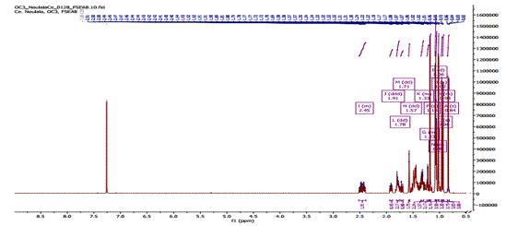
Figure 1S: ¹H NMR (500 MHz, CDCl₃) spectrum of 3-oxo-20R-hydroxytarastane (1)
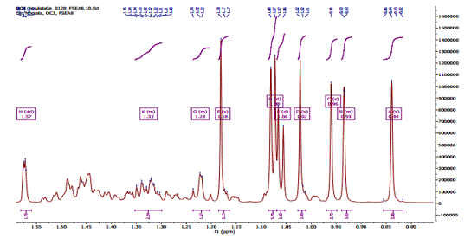
Figure 2S: ¹H NMR (500 MHz, CDCl₃) wide spectrum of 3-oxo-20R-hydroxytarastane (1)
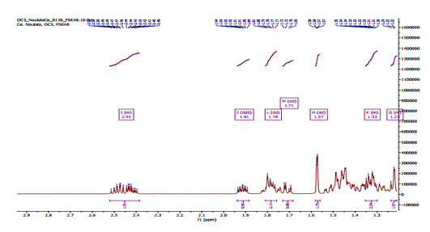
Figure 3S: Enlarged ¹H NMR spectrum of 3-oxo-20R-hydroxytarastane (1)
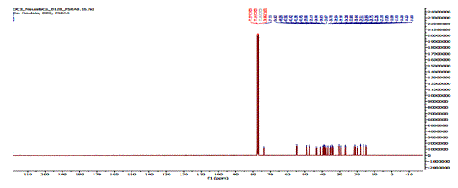
Figure 4S: ¹³C NMR (125 MHz, CDCl₃) spectrum of 3-oxo-20R-hydroxytarastane (1)
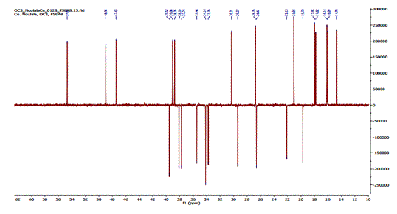
Figure 5S: 135-DEPT spectrum of 3-oxo-20R-hydroxytarastane (1)

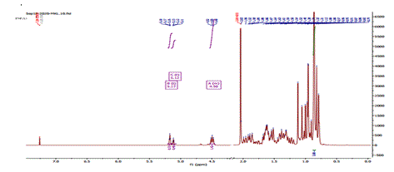
Figure 6S: ¹H NMR Spectrum (500 MHz, CDCl₃) of acetate of α and β-amyrin (2, 4)
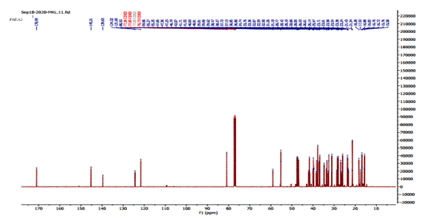
Figure 7S: ¹³C NMR Spectrum (125 MHz, CDCl₃) of acetate of α and β-amyrin (2, 4)
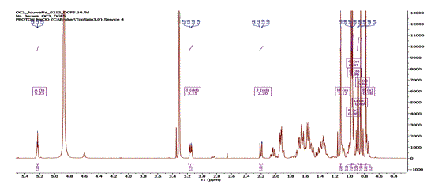
Figure 8S: ¹H NMR Spectrum (500 MHz, CD₃OD) of ursolic acid (3)
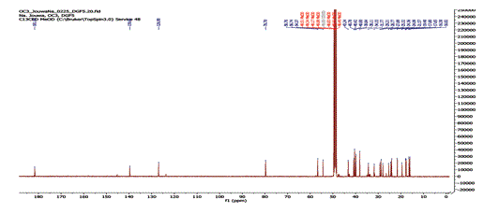
Figure 9S: ¹³C NMR spectrum (125 MHz, CD₃OD) of ursolic acid (3)
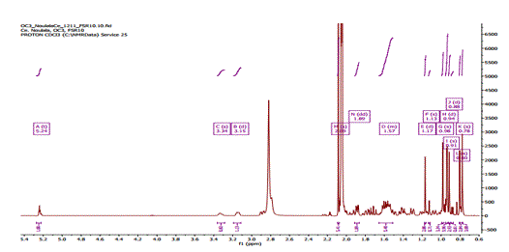
Figure 10S: ¹H NMR Spectrum (500 MHz, Acetone-d₆) of oeanolic acid (5)
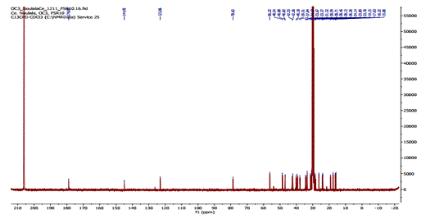
Figure 11S: ¹³C NMR Spectrum (125 MHz, acetone-d₆) of oleanolic acid (5)
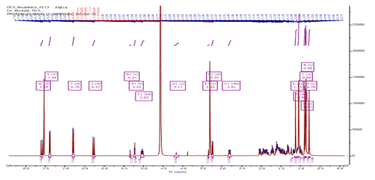
Figure 12S: ¹H NMR Spectrum (500 MHz, MeOD+CDCl₃) of compound 6
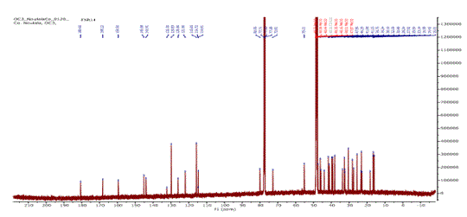
Figure 13S: ¹³C NMR Spectrum (125 MHz, MeOD) of compound 6
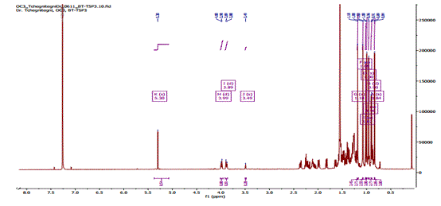
Figure 14S: ¹H NMR Spectrum (500 MHz, CDCl₃) of 28-hydroxyfriedelan-3-one (7)
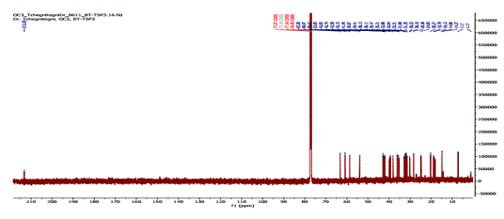
Figure 15S: ¹³C NMR Spectrum (125 MHz, CDCl₃) of 28-hydroxyfriedelan-3-one (7)
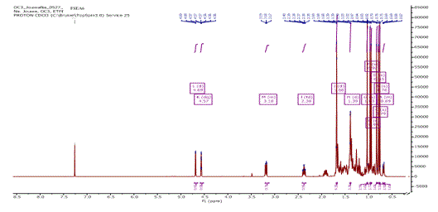
Figure 16S: ¹H NMR Spectrum (500 MHz, CDCl₃) of lupeol (8)
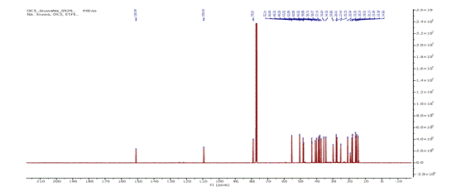
Figure 17S: ¹³C NMR Spectrum (125 MHz, CDCl₃) of lupeol (8)
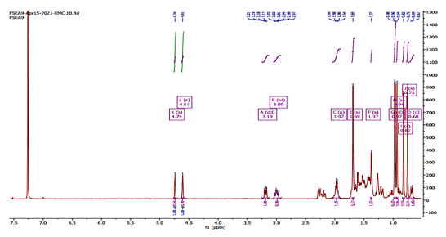
Figure 18S: ¹H NMR Spectrum (500 MHz, CDCl₃) of betulinic acid (9)
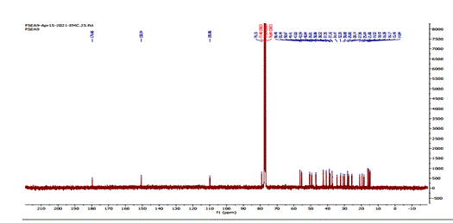
Figure 19S : ¹³C NMR Spectrum (125 MHz, CDCl₃) of betulinic acid (9)
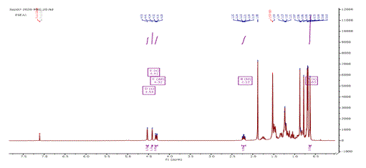
Figure 20S: ¹H NMR Spectrum (500 MHz, CDCl₃) of lupeol acetate (10)
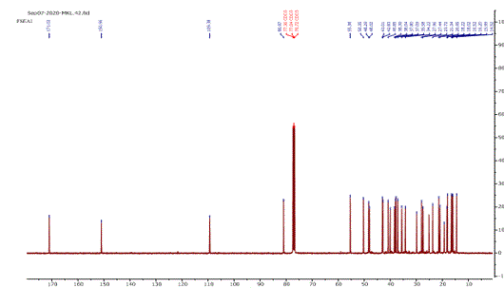
Figure 21S: ¹³C NMR Spectrum (125 MHz, CDCl₃) of lupeol acetate (10)
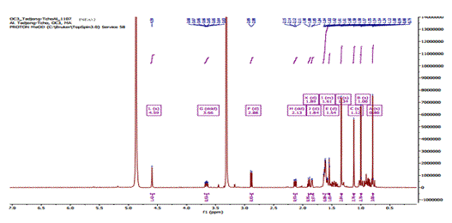
Figure 22S: ¹H NMR Spectrum (500 MHz, MeOD) of ent-kauran-2β,3α,16α-triol (11)
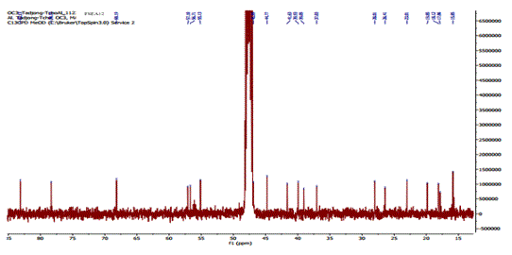
Figure 23S: ¹³C NMR Spectrum (125 MHz, MeOD) of ent-kauran-2β,3α,16α-triol (11)
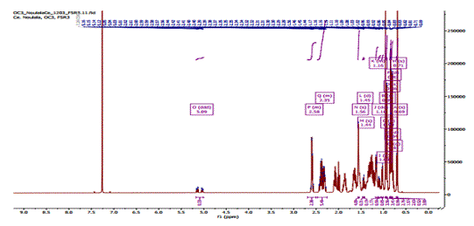
Figure 24S: ¹H NMR Spectrum (500 MHz, CDCl₃) of stigmast-22-en-3,6-dione (13)
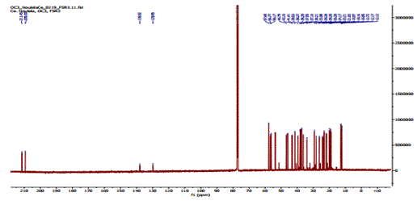
Figure 25S: ¹³C NMR Spectrum (125 MHz, CDCl₃) of stigmast-22-en-3,6-dione (13)
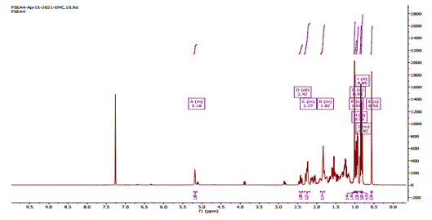
Figure 26S: ¹H NMR Spectrum (500 MHz, CDCl₃) of stigmast-7-en-3-one (14)
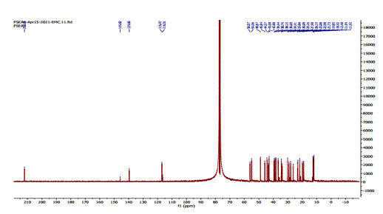
Figure 27S: ¹³C NMR Spectrum (125 MHz, CDCl₃) of stigmast-7-en-3-one (14)
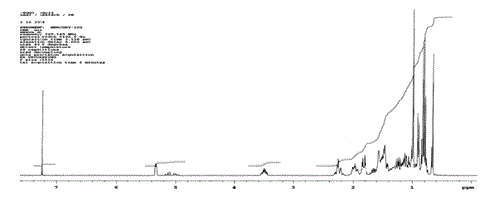
Figure 28S: ¹H NMR Spectrum (500 MHz, CDCl₃) of a mixture of stigmasterol (12) and β-sitosterol (15)
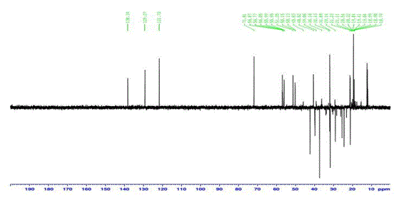
Figure 29S: 135-DEPT (125 MHz, CDCl₃) Spectrum of a mixture of stigmasterol (12) and β-sitosterol (15)
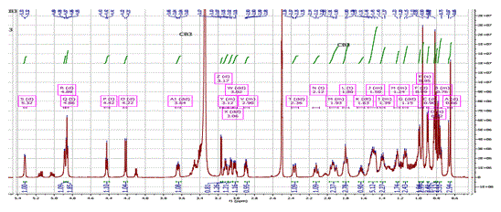
Figure 30S: ¹H NMR Spectrum (500 MHz, CDCl₃) of β-sitosterol-3-O-β-D-glucopyranoside (16)
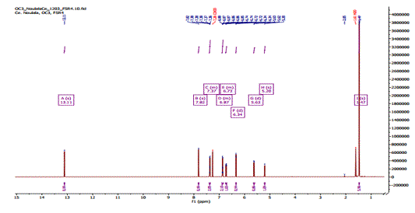
Figure 31S: ¹H NMR Spectrum (500 MHz, CDCl₃) of alpinumisoflavone (17)
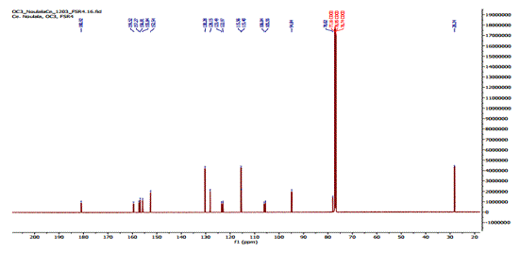
Figure 32S: ¹³C NMR Spectrum (125 MHz, CDCl₃) of alpinumisoflavone (17)
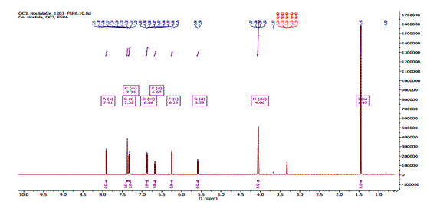
Figure 33S: ¹H NMR Spectrum (500 MHz, CDCl₃) of derrone (18)
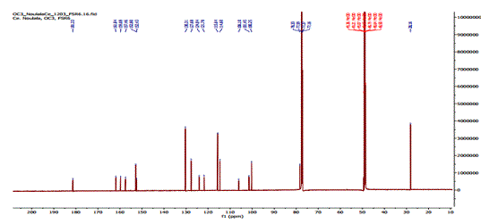
Figure 34S: ¹³C NMR Spectrum (125 MHz, CDCl₃) of derrone (18)
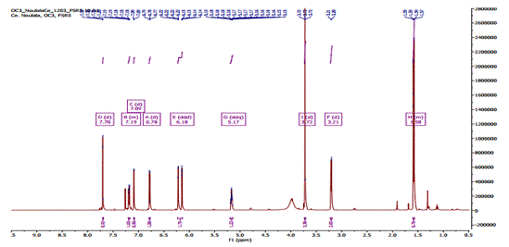
Figure 35S: RMN ¹H (500MHz; CDCl₃ + CD₃OD) spectrum of 3'-(3-méthylbut-2-enyl) biochanin A (19)
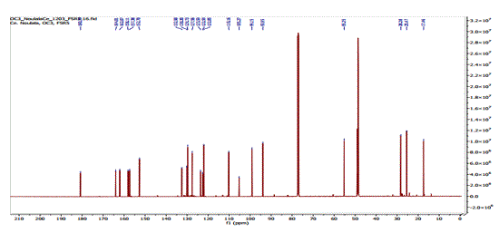
Figure 36S: ¹³C NMR (125 MHz; CDCl₃ + CD₃OD) spectrum of 3'-(3-methylbut-2-enyl) biochanin A (19)
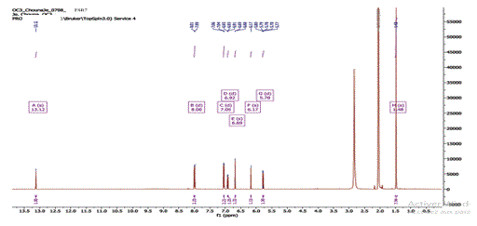

Figure 37S: RMN ¹H spectrum (500 MHz; Acetone-d₆) of atalantoflavone (20)
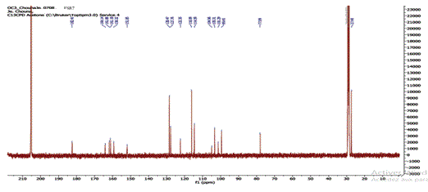

Figure 38S: RMN ¹³C spectrum (125 MHz; Acetone-d₆) of atalantoflavone (20)
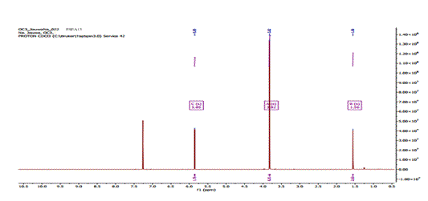
Figure 38S: ¹H NMR Spectrum (500 MHz, CDCl₃) of 2,6-dimethoxybenzophenone (21)
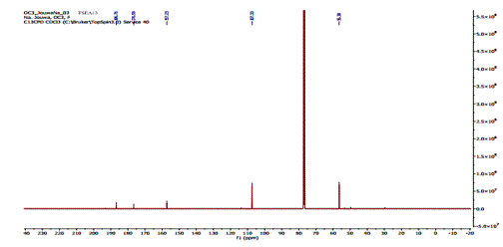
Figure 40S: ¹³C NMR Spectrum (125 MHz, CDCl₃) of 2,6-dimethoxybenzophenone (21)
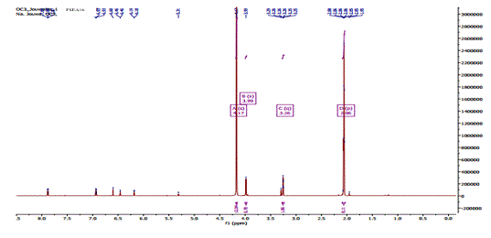
Figure 41S: ¹H NMR Spectrum (500 MHz, Acetone-d₆+MeOD) of 2-(4-hydroxyphenyl)-ethyl docyoctadecanoate (22)
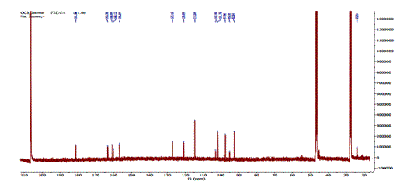
Figure 42S: ¹³C NMR Spectrum (125 MHz, Acetone-d₆+MeOD) of 2-(4-hydroxyphenyl)-ethyl docyoctadecanoate (22)
FSEA16
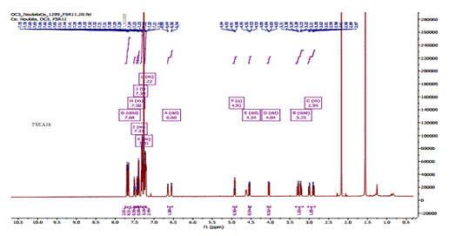
Figure 43S: ¹H NMR Spectrum (500 MHz, CDCl₃) of asperfenamate (23)
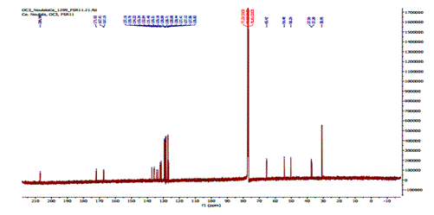
Figure 44S: ¹³C NMR Spectrum (125 MHz, CDCl₃) of asperfenamate (23)
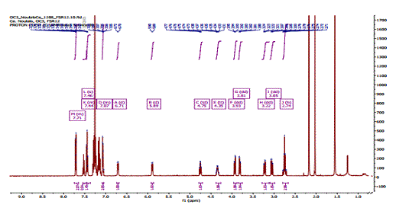
Figure 45S : ¹H NMR Spectrum (500 MHz, CDCl₃) of asperglaucide (24)

