Supplementary information
In silico Investigation of inhibitory characteristics of phytoconstituents from Moringa oleifera against SARS-CoV-2 viral proteins
Amit Kumar Shrivastava¹*, Dipendra Chaudhary², Laxmi Shrestha¹, Anjan Palikhey¹, Chandrajeet Kumar Yaadav¹, Deepak Basyal³, Bishal Joshi⁴, Mohammad Ujair Shekh⁵
¹ Department of Pharmacology, Universal College of Medical Sciences, Bhairahawa, Rupandehi, Nepal
² Department of Pharmacy, Lumbini Provincial Hospital, Butwal, Rupandehi, Nepal
³ Department of Pharmacy, Maharajgunj Medical Campus, Institute of Medicine, Tribhuvan University, Nepal
⁴ Department of Physiology, Universal College of Medical Sciences, Bhairahawa, Rupandehi, Nepal
⁵ Department of Pharmacy, Universal College of Medical Sciences, Bhairahawa, Rupandehi, Nepal
Correspondence: Amit Kumar Shrivastava (sr.akshri.ucms.np@gmail.com)

Supplementary figure 1: Schematic representation of SARS-CoV-2 cell entry and replication into the host cell
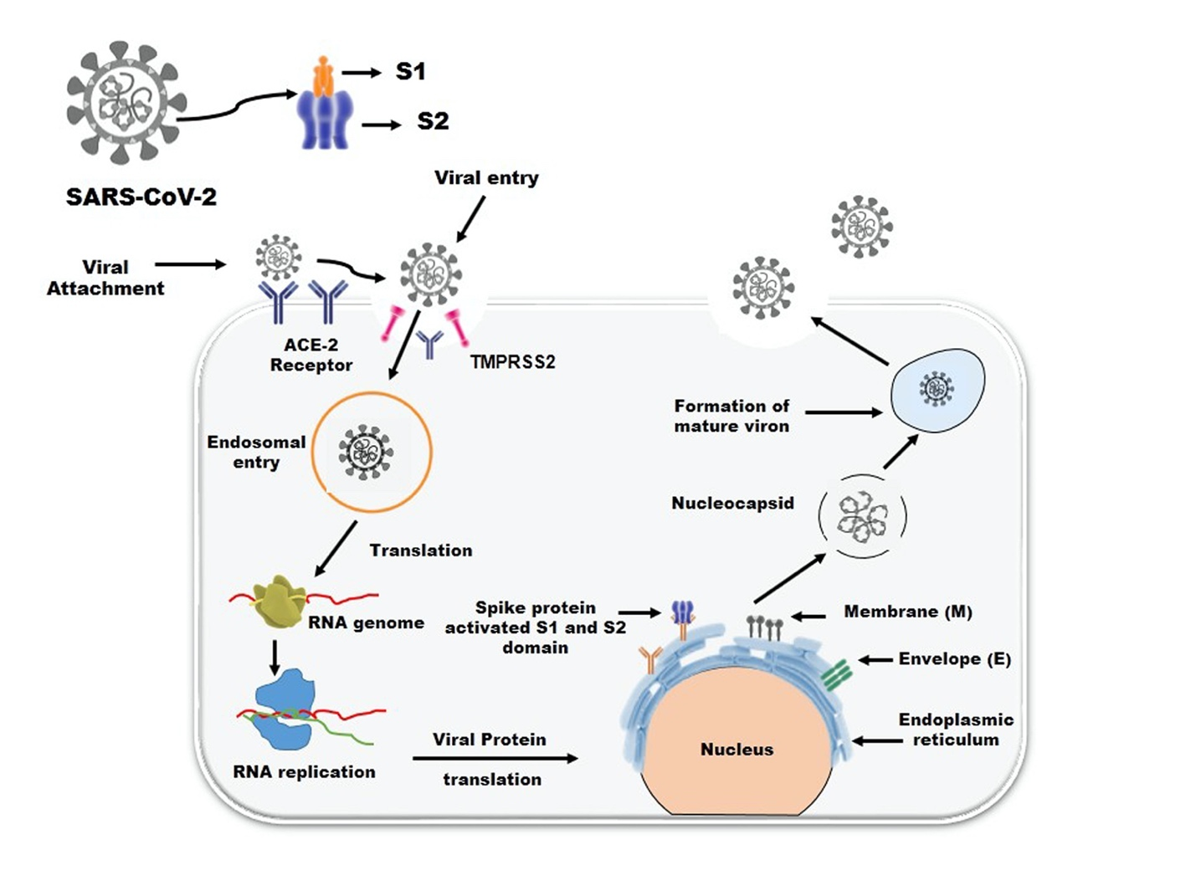

Supplementary figure 2: Frequency of Protein target prediction of compounds (A) Beta Carotene (B) Myricetin (C) Phytol (D) Quinic Acid (E) Quercetin (F) Squalene (G) Vitamin E (H) Hydroxychloroquine as shown in Pi chart and calculated by using Swiss Target Prediction (SwissADME).
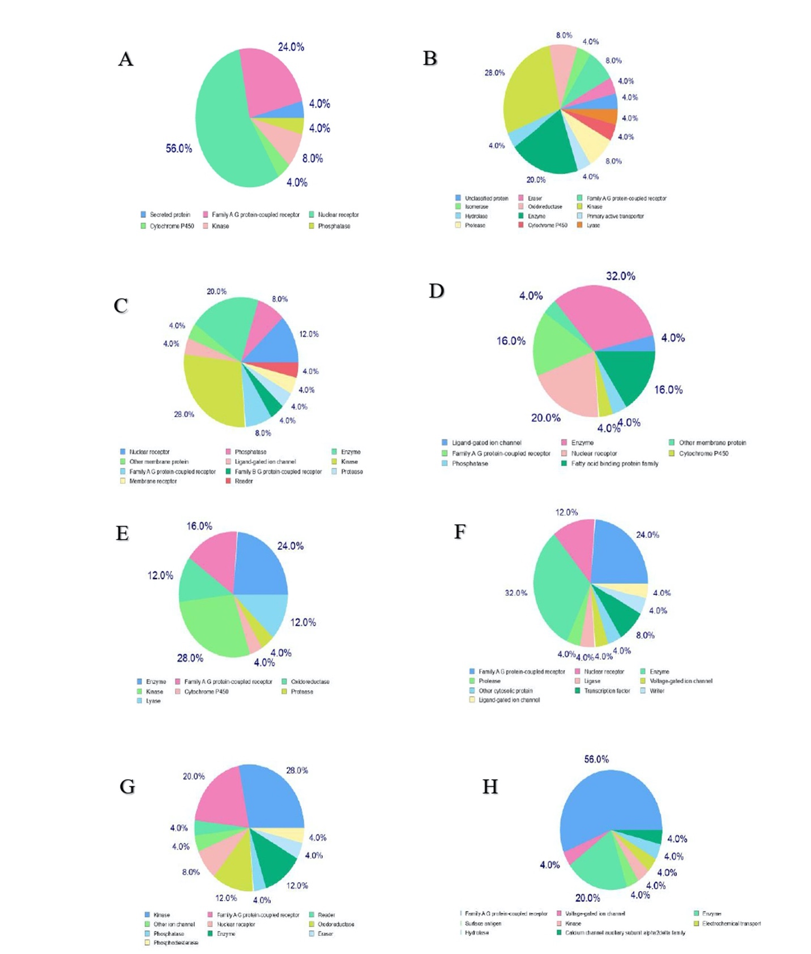
Supplementary figure 3: Boiled egg plot of water partition coefficient (WlogP) versus topological polar surface area (TPSA) of active phyto-consituent of Moringa oleifera (A) Beta Carotene (B) Myricetin (C) Phytol (D) Quinic Acid (E) Quercetin (F) Squalene (G) Vitamin E versus reference drug (H) Hydroxychloroquine.
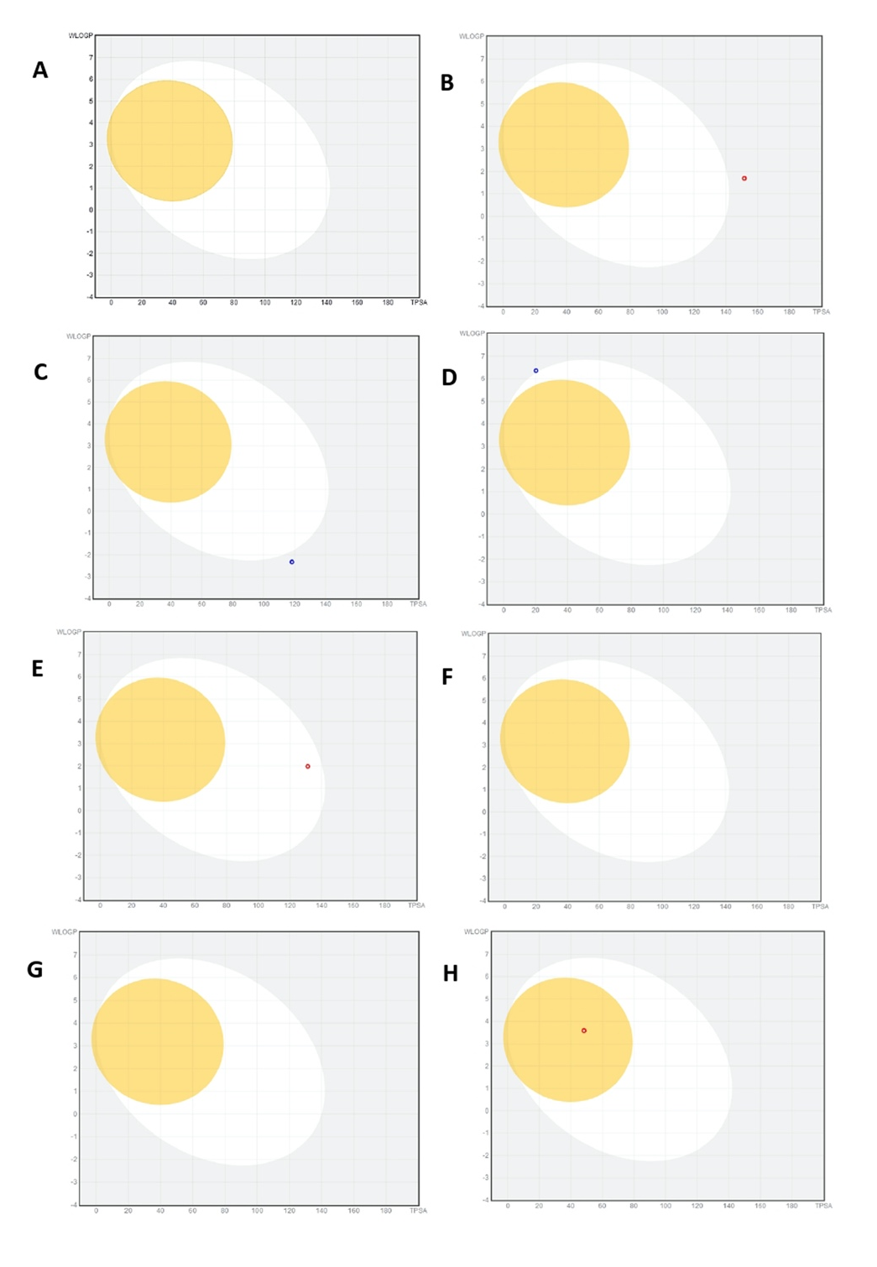
Supplementary figure 4: Bioavailability radar of active phyto-consituent of Moringa oleifera (A) Beta Carotene (B) Myricetin (C) Phytol (D) Quinic Acid (E) Quercetin (F) Squalene (G) Vitamin E versus reference drug (H) Hydroxychloroquine.
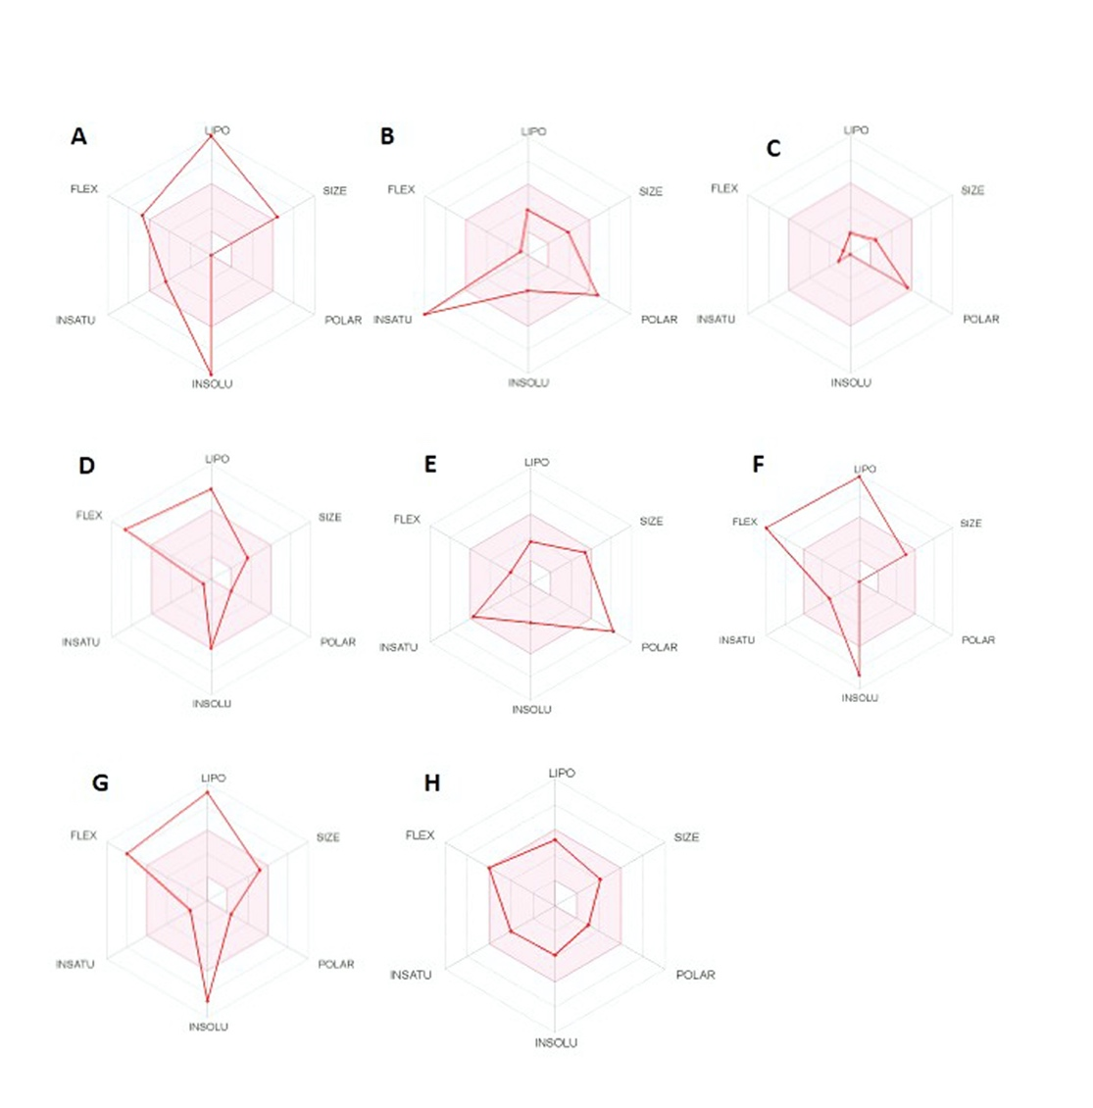

Supplementary table 1: PASS analysis of all phyto-constituents of Moringa oleifera versus reference drug (Hydroxychloroquine) calculated by OSIRIS property explorer.
S.N. | Ligand | % Abs  (>50%) | TPSA  (Å) | MW  (<500) | clogP  (<5) | HA | HBD | HBA | NRB | Lipinski’s  violation | Drug score
1 | Beta Carotene | 109 | 0.00 | 536 | 13.87 | 40 | 0 | 0 | 10 | 2 | 0.1
2 | Myricetin | 58.07 | 147.6 | 318 | 1.14 | 23 | 6 | 8 | 1 | 1 | 0.46
3 | Quinic acid | 68.22 | 118.2 | 192 | -2.33 | 13 | 5 | 6 | 1 | 0 | 0.48
4 | Phytol | 102.02 | 20.23 | 296 | 7.42 | 21 | 1 | 1 | 13 | 1 | 0.21
5 | Qurecetin | 65.047 | 127.4 | 302 | 1.49 | 22 | 5 | 7 | 1 | 0 | 0.3
6 | Squalene | 109 | 0.00 | 410 | 13.1 | 30 | 0 | 0 | 15 | 1 | 0.14
7 | Vitamin E | 98.83 | 29.46 | 430 | 9.64 | 31 | 1 | 2 | 12 | 1 | 0.12
8 | Hydroxychloroquine | 92.30 | 48.39 | 335 | 3.03 | 23 | 2 | 3 | 9 | 0 | 0.48

Note: Topological Polar Surface Area (TPSA), Molecular Weight (MW), Heavy Atoms (HA), Hydrogen Bond Donor (HBD), Hydrogen Bond Acceptor (HBA), Number of Rotational Bond (NRB), Absorption (Abs.)
¹Percentage of absorption was calculated as: % Absorption =109 - [0.0345* Topological Polar Surface Area]
²Topological Polar Surface area (defined as a sum of surface of polar atoms in a molecule).
³Logarthim of compound partition coefficient between n-octanol and water.

S.N. | Compound | GCPR ligand | Ion Channel Modulator | Kinase inhibitor | Nuclear receptor ligand | Protease Inhibitor | Enzyme inhibitor | Drug likeness
1 | Beta carotene | -0.04 | -0.15 | -0.15 | 0.40 | -0.06 | 0.17 | -3.35
2 | Myricetin | -0.06 | -0.18 | 0.28 | 0.32 | -0.20 | 0.30 | 0.75
3 | Phytol | 0.08 | 0.17 | -0.37 | 0.32 | -0.04 | 0.33 | -3.77
4 | Quinic acid | -0.24 | 0.10 | -0.77 | 0.16 | -0.26 | 0.60 | 0.51
5 | Quercetin | -0.06 | -0.19 | 0.28 | 0.36 | -0.25 | 0.28 | 1.6
6 | Squalene | 0.04 | 0.01 | -0.10 | 0.19 | -0.03 | 0.16 | -3.52
7 | Vitamin E | 0.25 | 0.14 | -0.21 | 0.41 | 0.28 | 0.24 | -4.78
8 | Hydroxychloroquine | 0.35 | 0.30 | 0.44 | -0.12 | 0.12 | 0.15 | 6.54

Supplementary table 2: bioactivity score and Drug likeness of active phyto-consituent of Moringa oleifera versus Hydroxychloroquine was calculated by Molinspiron software.

Supplementary table 3: determination Drug likeness and bioavailability score of seven phyto-consituent of Moringa oleifera vs Hydroxychloroquine by using SwissADME online software.
Compounds | Lipenski’s Rule | Ghose Filter | Veber Rule | Egan Filter | Muegge Filter | Bioavailability score
Beta carotene | No; 2 violations: MW>500, MLOGP>4.15 | No; 4 violations: MW>480, WLOGP>5.6, MR>130, #atoms>70 | Yes (0 violations) | No; 1 violation: WLOGP>5.88 | No; 2 violations: XLOGP3>5, Heteroatoms<2 | 0.17
Myricetin | Yes; 1 violation: NHorOH>5 | Yes (0 violations) | No; 1 violation: TPSA>140 | No; 1 violation: TPSA>131.6 | No; 2 violations: TPSA>150, H-don>5 | 0.55
Phytol | Yes; 1 violation: MLOGP>4.15 | No; 1 violation: WLOGP>5.6 | No; 1 violation: Rotors>10 | No; 1 violation: WLOGP>5.88 | No; 2 violations: XLOGP3>5, Heteroatoms<2 | 0.55
Quinic acid | Yes; 0 violation | No; 1 violation: WLOGP<-0.4 | Yes | Yes | No; 2 violations: MW<200, XLOGP3<-2 | 0.56
Querecitin | Yes; 0 violation | Yes | Yes | yes | yes | 0.55
Squalene | Yes; 1 violation: MLOGP>4.15 | No; 3 violations: WLOGP>5.6, MR>130, #atoms>70 | No; 1 violation: Rotors>10 | No; 1 violation: WLOGP>5.88 | No; 2 violations: XLOGP3>5, Heteroatoms<2 | 0.55
Vitamin E | Yes;1 violation: MLOGP>4.15 | No;3 violations: WLOGP>5.6, MR>130, #atoms>70 | No;1 violation: Rotors>10 | No;1 violation: WLOGP>5.88 | No;1 violation: XLOGP3>5 | 0.55
Hydrooxy  Chloroquine | Yes;1 violation: MLOGP>4.15 | No;3 violations: WLOGP>5.6, MR>130, #atoms>70 | No;1 violation: Rotors>10 | No;1 violation: WLOGP>5.88 | No;1 violation: XLOGP3>5 | 0.55

Nor: No. of Rotatable bond, MW: Molecular Weight, MR: Molar Refractivity

Supplementary table 4: Toxicity calculation of phyto-consituent of Moringa oleifera versus Hydroxychloroquine calculated by OSIRS property explorer.
S.N. | Compounds | Mutagenic | Tumorigenic | Reproductive effect | Irritant
1 | Beta Carotene | None | None | None | None
2 | Myricetin | High | None | None | None
3 | Phytol | None | None | None | None
4 | Quinic acid | High | None | None | None
5 | Quericitin | High | High | None | None
6 | Squalene | None | None | None | None
7 | Vitamin E | None | None | None | None
8 | Hydroxychloroquine | High | None | None | None

Supplementary table 5: Evaluation of Pharmacokinetics parameters of Moringa oleifera phyto-consituent versus Hydroxychloroquine by using SwissADME
S.N. | PK Properties | Beta carotene | Myricetin | Phytol | Quinic acid | Querecitin | Squalene | Vitamin E | Hydroxychloroquine
1 | GI absorption | Low | Low | Low | Low | High | Low | Low | High
2 | BBB permeant | No | No | No | No | No | No | No | Yes
3 | p-gp substrate | Yes | No | Yes | Yes | No | No | Yes | No
4 | CYP1A2  Inhibitor | No | Yes | No | No | Yes | No | No | Yes
5 | CYP2C19  Inhibitor | No | No | No | No | No | No | No | No
6 | CYP2C9  Inhibitor | No | No | Yes | No | No | No | No | No
7 | CYP2D6  Inhibitor | No | No | No | No | Yes | No | No | Yes
8 | CYP3A4  Inhibitor | No | No | No | No | Yes | No | No | No
8 | Log KP  (Skin permeation) | -9.15 cm/s | -7.40 cm/s | -2.29 cm/s | -9.15 cm/s | -7.05 cm/s | -0.58 cm/s | -1.33 cm/s | -5.81 cm/s
Note: GI absorption: gastrointestinal absorption, BBB: Blood brain barrier, P-gp substrate: P-glycoprotein substrate 1, CYP1A2 inhibitor: Cytochrome P450 1A2 inhibitor, CYP2C19 inhibitor: Cytochrome P450 2C19 inhibitor, CYP2C9 inhibitor: Cytochrome P450 2C9 inhibitor, CYP2D6 inhibitor: Cytochrome P450 2D6 inhibitor, CYP3A4 inhibitor: Cytochrome P450 3A4 inhibitor

Supplementary table 6: Evaluation of biochemical properties of Moringa oleifera containing active phyto-consituent versus Hydroxychloroquine calculated by using SwissADME software.
S.N. | Medicinal chemistry | Beta carotene | Myricetin | Phytol | Quinic acid | Qurecetin | Squalene | Vitamin E | Hydroxy  chloroquine
1 | PAINS | 0 | 1 alert: catechol_A | 0 alert | 0 alert | 1 alert: catechol_A | 0 alert | 0 alert | 0 alert
2 | Brenk | 1 alert: polyene | 1 alert: catechol | 1 alert: isolated_alkene | 0 alert | 1 alert: catechol | 1 alert: isolated alkene | 0 alert | 0 alert
3 | Lead likeness | No; 3 violations: MW>350, Rotors>7, XLOGP3>3.5 | Yes | No; 2 violations: Rotors>7, XLOGP3>3.5 | No; 1 violation: MW<250 | No; 1 violation: MW>350 | No; 3 violations: MW>350, Rotors>7, XLOGP3>3.5 | No; 3 violations: MW>350, Rotors>7, XLOGP3>3.5 | No; 2 violations: Rotors>7, XLOGP3>3.5
4 | Synthetic accessibility | 6.19 | 3.27 | 4.30 | 3.34 | 5.28 | 4.73 | 5.17 | 2.82

Supplementary table 7: Bioavailability radar of active phyto-consituent of Moringa oleifera versus reference drug Hydroxychloroquine.
s.no | Compound name | LIPO  (Lipophility) | SIZE  (MW) | POLAR  (Polarity) | INSOLU  (Insolubility) | INSATU  (Instauration) | FLEX  (Flexibility)
1 | Beta carotene | 13.54 | 536.87 g/mol | 0.00 Å² | -11.04 | 0.45 | 10
2 | Myricetin | 1.18 | 318.24 g/mol | 151.59 Å² | -3.01 | 0.00 | 1
3 | Quinic acid | -2.37 | 192.17 g/mol | 118.22 Å² | 0.53 | 0.86 | 1
4 | Phytol | 8.19 | 296.53 g/mol | 20.23 Å² | -5.98 | 0.90 | 13
5 | Quercetin | 1.54 | 302.24 g/mol | 131.36 Å² | -3.16 | 0.00 | 1
6 | Squalene | 11.58 | 410.72 g/mol | 0.00 Å² | -8.69 | 0.60 | 15
7 | Vitamin E | 10.70 | 430.71 g/mol | 29.46 Å² | -8.60 | 0.79 | 12
8 | Hydroxychloroquine | 3.58 | 335.87 g/mol | 48.39 Å² | -3.91 | 0.50 | 9

LIPO: Lipophilicity [-0.7< XLOGP3 < +5.0]
SIZE: Size [150 g/mol < MW < 500 g/mol]
POLAR: Polarity [20 Å² < TPSA < 130 Å²]
INSOLU: Insolubility [0 < Log S (ESOL) < 6]
INSATU: Instauration [0.25 < Fraction Csp3 < 1]
FLEX: Flexibility [0 < Num. rotatable bonds < 9]

Supplementary table 8: 3D representation of the best docking poses of various phyto-consituent of Moringa oleifera with SARS-CoV-2 protein M^{pro} (PDB ID: 6LU7) generated by using AutoDock 4.2.6 and AutoDock Vina

S.N. | Ligand | AutoDock 4.2.6 | AutoDock Vina
1 | Beta carotene | 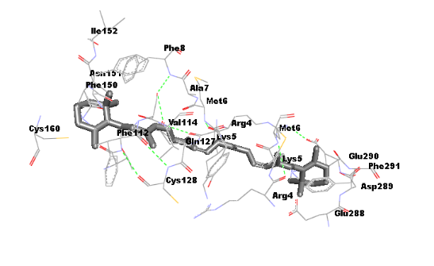 | 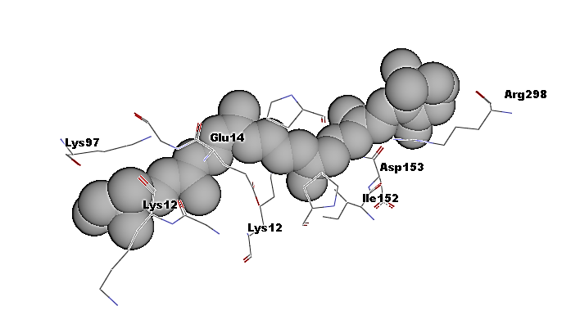
2 | Myricetin | 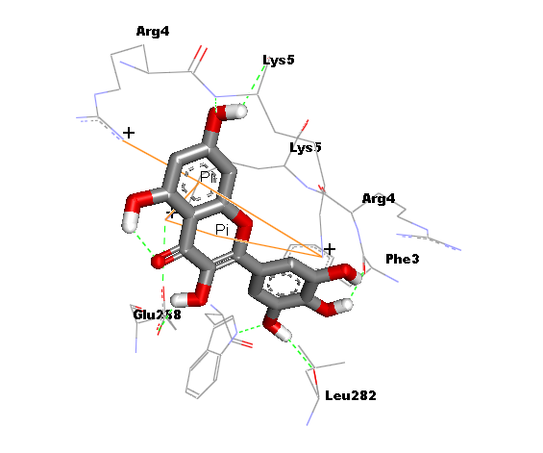 | 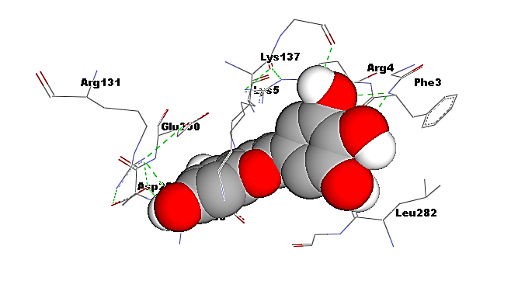
3 | Quinic Acid | 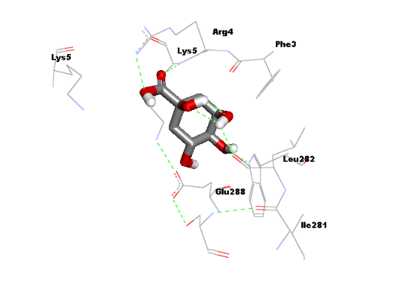 | 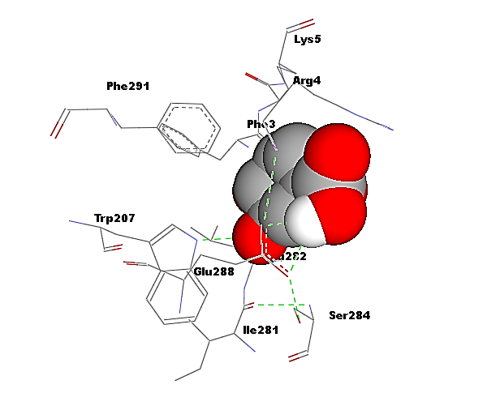
4 | Phytol | 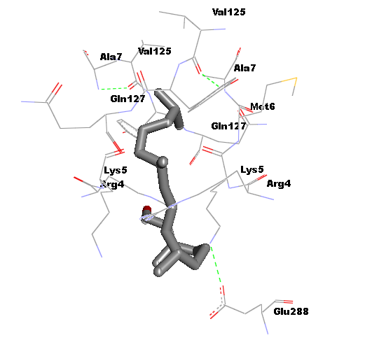 | 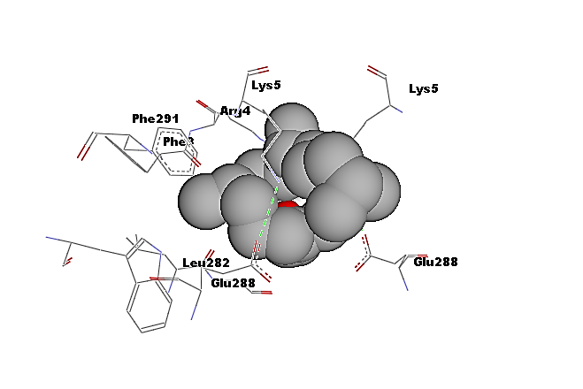
5 | Quercetin | 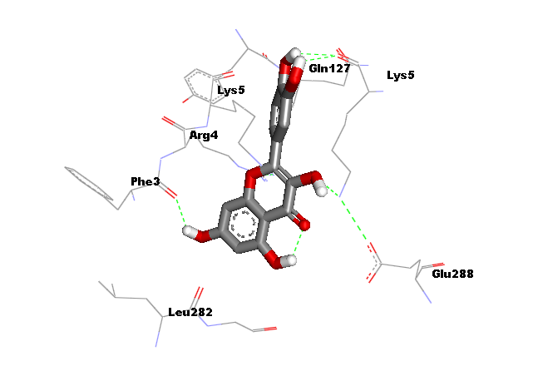 | 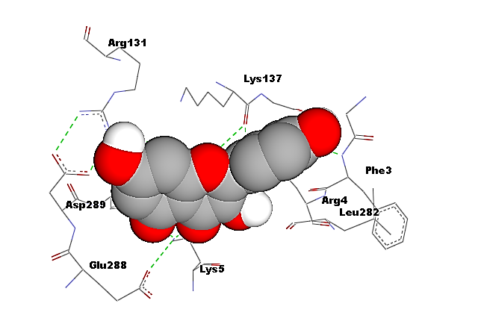
6 | Squalene | 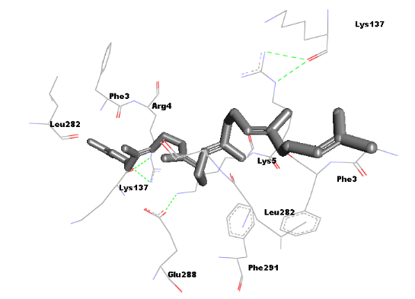 | 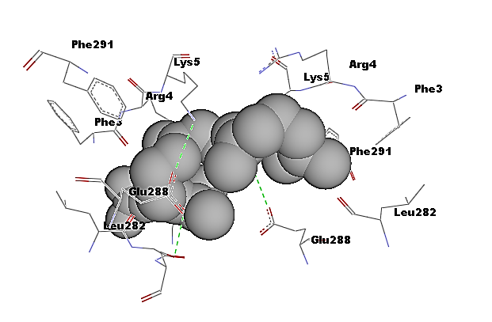
7 | Vitamin E | 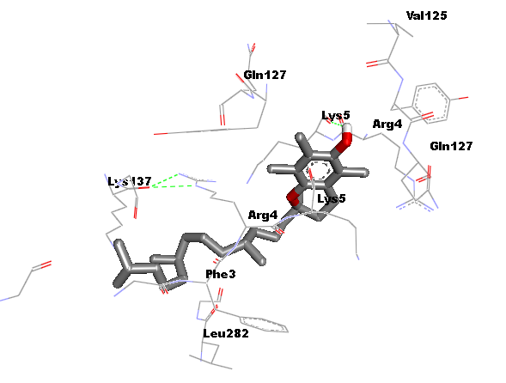 | 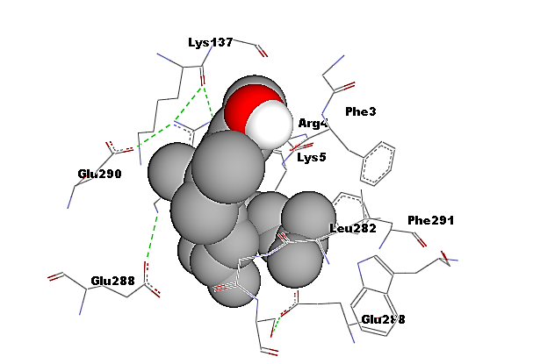
8 | Hydroxychloroquine | 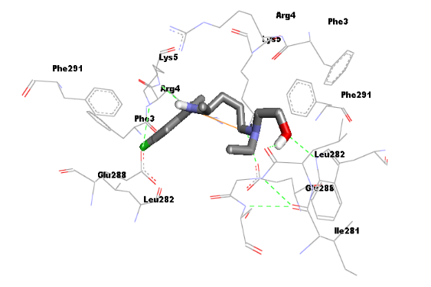 | 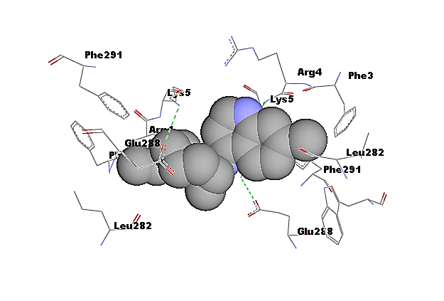

Supplementary table 9: 3D representation of the best docking poses of various phyto-consituent of Moringa oleifera with SARS-CoV-2 papain like protease (PDB ID: 6W9C) generated by using AutoDock 4.2.6 and AutoDock Vina
S.N. | Ligand | AutoDock 4.2.6 | AutoDock vina
1 | Beta carotene | 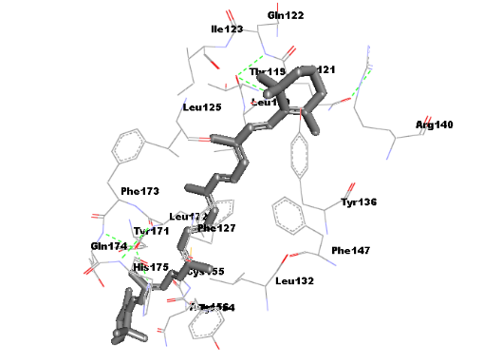 | 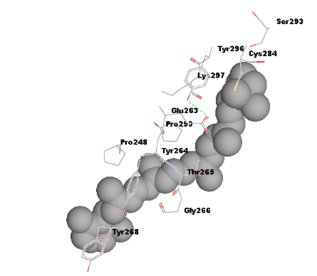
2 | Myricetin | 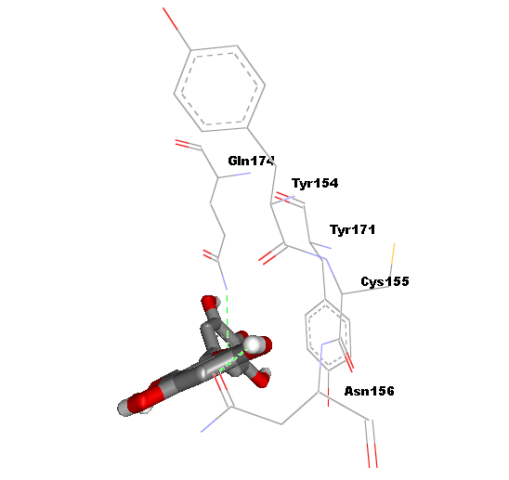 | 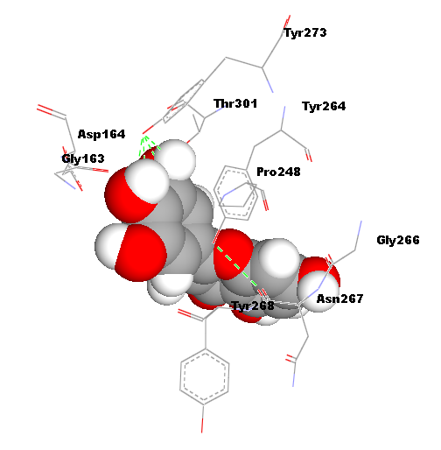
3 | Quinic Acid | 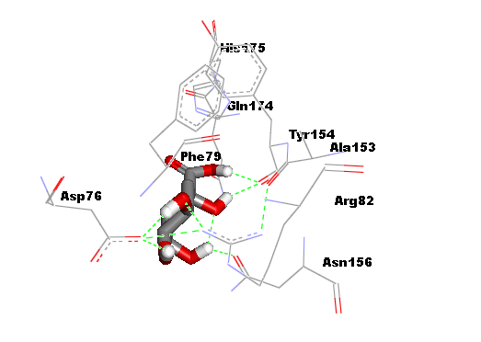 | 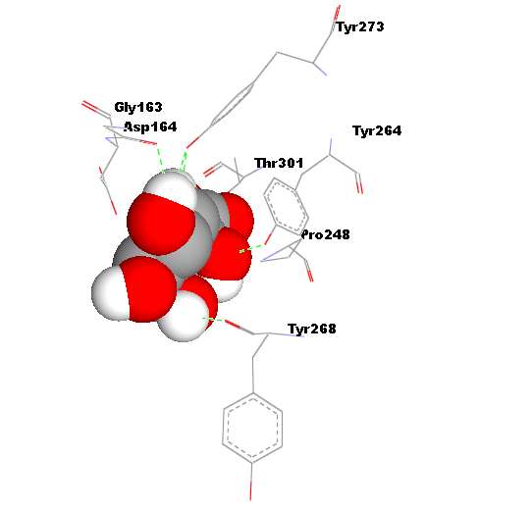
4 | Phytol | 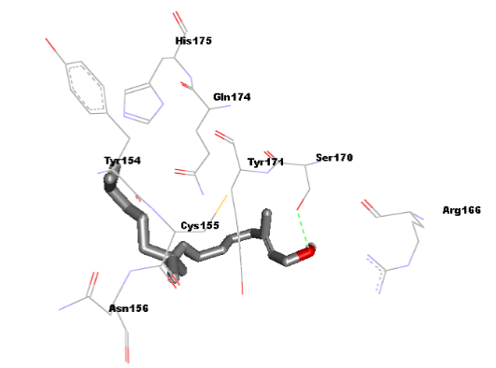 | 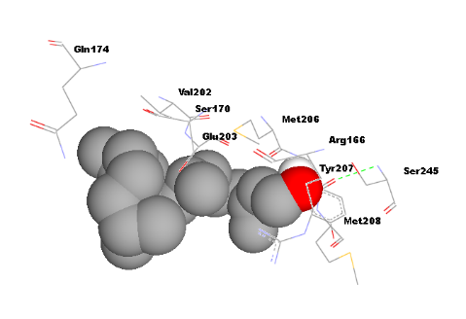
5 | Quercetin | 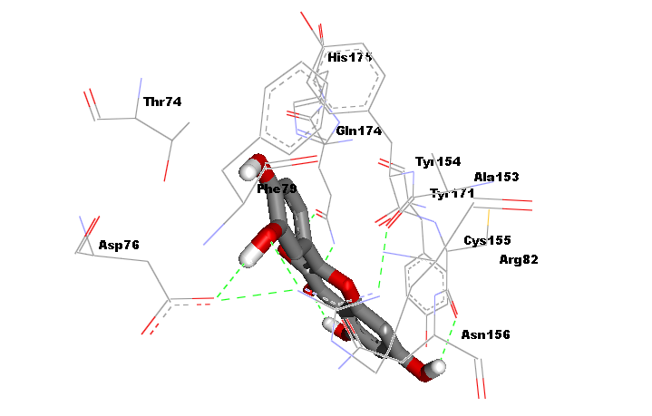 | 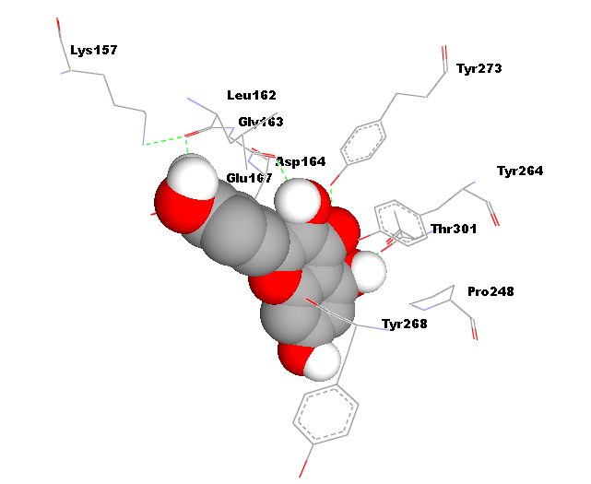
6 | Squalene | 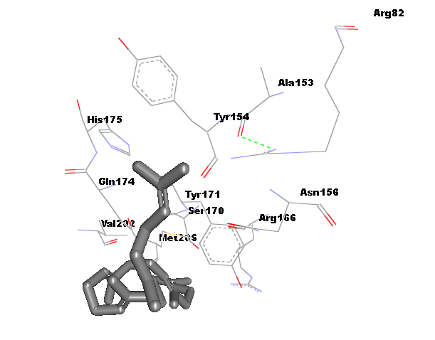 | 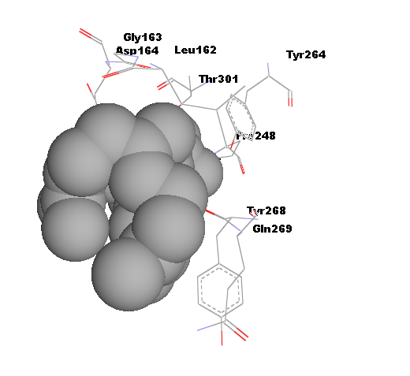
7 | Vitamin E | 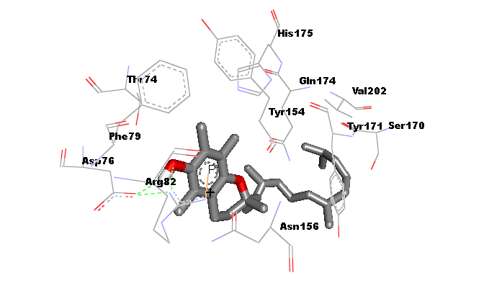 | 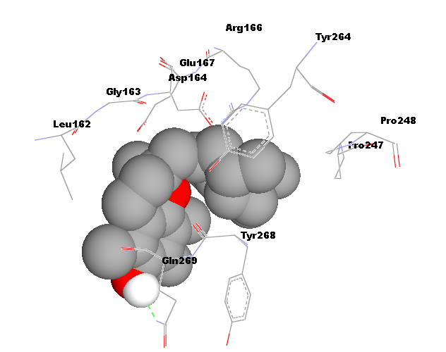
8 | Hydroxychloroquine | 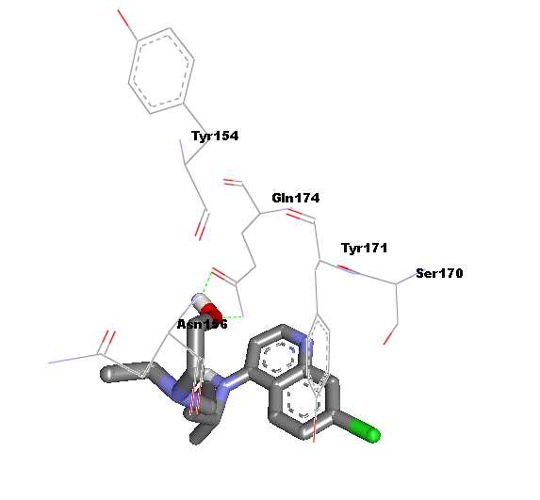 | 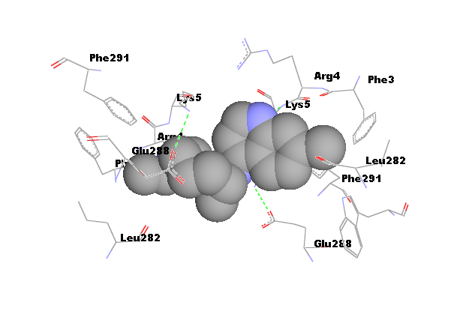
Supplementary table 10: 3D representation of the best docking poses of various phyto-consituent of Moringa oleifera with SARS-CoV-2 helicase protein (PDB ID: 5RMD) generated by using AutoDock 4.2.6 and AutoDock Vina
S.N. | Ligand | AutoDock 4.2.6 | AutoDock Vina
1 | Beta carotene | 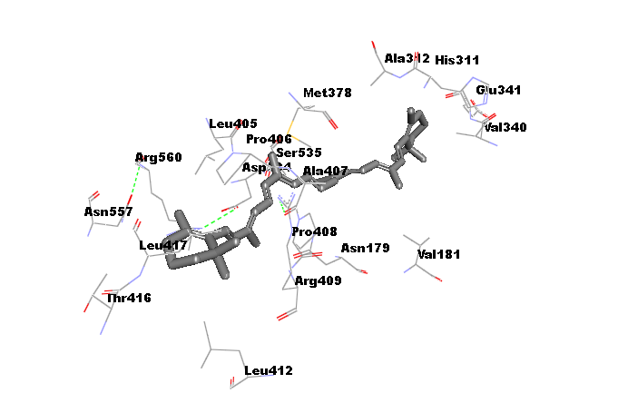 | 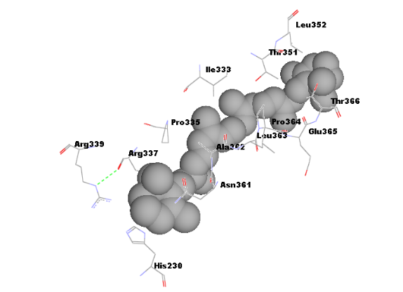
2 | Myricetin | 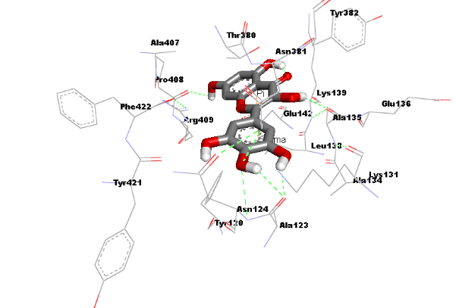 | 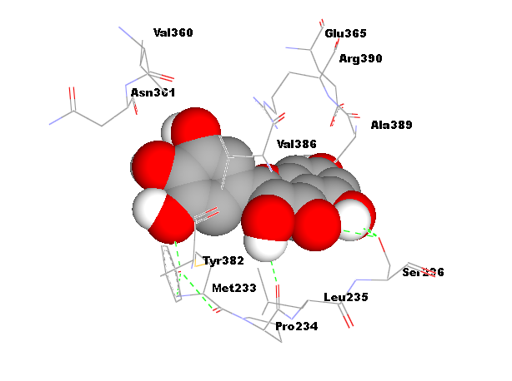
3 | Quinic Acid | 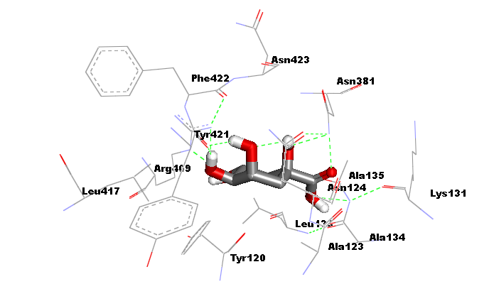 | 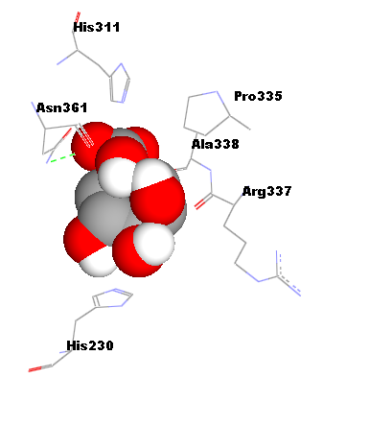
4 | Phytol | 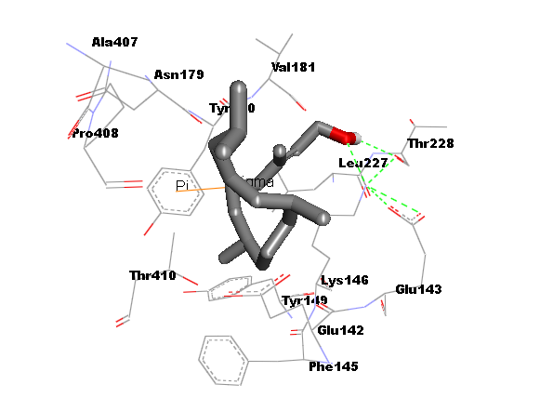 | 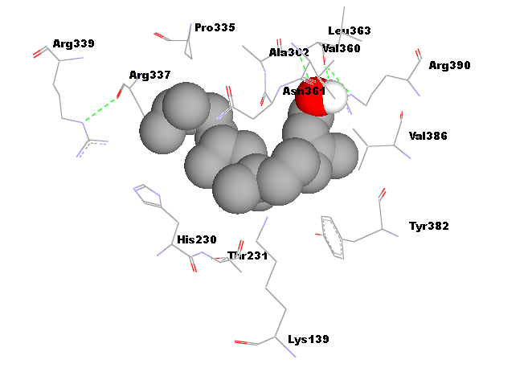
5 | Quercetin | 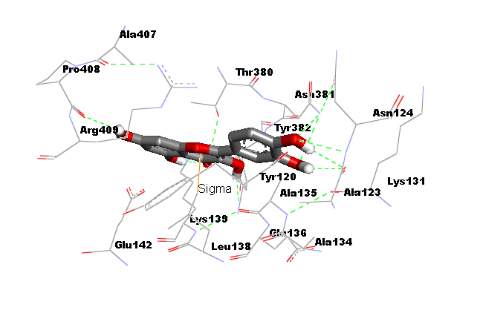 | 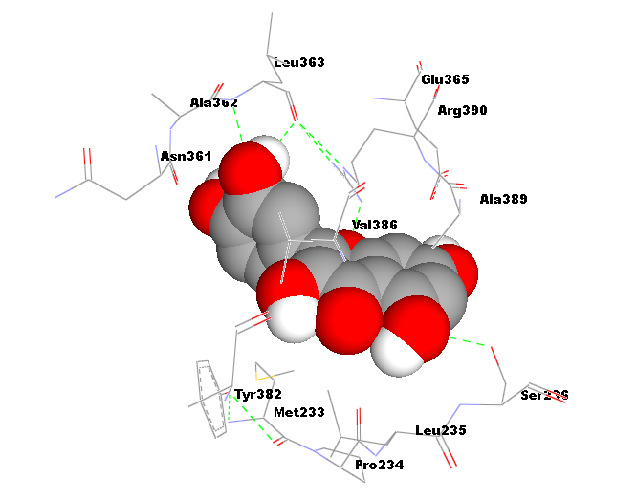
6 | Squalene | 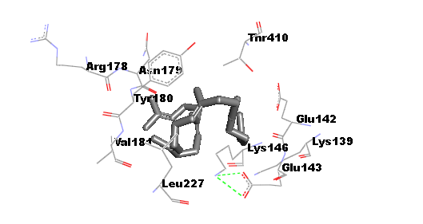 | 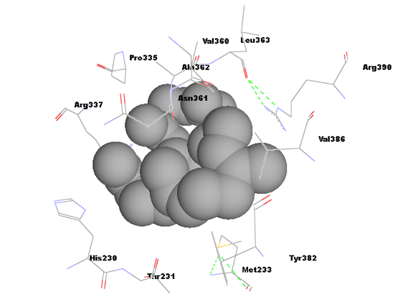
7 | Vitamin E | 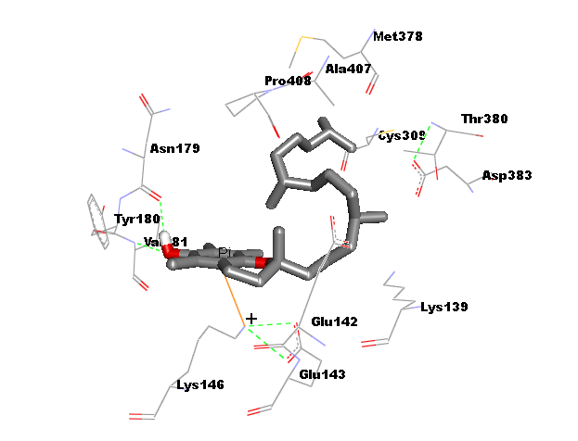 | 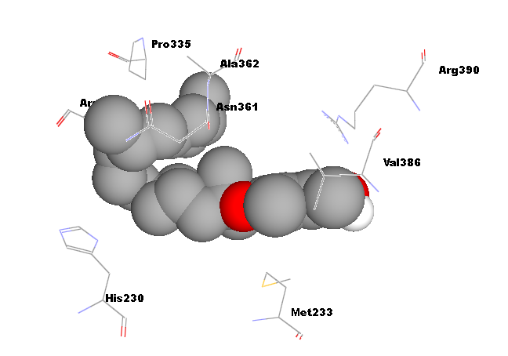
8 | Hydroxychloroquine | 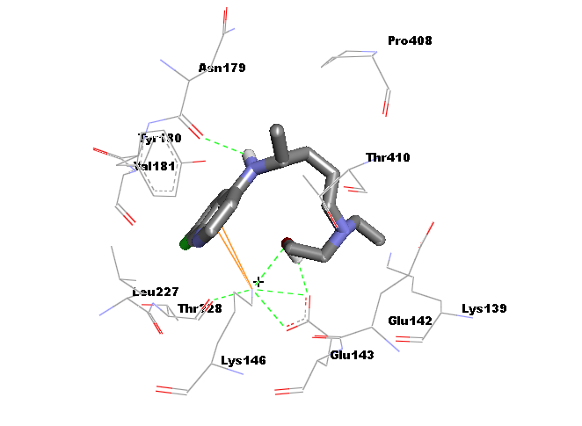 | 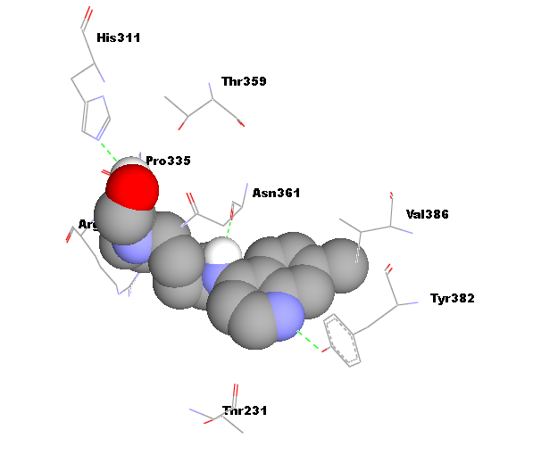

Supplementary table 11: 3D representation of the best docking poses of various phyto-consituent of Moringa oleifera with ACE-2 protein (PDB ID: 1o8A) generated by using AutoDock 4.2.6 and AutoDock Vina
S.N. | Ligand | AutoDock 4.2.6 | AutoDock Vina
1 | Beta carotene | 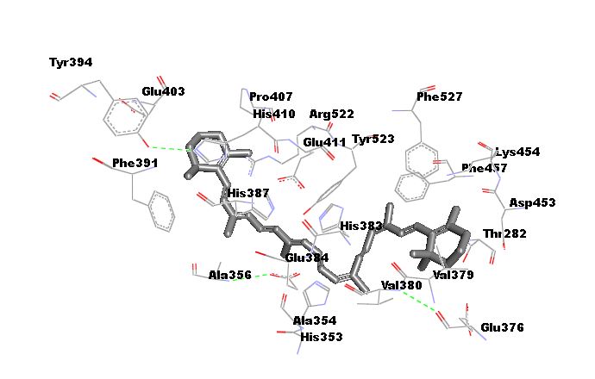 | 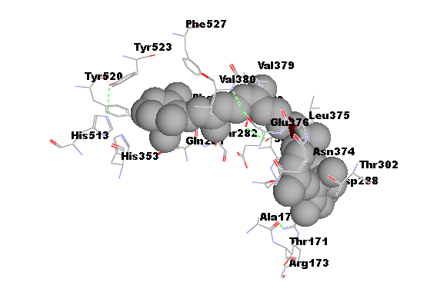
2 | Myricetin | 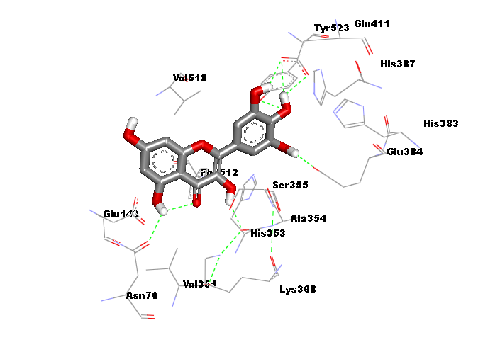 | 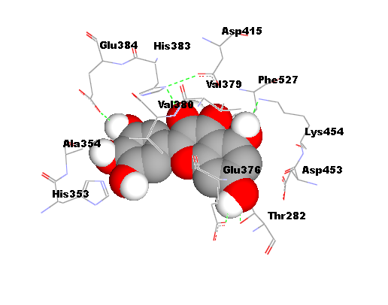
3 | Quinic Acid | 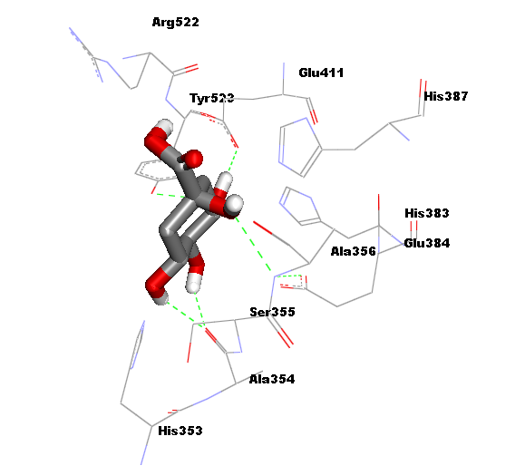 | 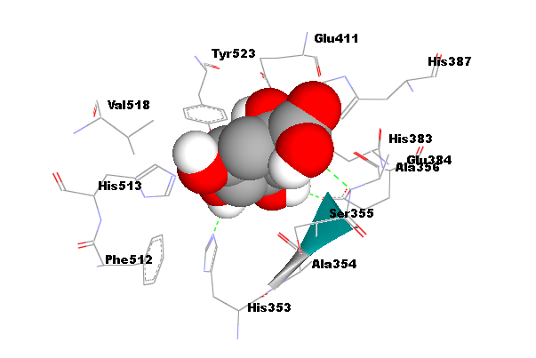
4 | Phytol | 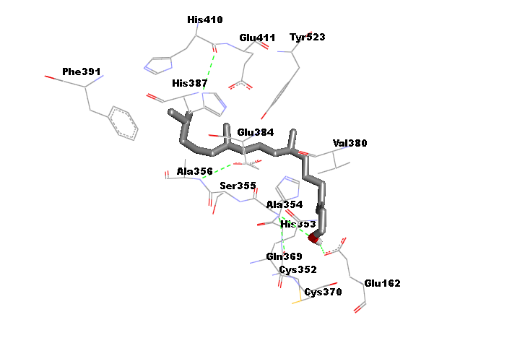 | 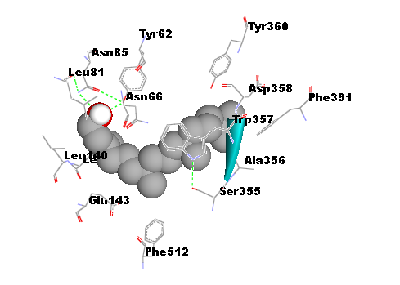
5 | Quercetin | 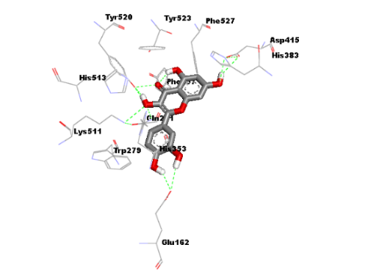 | 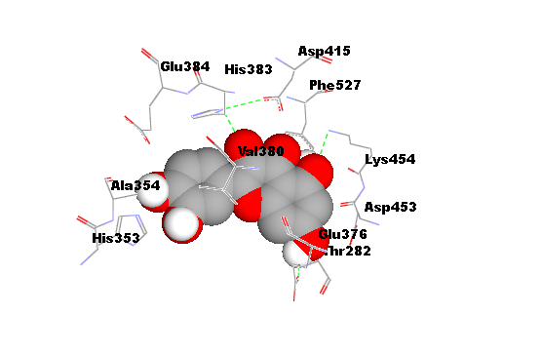
6 | Squalene | 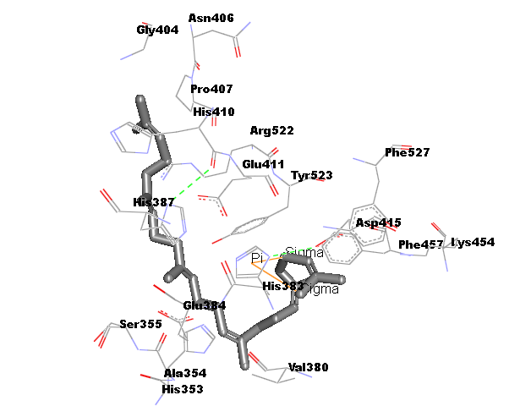 | 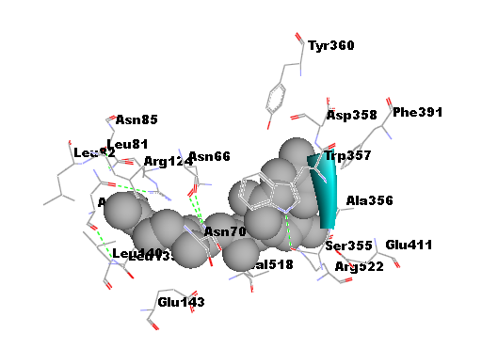
7 | Vitamin E | 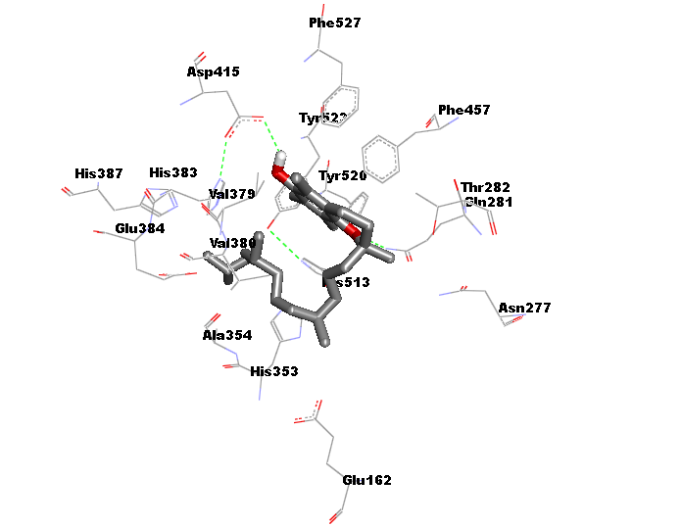 | 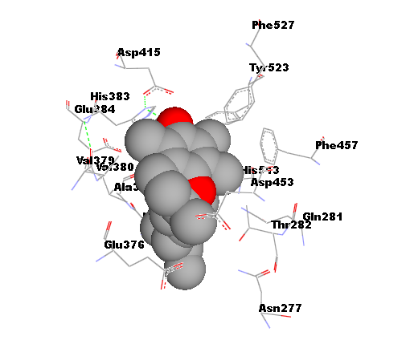
8 | Hydroxychloroquine | 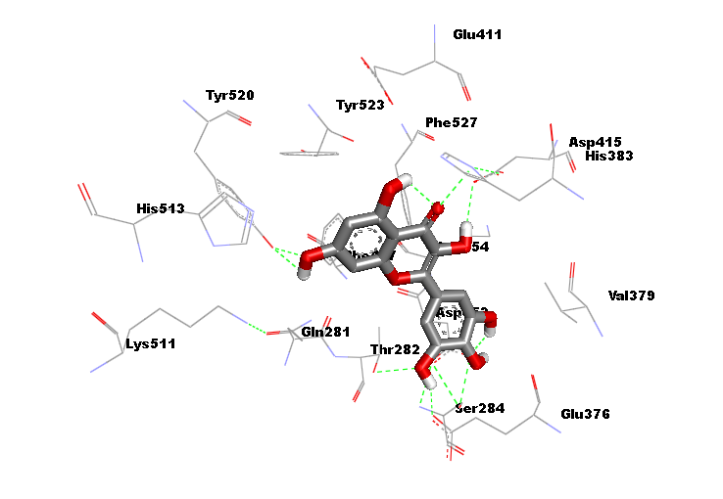 | 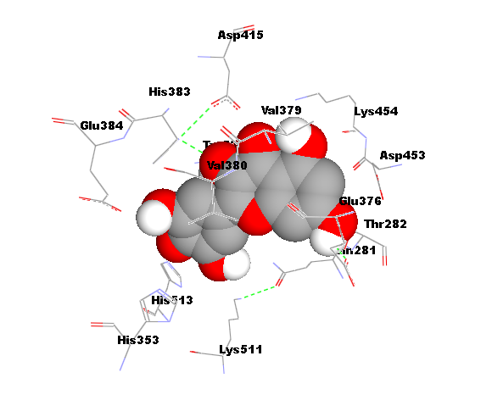

Supplementary table 12: 3D representation of the best docking poses of various phyto-consituent of Moringa oleifera with ACE-2 protein (PDB ID: 6LZG) generated by using AutoDock 4.2.6 and AutoDock Vina
S.N. | Ligand | AutoDock 4.2.6 | AutoDock Vina
1 | Beta carotene | 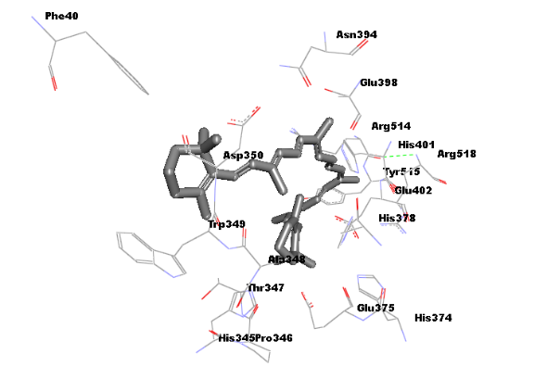 | 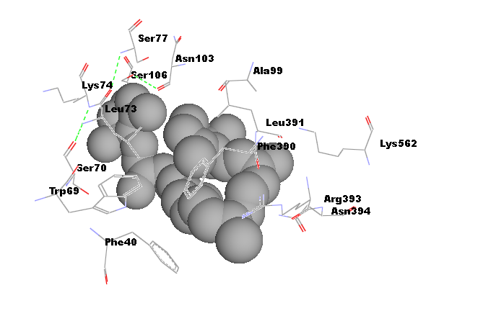
2 | Myricetin | 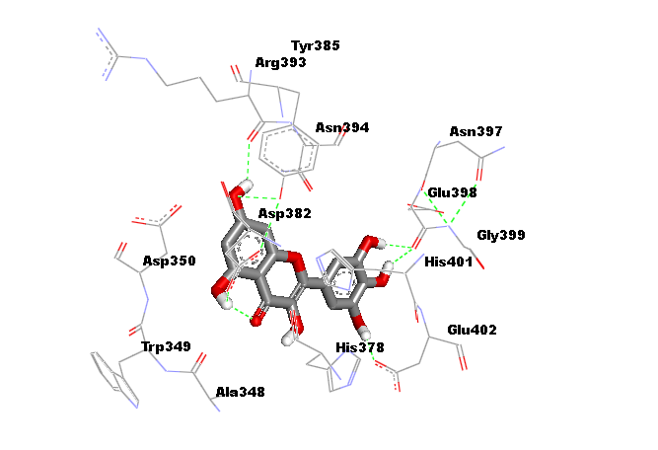 | 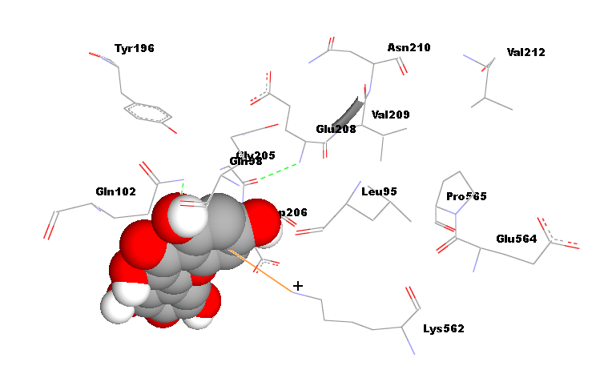
3 | Quinic Acid | 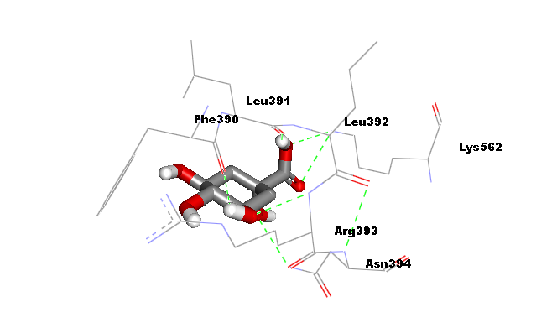 | 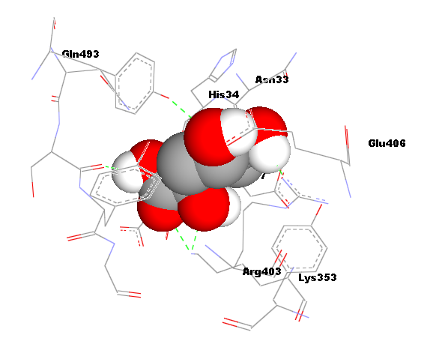
4 | Phytol | 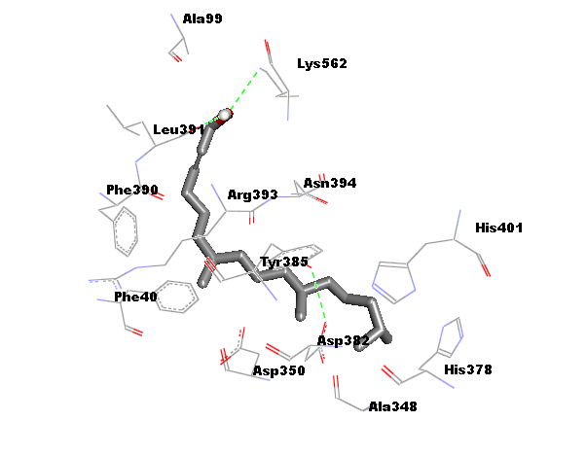 | 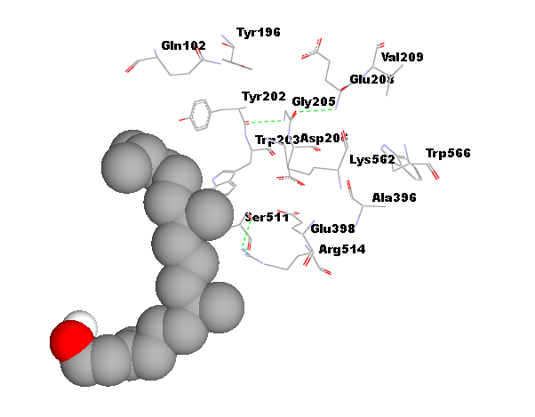
5 | Quercetin | 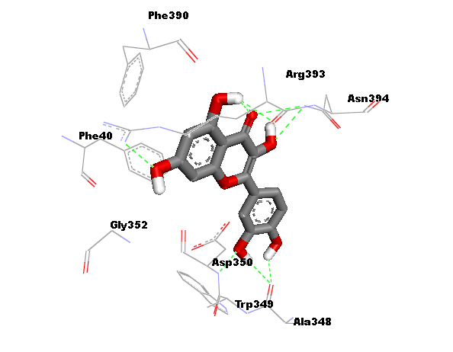 | 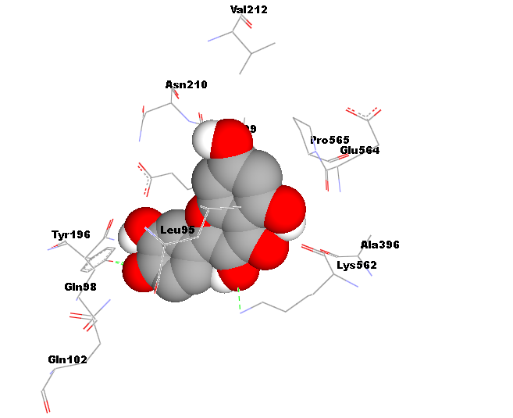
6 | Squalene | 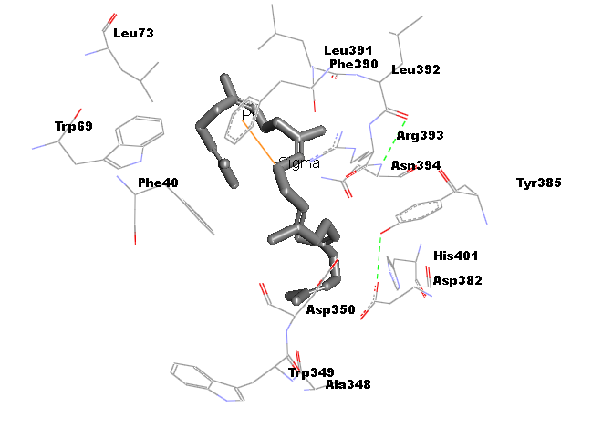 | 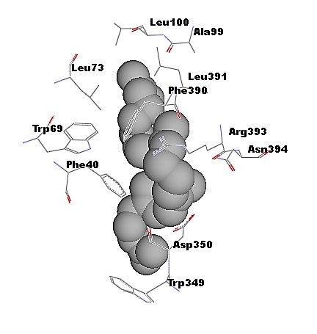
7 | Vitamin E | 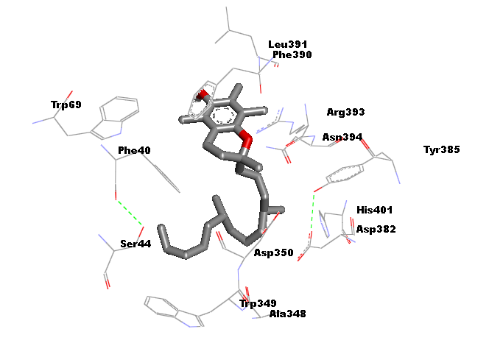 | 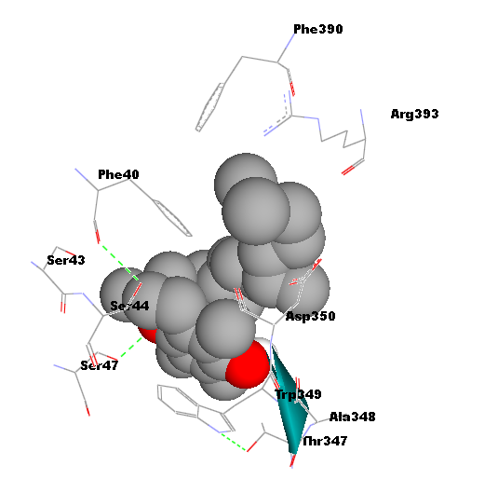
8 | Hydroxychloroquine | 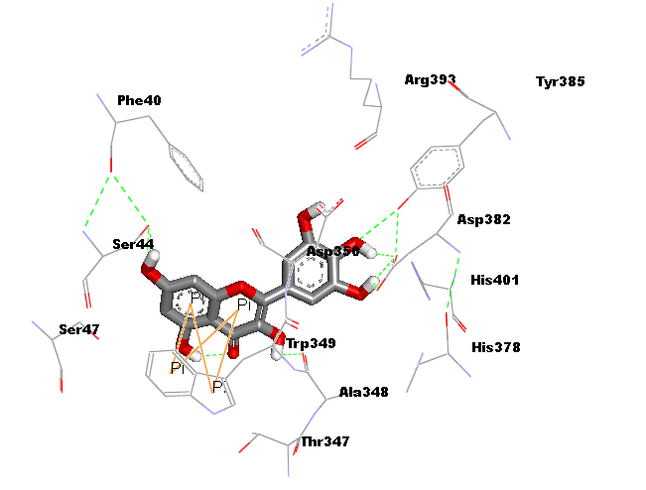 | 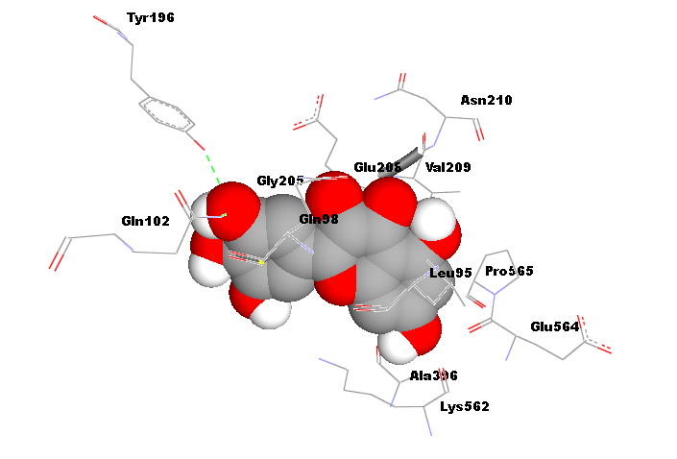
Supplementary table 13: 3D representation of the best docking poses of various phyto-consituent of Moringa oleifera with ACE-2 protein (PDB ID: 6MOJ) generated by using AutoDock 4.2.6 and AutoDock Vina
S.N. | Ligand | AutoDock 4.2.6 | AutoDock vina
1 | Beta carotene | 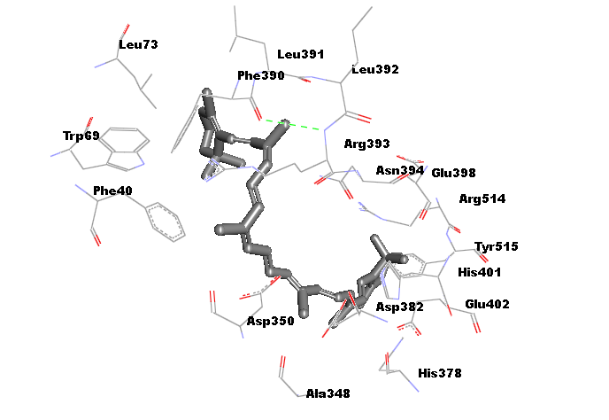 | 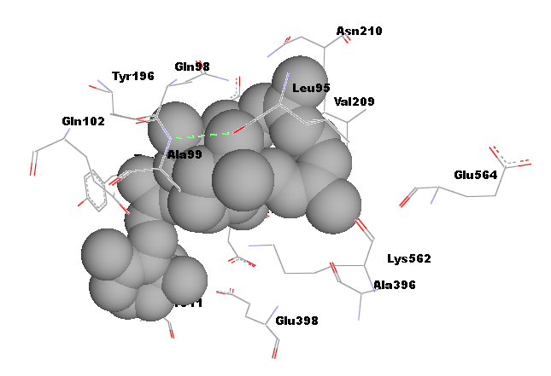
2 | Myricetin | 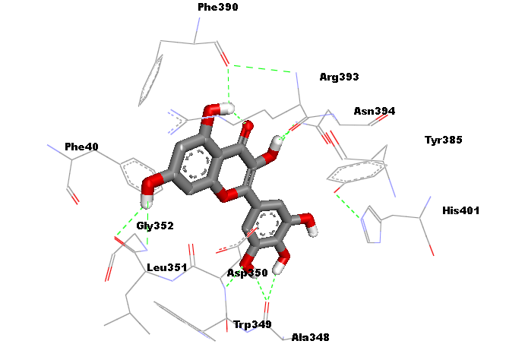 | 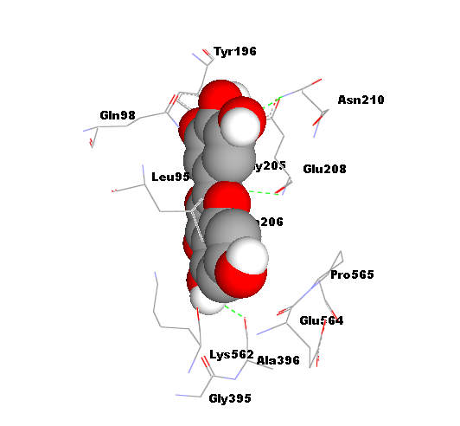
3 | Quinic Acid | 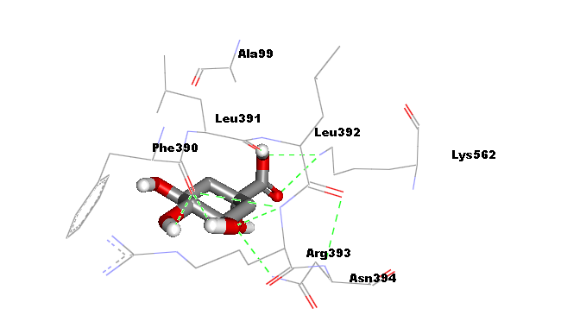 | 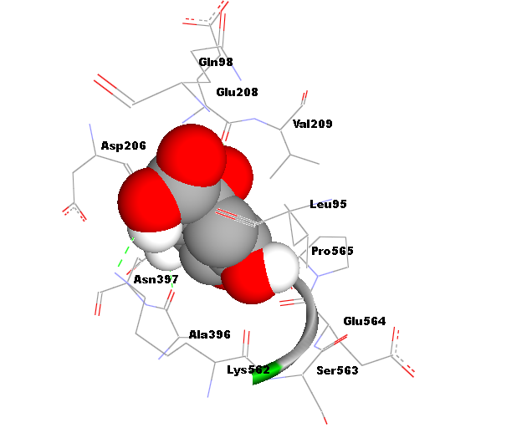
4 | Phytol | 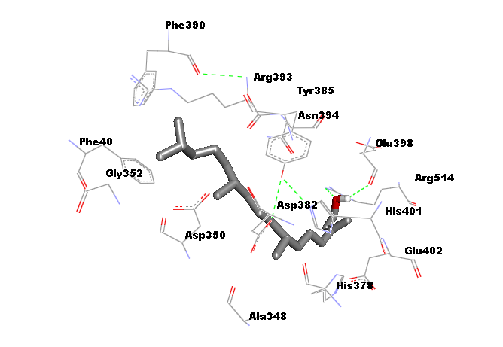 | 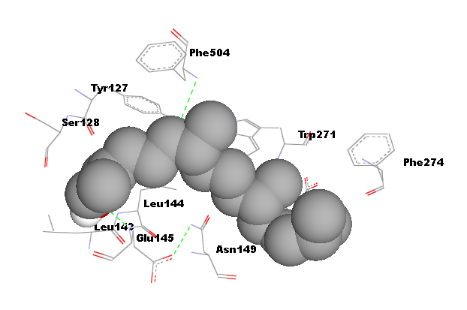
5 | Quercetin | 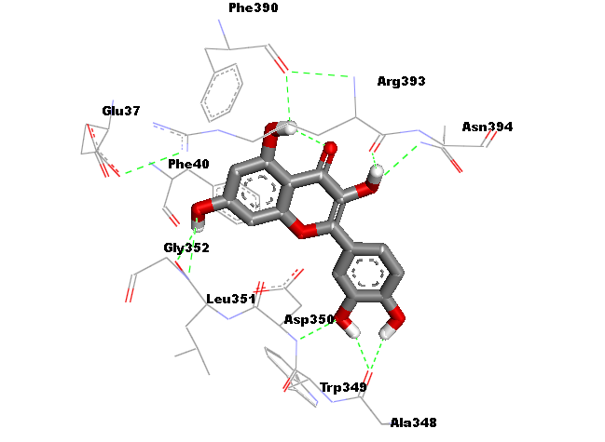 | 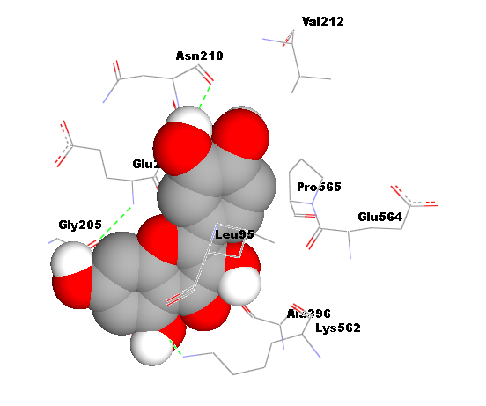
6 | Squalene | 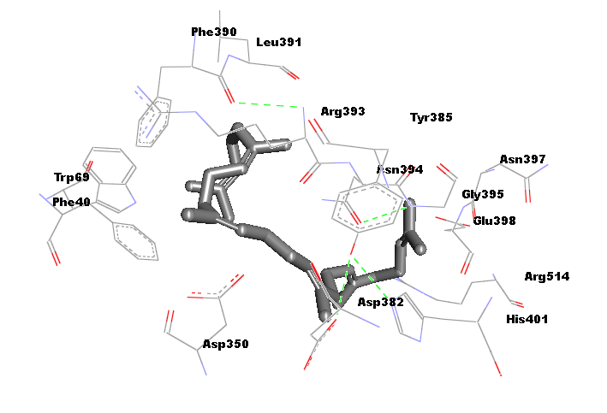 | 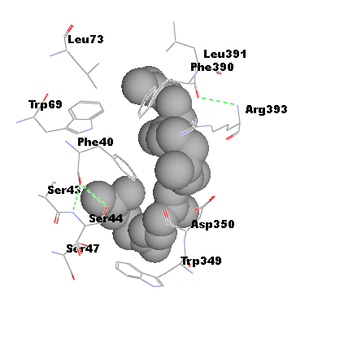
7 | Vitamin E | 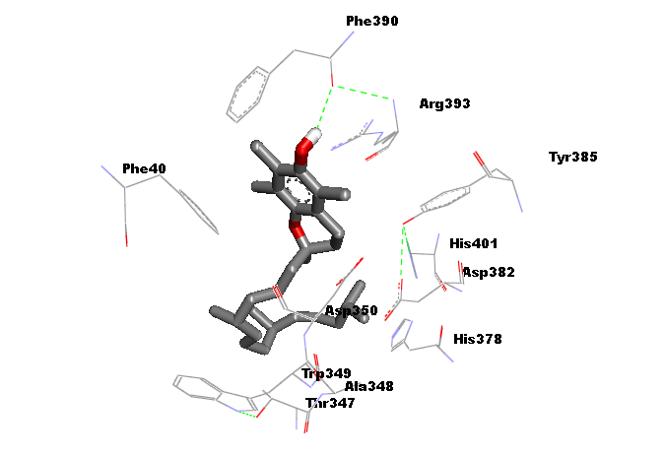 | 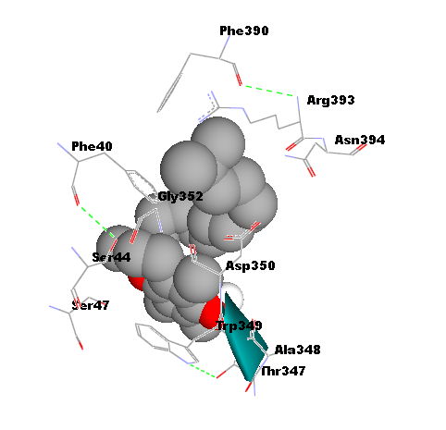
8 | Hydroxychloroquine | 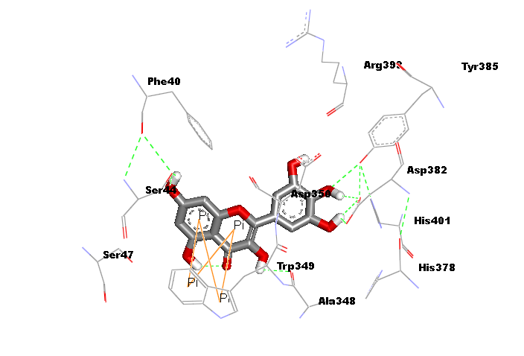
Supplementary table 14: 3D representation of the best docking poses of various phyto-consituent of Moringa oleifera with SARS-CoV-2 spike glycoprotein (PDB ID: 6VYB) generated by using AutoDock 4.2.6 and AutoDock Vina
S.N. | Ligand | AutoDock 4.2.6 | AutoDock Vina
1 | Beta carotene | 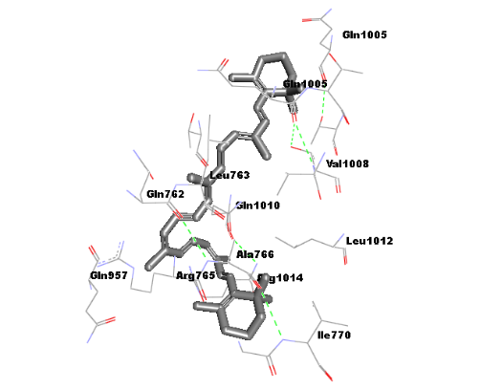 | 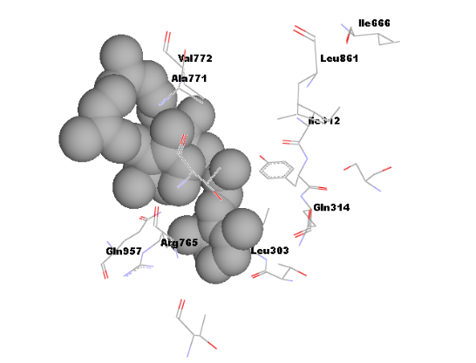
2 | Myricetin | 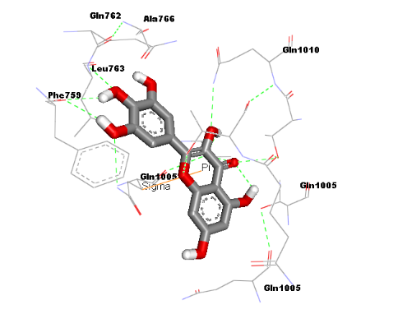 | 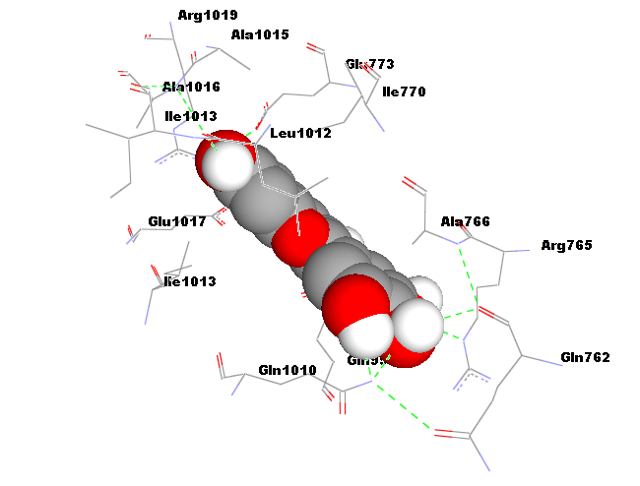
3 | Quinic Acid | 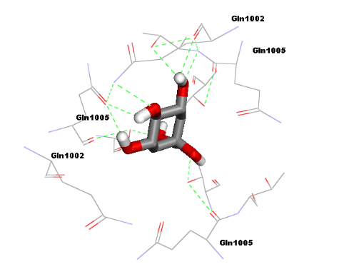 | 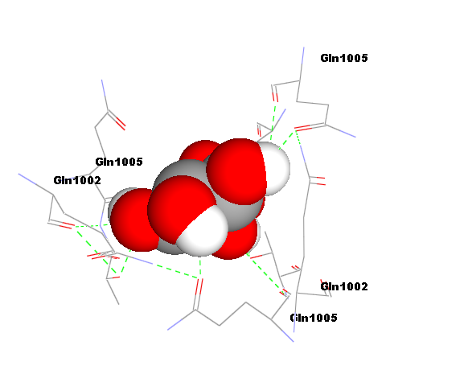
4 | Phytol | 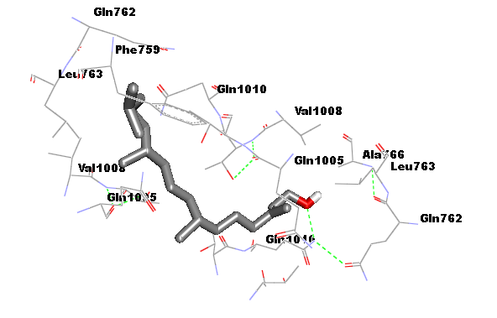 | 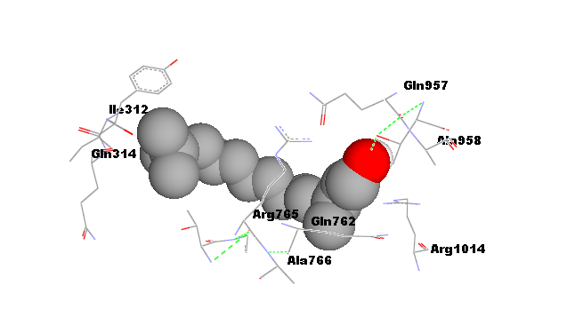
5 | Quercetin | 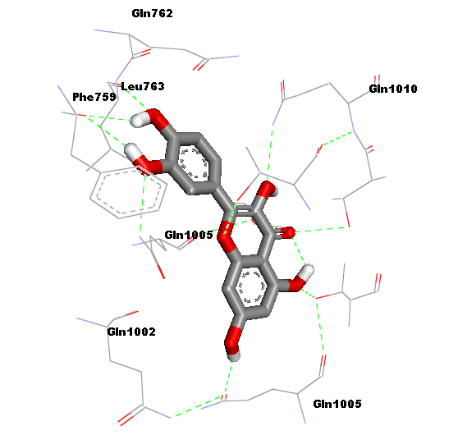 | 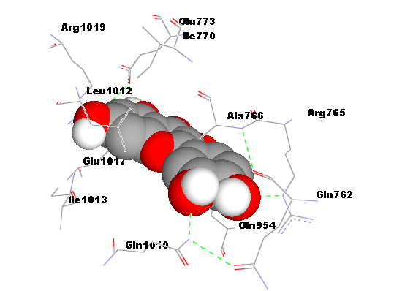
6 | Squalene | 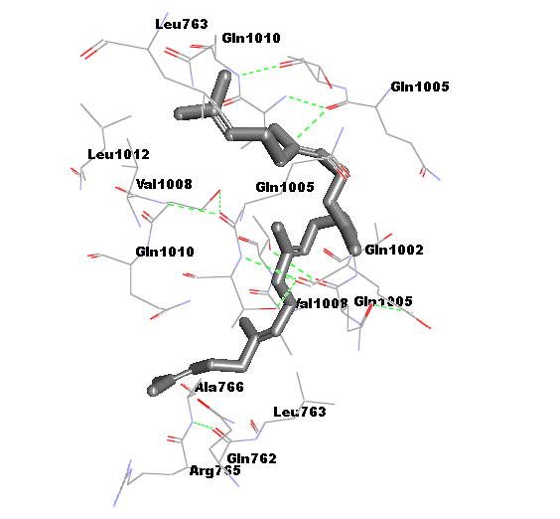 | 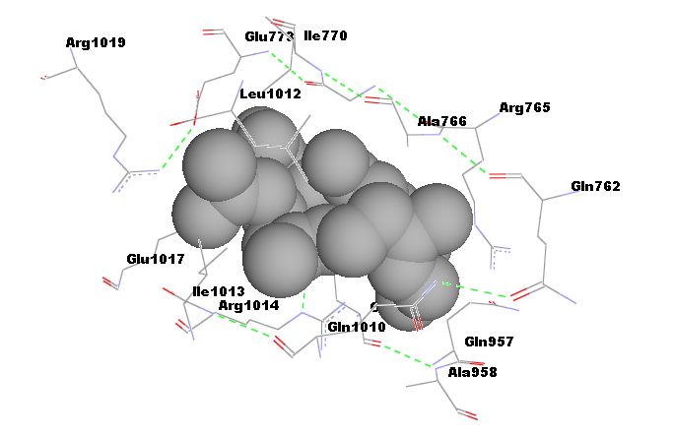
7 | Vitamin E | 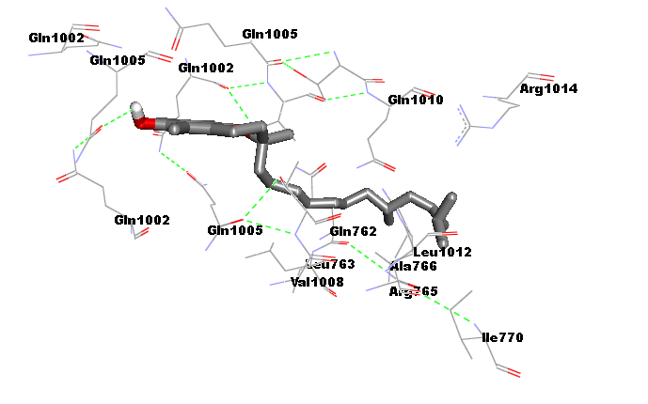 | 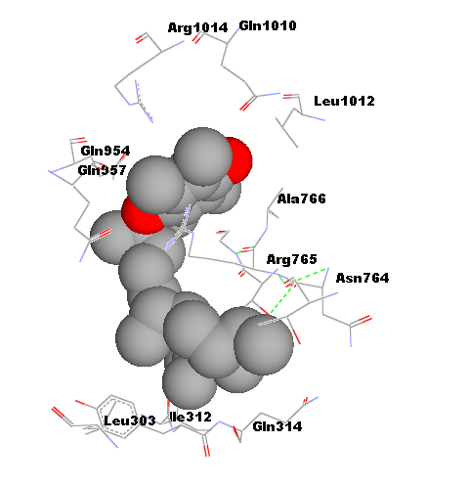
8 | Hydroxychloroquine | 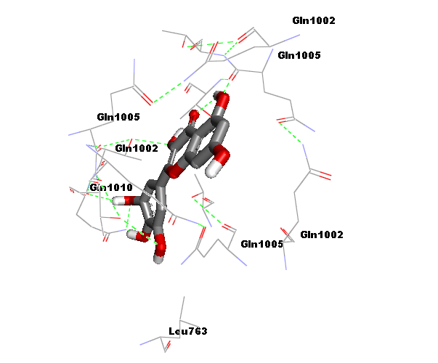 | 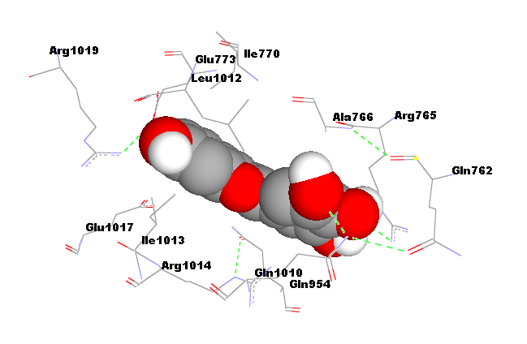

Supplementary table 15: 3D representation of the best docking poses of various phyto-consituent of Moringa oleifera with SARS-CoV-2 spike glycoprotein (PDB ID: 6VXX) generated by using AutoDock 4.2.6 and AutoDock Vina
S.N. | Ligand | AutoDock 4.2.6 | AutoDock Vina
1 | Beta carotene | 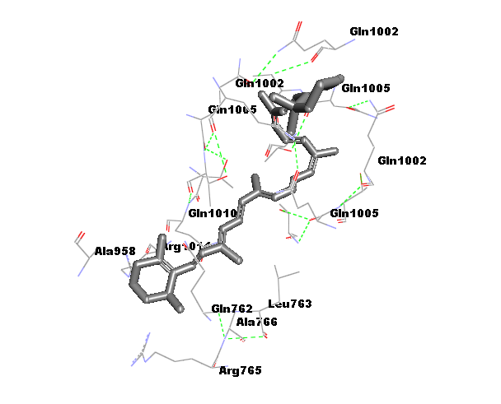 | 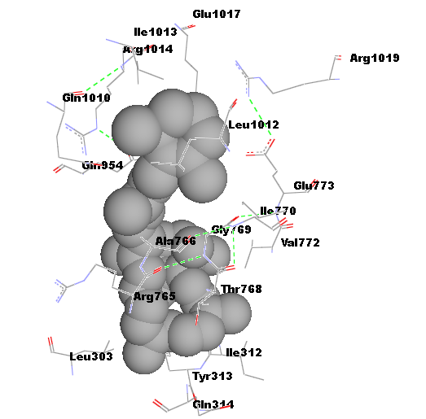
2 | Myricetin | 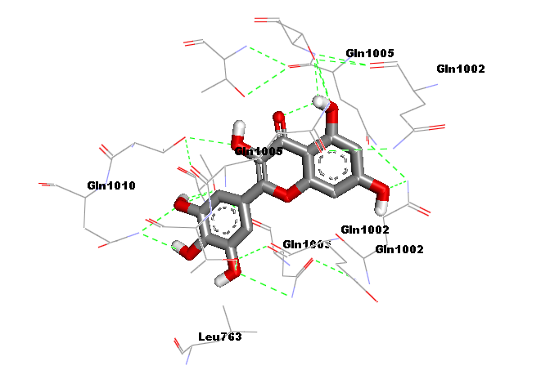 | 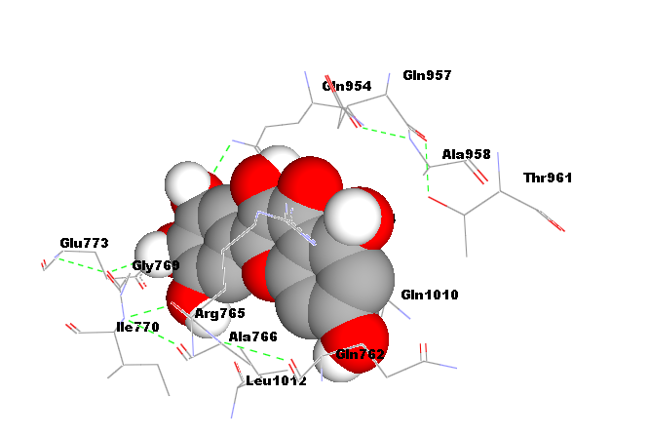
3 | Quinic Acid | 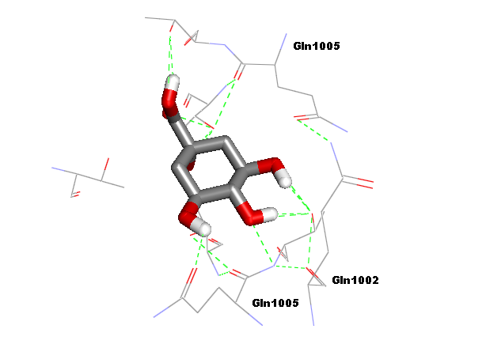 | 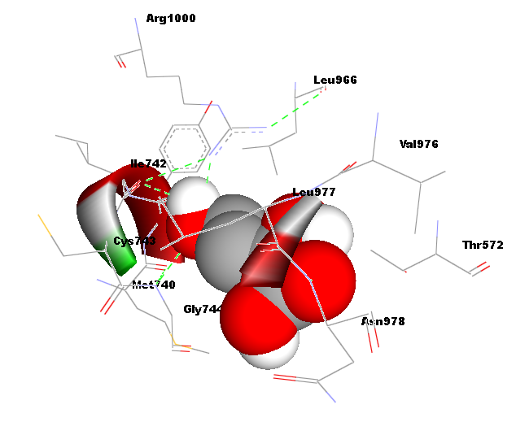
4 | Phytol | 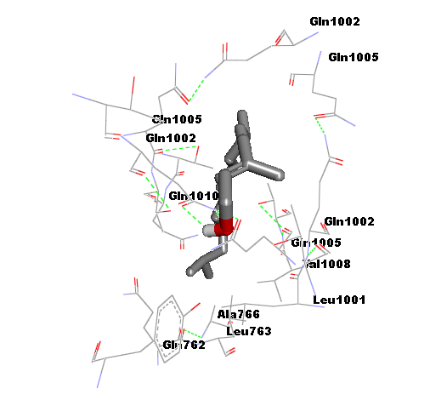 | 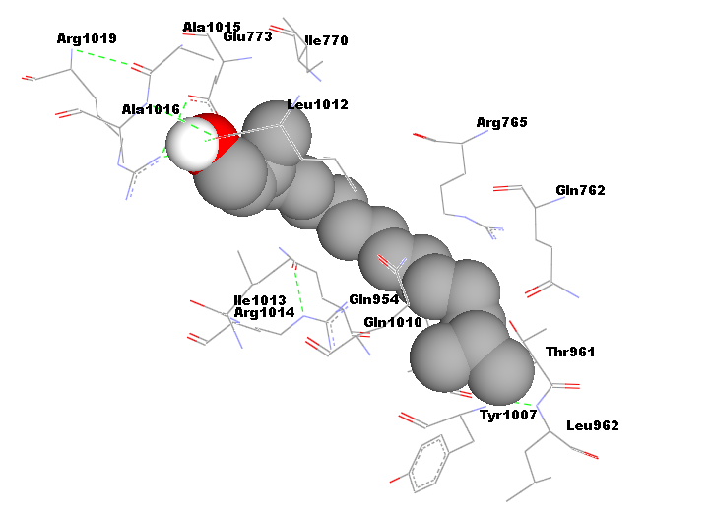
5 | Quercetin | 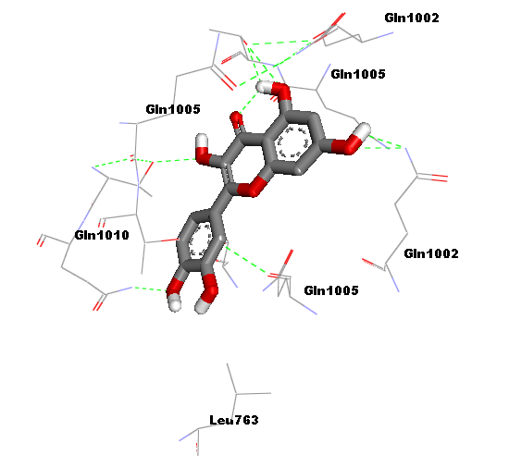
6 | Squalene | 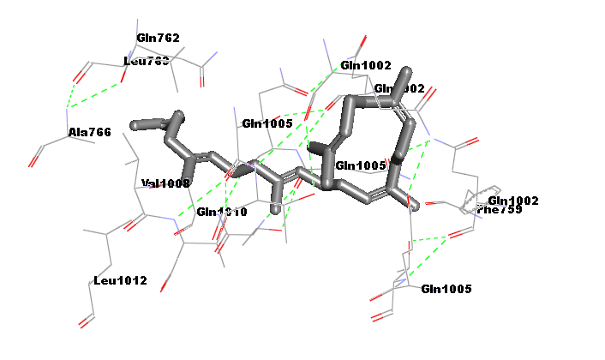
7 | Vitamin E | 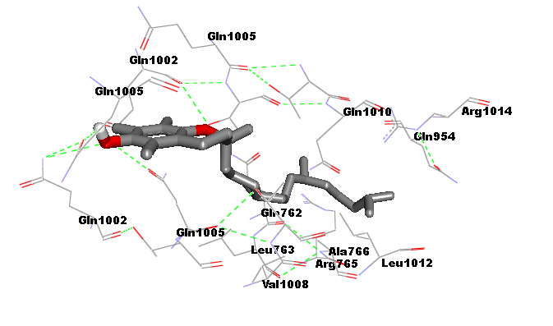
8 | Hydroxychloroquine | 

