Supplementary information

Phytochemical compounds of Guibourtia ehie and their antioxidant, urease and α-glucosidase inhibitory activities
Laurent Voufack Lefack Bongmo ¹, Mouthe Gervais Happi ²*, George Bellier Tabekoueng ¹, Mehreen Lateef ³, Alain François Kamdem Waﬀo ¹, Muhammad Shaiq Ali ⁴, Iqbal Choudhary Muhammad⁴, Achille Bissoue Nouga ¹, Jean Duplex Wansi ¹
¹Department of Chemistry, University of Douala, Faculty of Sciences, Cameroon
²Department of Chemistry, Higher Teacher Training College Bambili, The University of Bamenda, 39, Bambili, Cameroon
³Multi Disciplinary Research Lab, Medical and Dental College, Bahria University, Pakistan
⁴H.E.J. Research Institute of Chemistry, International Center for Chemical and Biological Sciences (ICCBS), University of Karachi, Pakistan
Corresponding author : gervais20022003@yahoo.fr (Gervais Mouthé Happi), jdwansi@yahoo.fr (Jean Duplex Wansi)

General instrumentation
The optical rotation was measured using a JASCO DIP-3600 digital polarimeter (JASCO, Tokyo, Japan) in methanol at 23°C. Ultraviolet spectra were recorded on a Hitachi UV 3200 spectrophotometer in MeOH. Infrared spectra were recorded on a JASCO 302-A spectrophotometer. EI-MS and ESI-MS were recorded on a Finnigan MAT 95 spectrometer (70 eV) with perfluorokerosene as a reference substance for EI–HR–MS. The spectrometer operated in positive and negative modes (m/z: 50-1500, with a scan rate of 1.00 Hz) with automatic gain control to provide high-accuracy mass measurements within 1 ppm deviation using Na formate as calibrant. The following parameters were used for experiments: spray voltage of 4.5 kV, the capillary temperature of 200 °C. Nitrogen was used as sheath gas (4 l/min). The ¹H- and ¹³C-NMR spectra were recorded at 500 MHz and 125 MHz, respectively on Bruker AMX 500 NMR spectrometers chemical shifts are reported in δ (ppm) using TMS as internal standard and coupling constants (J) were measured in Hz. Column chromatography was carried out on silica gel (70‒230 mesh, Merck). Thin-layer chromatography (TLC) was performed on Merck precoated silica gel 60 F₂₅₄ aluminium foil, and spots were detected using ceric sulphate spray reagent.

Determination of DPPH radical scavenging activity
The free radical scavenging activity was measured by 1,1-diphenyl-2-picryl-hydrazil (DPPH) using the method described by Gülcin et al. (2005). The solution of DPPH of 0.3 mM was prepared in ethanol. Five microliters of each sample of different concentrations (62.5 μg ‒ 500 μg) was mixed with 95 µL of DPPH solution in ethanol. The mixture was dispersed in 96 well plates and incubated at 37° C for 30 min. The absorbance was measured at 515 nm by a microtitre plate reader (Spectramax plus 384 Molecular Device, USA) and percent radical scavenging activity was determined in comparison with the methanol treated control. Butylhydroxyanisole (BHA) was used as standard. DPPH scavenging effect (%) = Ac – As/Ac × 100 where Ac is the absorbance of the control (DMSO treated) and As the absorbance of the sample.

Urease inhibition assay
Reaction mixtures comprising 25 μL of enzyme (Jack bean Urease) solution and 55 μL of buffers containing 100 mM urea were incubated with 5 μL of test compounds (1 mM concentration) at 30 ºC for 15 min in 96-well plates. Urease activity was determined by measuring ammonia production using the indophenol method as described by Weather burn. Briefly, 45 μL each of phenol reagent (1% w/v phenol and 0.005% w/v sodium nitroprusside) and 70 μL of alkali reagent (0.5% w/v NaOH and 0.1 % active chloride NaOCl) were added to each well. The increasing absorbance at 630 nm was measured after 50 min, using a microplate reader (Molecular Device, USA). All reactions were performed in triplicate in a final volume of 200 μL. The results (change in absorbance per min) were processed by using SoftMax Pro software (Molecular Device, USA). All the assays were performed at pH 8.2 (0.01 M K₂HPO₄.3H₂O, 1 mM EDTA and 0.01 M LiCl₂). Percentage inhibitions were calculated from the formula 100 - (OD_{testwell}/OD_{control}) x100. Thiourea was used as the standard inhibitor of urease.

α-glucosidase inhibition assay
The enzyme inhibition assay is based on the breakdown of a substrate to produce a coloured product, followed by measuring the absorbance over a while (Atsumi et al., 1990; Kurihara et al., 1994). Briefly, alpha-glucosidase (Sigma, type III, from yeast) was dissolved in buffer A (0.1 mol/L potassium phosphate, 3.2 mmol/L-MgCl₂, pH = 6.8) (0.1 units/ml) along with p-nitrophenyl-α-D-glucopyranoside dissolved at 6 mmol/L to obtain the substrate. Then, 102 µL of buffer B (0.5 mol/L potassium phosphate, 16 mmol/L-MgCl₂, pH = 6.8), 120 µL of sample solution (0.6 mg/mL in dimethylsulfoxide), 282 µL of water and 200 µL of substrate were mixed. This mixture was incubated in a water-bath at 37 °C for 5 min and then 200 µL of enzyme solution was added and mixed. The enzyme reaction was carried out at 37° C for 30 min and then 1.2 mL 0.4 mol/L glycine buffer (pH=10.4) was added to complete the reaction. Enzymatic activity was quantified by measuring the absorbance at 410 nm. 1-Deoxynojirimycin hydrochloride is a positive control. The Percentage of inhibition is equal to Ac – As/Ac × 100, Ac is the Absorbance of control and As is the absorbance of the sample

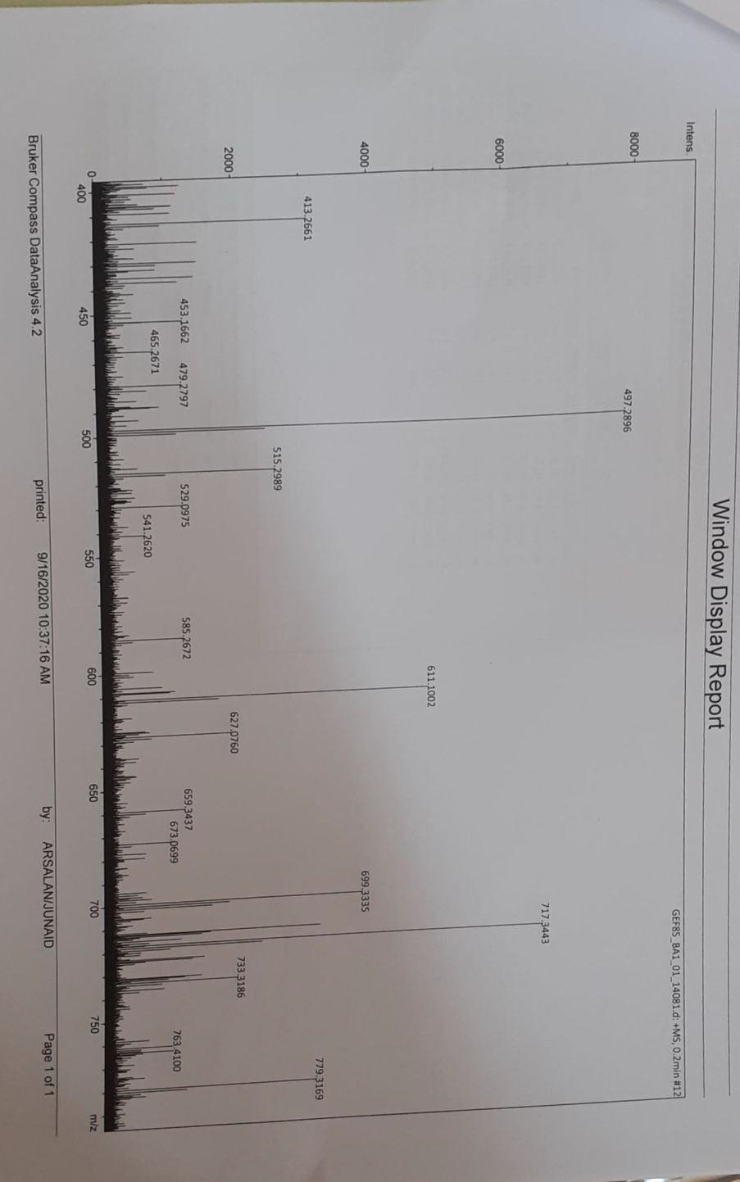

Figure 1S: Mass Spectrum ESI of compound 2a
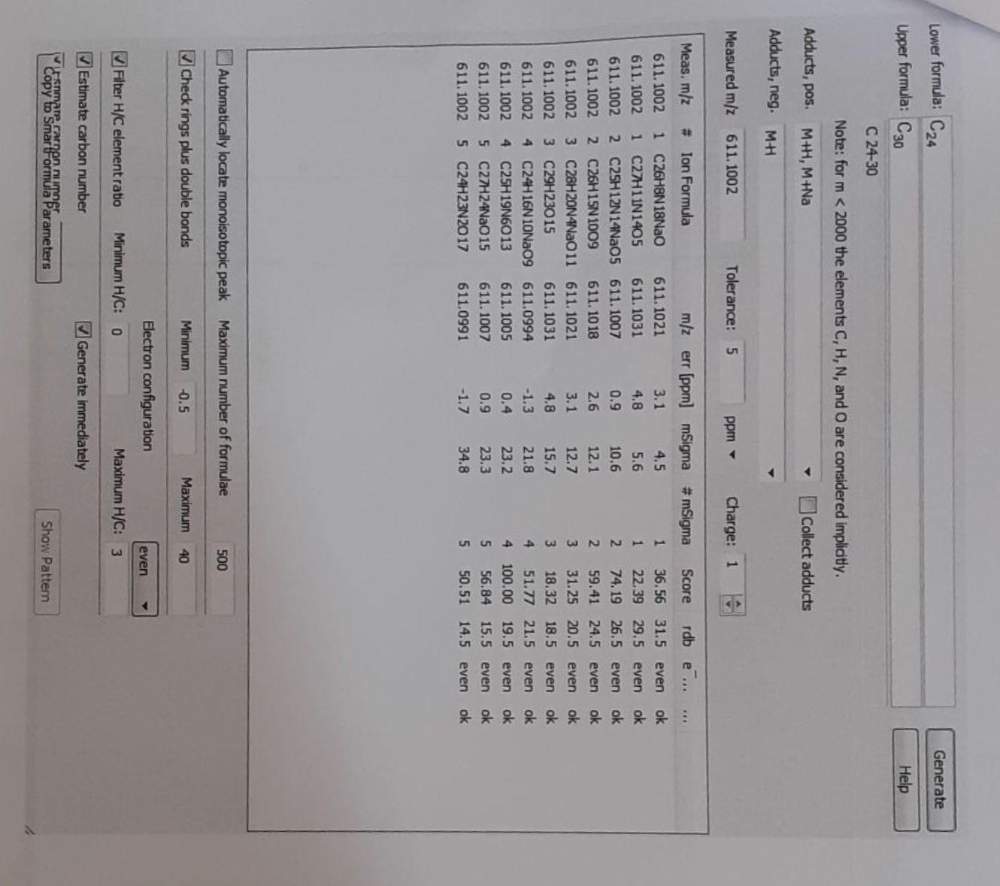

Figure 2S: Acurate Mass of compound 2a

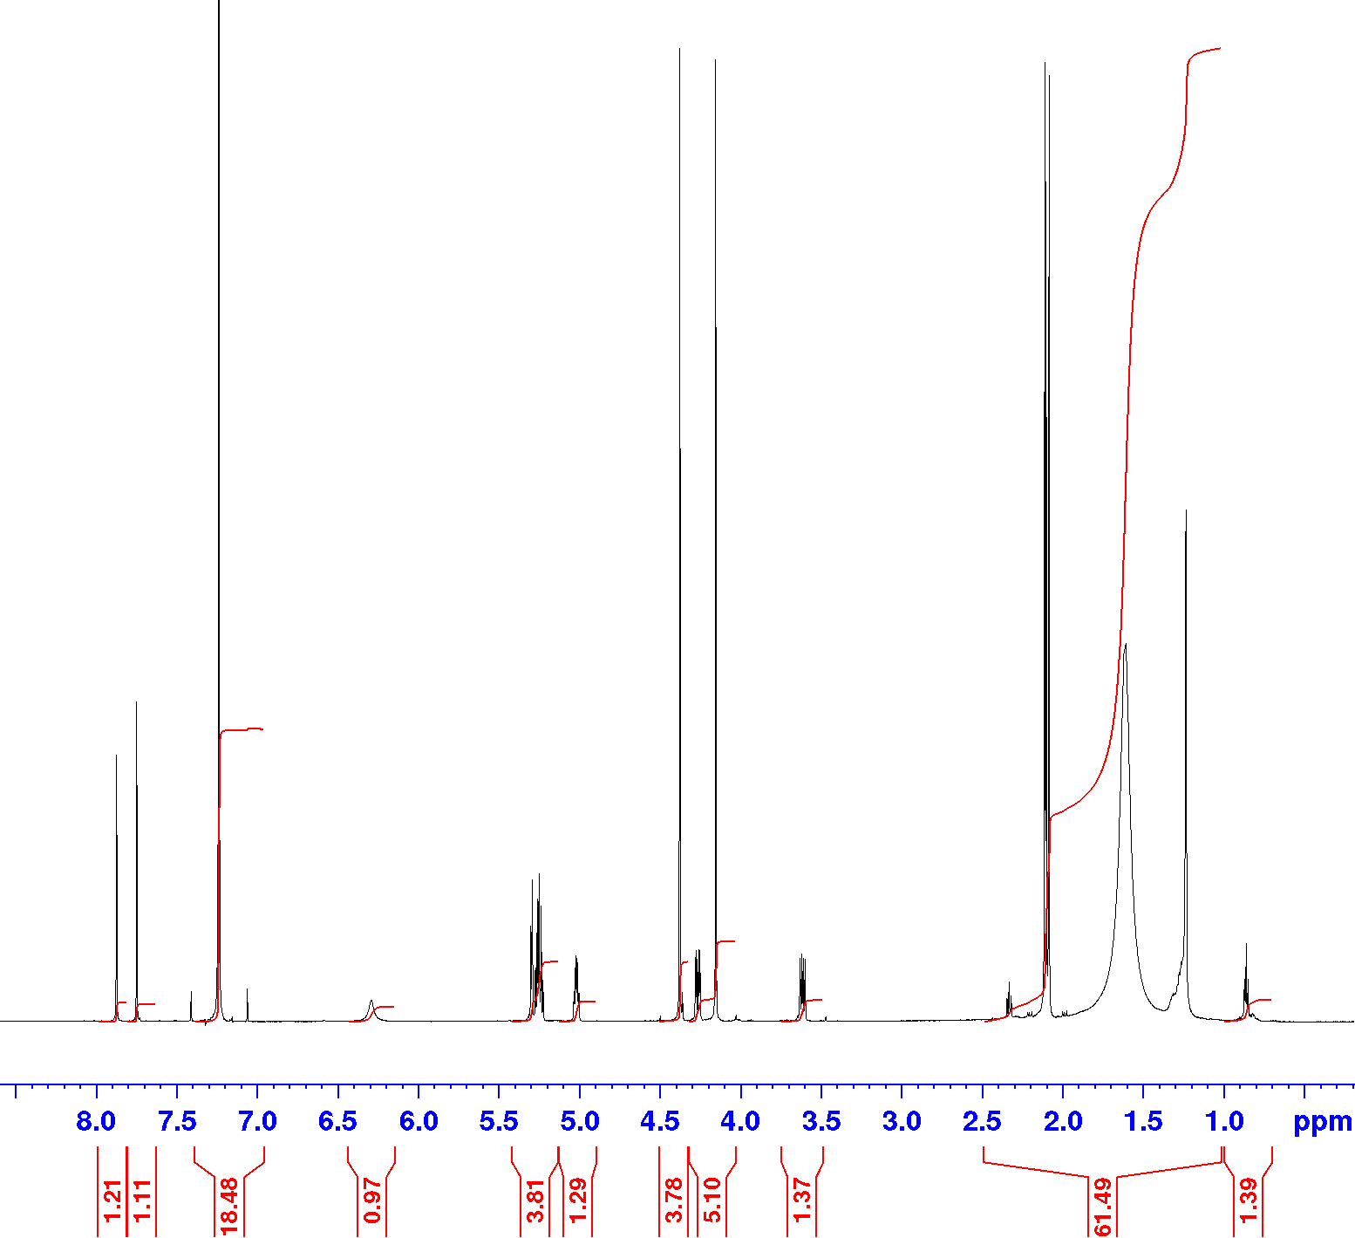

Figure 3S: ¹H (600 MHz, CDCl3) Spectrum of compound 2a

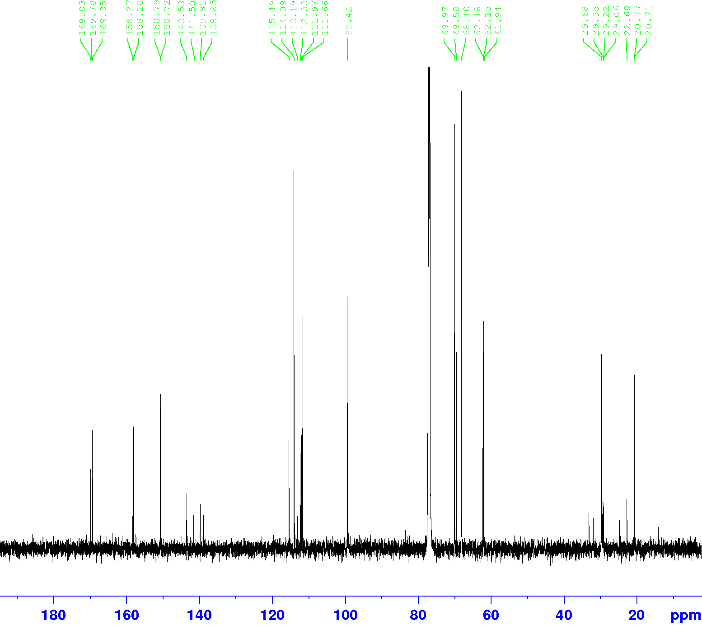

Figure 4S: ¹³C (150 MHz, CDCl3) Spectrum of compound 2a

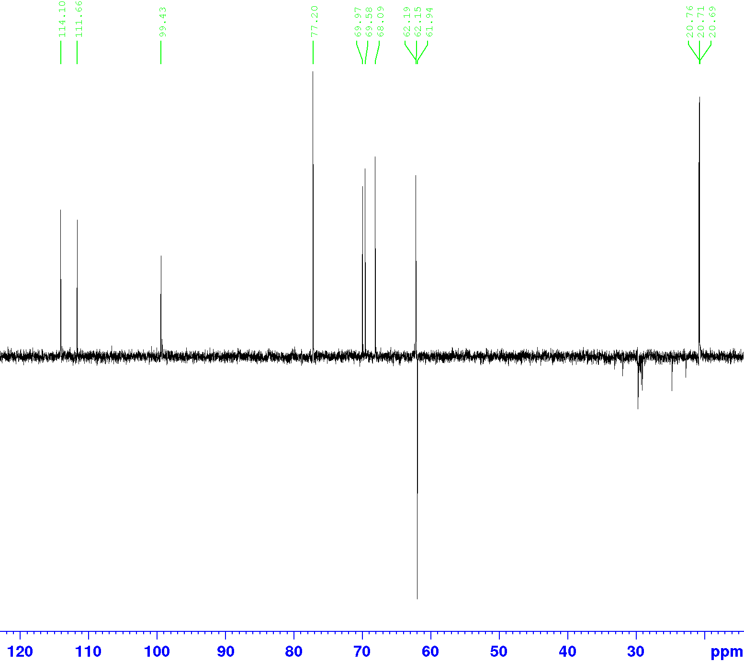
Figure 5S: DEPT-135 Spectrum of compound 2a

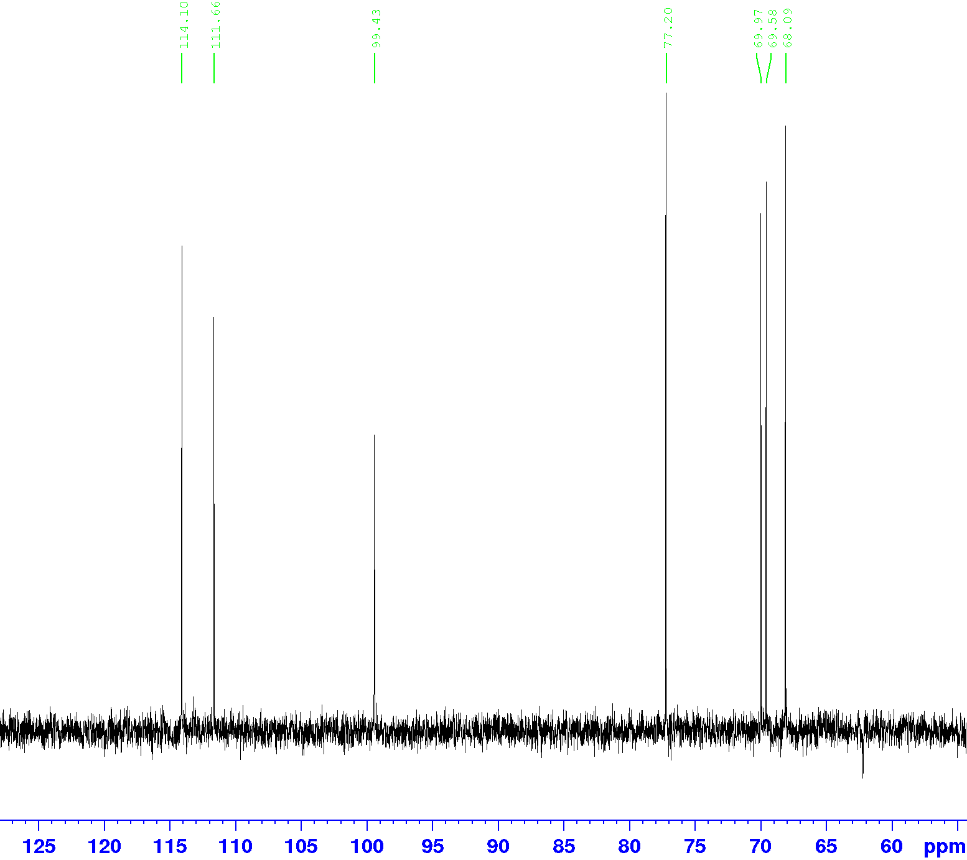

Figure 6S: DEPT-90 Spectrum of compound 2a

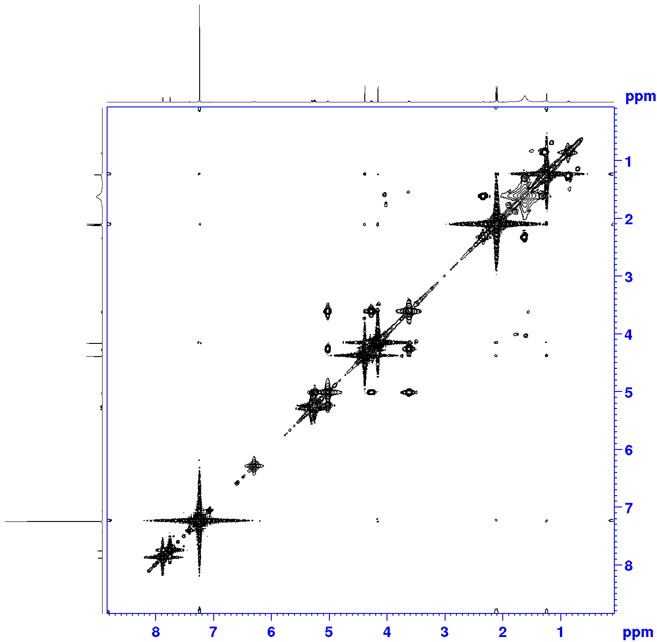

Figure 7S: COSY Spectrum of compound 2a

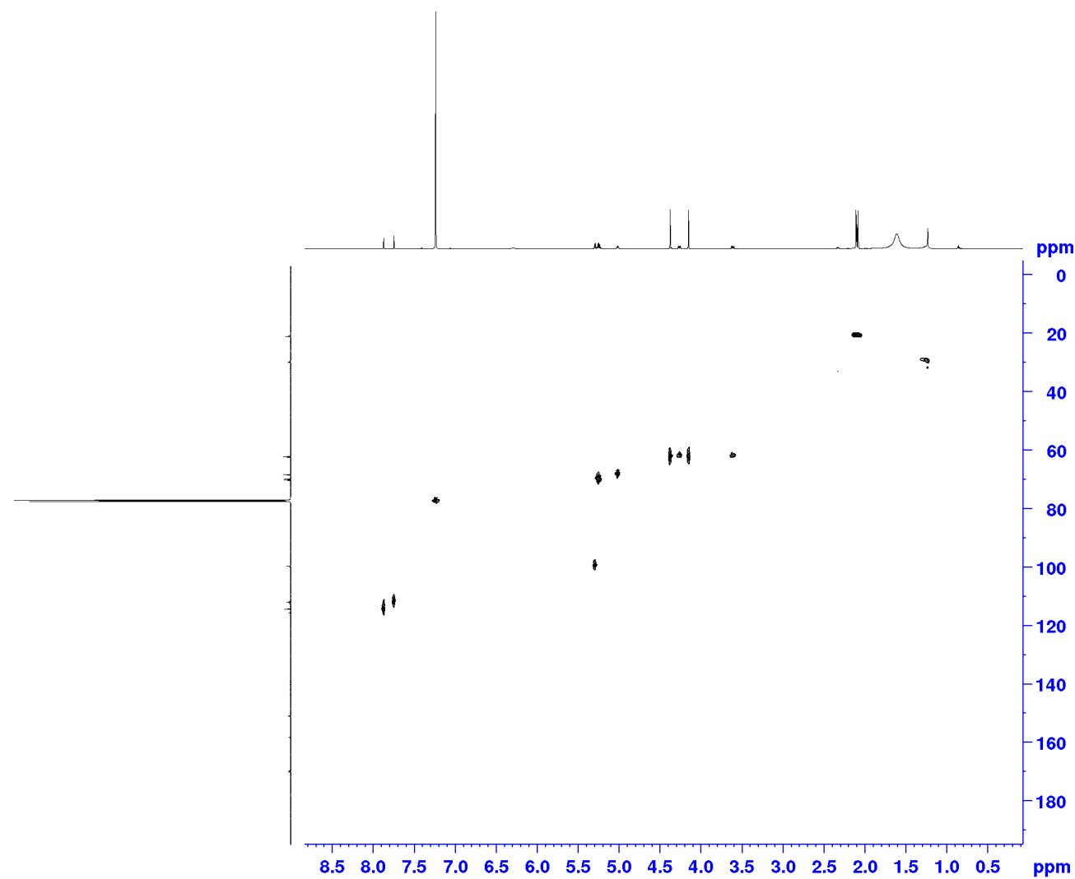

Figure 8S: HSQC Spectrum of compound 2a

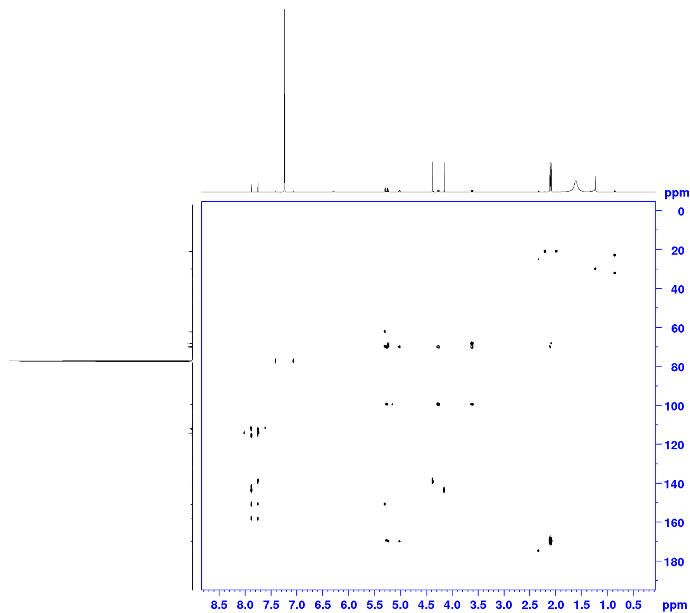

Figure 9S: HMBC Spectrum of compound 2a

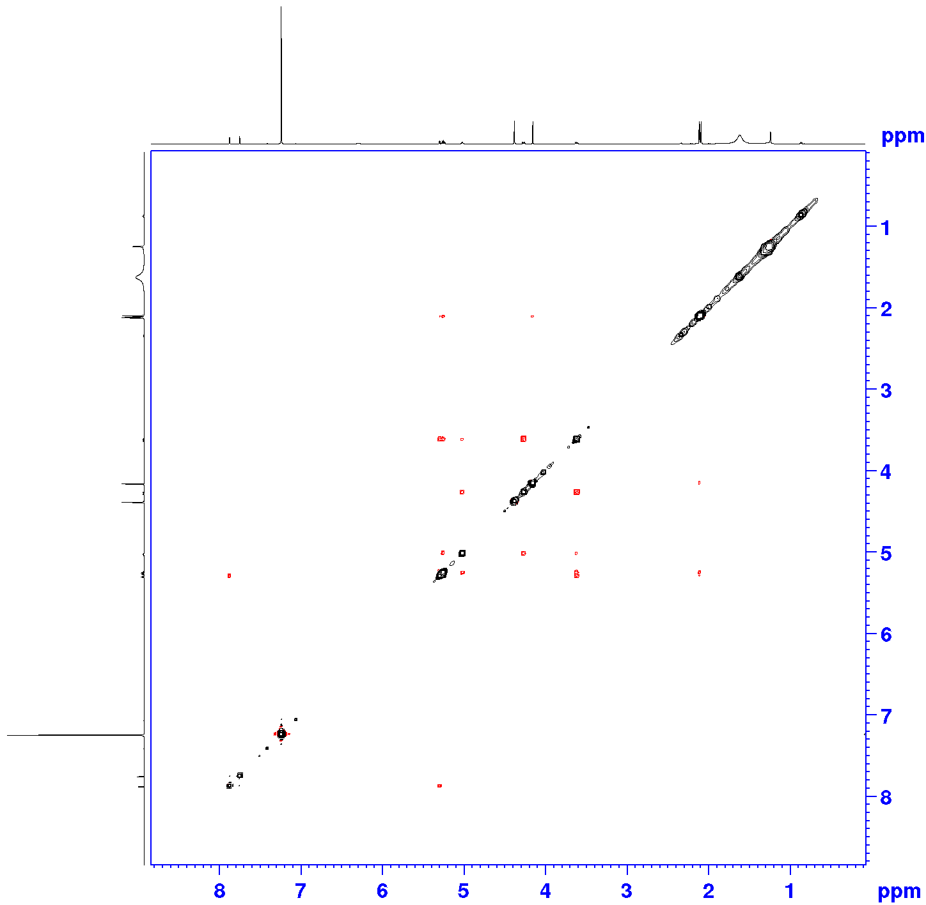

Figure 10S: NOESY Spectrum of compound 2a

Table 1S: The Mass and NMR data of isolated compounds

Compound and Aspect | Mass | ¹H NMR; δ (mult., J in Hz) | 13C NMR (δ)
Ellagic acid (1)  Yellowish powder | HR-ESI-MS (m/z): 325.1948 [M+Na]⁺ | ¹H-NMR (DMSO-d₆, 500 MHz) δ: 7.46 (2H, s, H-5, H-5′) | ¹³C-NMR (DMSO-d₆, 125 MHz) δ: 159.6 (C-7, C-7′), 148.6 (C-4, C-4′), 140.4 (C-3, C-3′), 136.8 (C-2, C-2′), 112.8 (C-5, C-5′), 110.6 (C-6, C-6′), 107.8 (C-1, C-1′)
3,3′-di-O-methylellagic acid 4′-O-β-D-xylopyranoside (2)  Yellow powder | HR-ESI-MS (m/z): 485.1006 [M+Na]⁺ | ¹H-NMR (C₅D₅N, 600 MHz) δ: 7.67 (1H, s, H-5), 7.35 (1H, s, H-5′), 5.51 (1H, d, J = 7.3 Hz, H-1′′), 5.25 (1H, m, H-2′′), 5.17, 5.08 (2H, m, H-5′′), 4.10 (1H, m, H-3′′), 4.08 (3H, s, 3′-OCH₃), 4.05 (3H, s, 3-OCH₃), 3.82 (1H, m, H-4′′) | ¹³C-NMR (C₅D₅N, 150 MHz) δ: 159.2 (C-7′), 159.1 (C-7), 152.6 (C-4′), 151.09 (C-4), 141.87 (C-3), 141.19 (C-2), 140.8 (C-2’), 140.02 (C-3′), 114.7 (C-1), 112.1 (C-1′), 112.02 (C-5), 111.5 (C-6, C-6′), 111.3 (C-5′), 102.8 (C-1′′), 75.3 (C-3′′), 72.9 (C-2′′), 69.2 (C-4′′), 65.8 (C-5′′), 61.2 (3-OCH₃), 60.9 (3′-OCH₃)
Rhaponticin (3)  Brown powder | HR-ESI-MS (m/z): 443.3420 [M+Na]⁺ | ¹H-NMR (C₅D₅N, 600 MHz) δ: 7.03 (1H, d, J = 2.0 Hz, H-2'), 6.94 (1H, d, J = 16.1 Hz, H-β), 6.91 (1H, dd, J = 8.1, 2.0 Hz, H-6'), 6.81 (1H, d, J = 16.1 Hz, H-α), 6.78 (1H, d, J = 8.1 Hz, H-5'), 6.76 (1H, brs, H-2), 6.59 (1H, brs, H-6), 6.48 (1H, dd, J = 1.8, 2.2 Hz, H-4), 4.92 (1H, d, J = 7.3 Hz, H-1''), 4.63 (1H, dd, J = 12.1, 2.2 Hz, H-6''a), 4.31 (1H, dd, J = 12.1, 7.7 Hz, H-6''b), 3.83 (1H, m, H-5"), 3.80 (3H, s, 4'-OCH₃), 3.52 (2H, m, H-2",H-3"), 3.39 (1H, dd, J = 9.1, 7.9 Hz, H-4") | ¹³C-NMR (C₅D₅N, 150 MHz) δ: 160.3 (C-5), 160.3 (C-3), 148.8 (C-4'), 147.4 (C-3'), 140.6 (C-1), 131.4 (C-1'),129.6 (C-β), 127.2 (C-α), 118.9 (C-6'), 113.4 (C-2'), 112.4 (C-5'), 108.7 (C-6), 105.9 (C-2), 103.1 (C-4), 100.5 (C-1''), 76.5 (C-3''), 76.1 (C-5''), 75.1(C-2''), 71.24 (C-4''), 62.3 (C-6''), 55.8 (4'-OCH₃)
2,6-dimethoxybenzoquinone (4)  Pale white powder | EIMS (m/z): 168.1 [M⁺] | ¹H-NMR (C₅D₅N, 600 MHz) δ: 5.93 (2H, s, H-3, H-5), 3.80 (6H, s, 2-OCH₃, 6-OCH₃) | ¹³C-NMR (C₅D₅N, 150 MHz) δ: 179.2 (C-1), 178.7 (C-4), 155.8 (C-2, C-6), 108.9 (C-3, C-5), 58.1 (2-OCH₃, 6-OCH₃)
Lupeol (5)  White glitter | EIMS (m/z): 426.3 [M⁺] | ¹H-NMR (CDCl₃, 500 MHz) δ: 4.70 (1H, J = 2.4 Hz, H-29b), 4.55 (1H, d, J = 2.4 Hz, H-29a), 3.18 (1H, dd, J = 11.4, 5.3 Hz, H-3), 2.39 (1H, m, H-19), 1.91 (1H, m, H-21b), 1.70 (3H, s, H-30), 1.69 (1H, m, H-15b), 1.66 (1H, m, H-1b), 1.66 (1H, m, H-12b), 1.65 (1H, m, H-13), 1.61 (1H, m, H-2a), 1.57 (1H, m, H-2b), 1.52 (1H, m, H-6a), 1.46 (1H, m, H-16b), 1.42 (1H, m, H-11a), 1.41 (1H, m, H-6b), 1.40 (2H, m, H-7), 1.38 (1H, m, H-18), 1.37 (1H, m, H-22b), 1.37 (1H, m, H-16a), 1.32 (1H, m, H-21a),1.26 (1H, m, H-9), 1.22 (1H, m, H-11b), 1.19 (1H, m, H-22a), 1.05 (3H, s, H-26), 1.05 (1H, m, H-12a), 0.99 (1H, m, H-15a), 0.98 (3H, s, H-23), 0.95 (3H, s, H-27), 0.91 (1H, m, H-1a), 0.84 (3H, s, H-25), 0.80 (3H, s, H-28), 0.77 (3H, s, H-24), 0.70 (1H, m, H-5)
Taraxerol (6)  White powder | EIMS (m/z): 426.2 [M⁺] | ¹H-NMR (CDCl₃, 500 MHz) δ: 5.53 (1H, dd, J = 8.1,3.2 Hz, H-15), 3.16 (1H,dd, J = 10.7, 4.9 Hz, H-3), 2.02,1.95 (2H, m, H-16),1.95,1.60 (2H, m, H-7), 1.62,1.40 (2H, m, H-2), 1.60,1.17 (2H, m, H-1), 1.60,1.17 (2H, m, H-6), 1.40 (1H, m, H-18), 1.40(1H, m, H-5), 1.40 (1H, m, H-9), 1.17 (10H, m, H-11,H-12,H-19,H-21,H-22), 0.96 (3H, s, H-27), 0.93 (3H, s, H-25 ), 0.92 (3H, s, H-28), 0.84 (3H, s, H-23), 0.84 (3H, s, H-24), 0.81 (3H, s, H-29), 0.81 (3H, s, H-30)
Friedelan-3-one (7)  White powder | EIMS (m/z): 426.7 [M⁺] | ¹H-NMR (CDCl₃, 500 MHz) δ: 2.40, 2.27 (2H,m, H-2), 2.37 (1H,s, H-4), 1.95,1.71 (2H, m, H-1), 1.75,1.38 (2H, m, H-7), 1.74,1.28 (1H, d, J = 7.4 Hz, H-6), 1.53 (1H, m, H-10), 1.58,1.35 (2H, m, H-16), 1.54 (1H, m, H-18), 1.51,0.93 (2H, m, H-22),1.50,1.32 (2H, m, H-21), 1.45,1.27 (2H, m, H-15), 1.43,1.25 (2H, m, H-11), 1.37 (1H, m, H-8), 1.37,1.22 (2H, m, H-19), 1.33,1.31 (2H, m, H-12), 1.18 (3H, s, H-28), 1.07 (3H, s, H-27), 1.00 (3H, s, H-29), 0.99 (3H, s, H-26), 0.95 (3H, s, H-30 ), 0.89 (3H, s, H-25), 0.88 (3H, d, J = 7.6 Hz, H-23), 0.74 (3H, s, H-24)
Lanosterol (8)  Whitish glitter powder | EI-MS (m/z): 426.5 [M⁺] | ¹H-NMR (CDCl₃, 500 MHz) δ: 5.10 (1H, t, J = 6.4 Hz, H-24), 3.43 (1H, dd, J = 10.3,4.7 Hz, H-3), 1.56 (3H, s, H-26), 1.54 (3H, s, H-27), 1.45 (1H, m, H-17), 1.35 (1H, m, H-20), 1.05 (1H, m, H-5), 0.89 (3H, s, H-19), 0.87 (3H, s, H-28), 0.83 (3H, d, J = 6.1 Hz, H-21), 0.79 (3H, s, H-29), 0.74 (3H, s, H-30), 0.61 (3H, s, H-18)
Scopoletin (9)  Pale yellowish powder | EIMS (m/z): 192.1 [M⁺] | ¹H-NMR (CD₃OD, 500 MHz) δ: 7.77 (1H, d, J = 9.4 Hz, H-4), 6.98 (1H, s, H-8), 6.81 (1H, s, H-5), 6 .21 (1H, d, J = 9.4 Hz, H-3), 3.91 (3H, s, 6-OCH₃) | ¹³C-NMR (CD₃OD, 125 MHz) δ: 162.9 (C-2), 151.3 (C-8a), 150.0 (C-7), 145.7 (C-6), 144.7 (C-4), 111.5 (C-3), 111.2 (C-4a), 108.4 (C-5), 102.9 (C-8), 55.8 (6-OCH₃)
Pilloin (10)  Yellow powder | EIMS (m/z): 314.3 [M⁺] | ¹H-NMR (CDCl₃, 500 MHz) δ: 7.42 (1H, d, J = 2.1 Hz, H-2’), 7.26 (1H, dd, J = 8.4, 2.1 Hz, H-6’), 6.97 (1H, d, J = 8.4 Hz, H-5’), 6.50 (1H, s, H-3), 6.42 (1H, d,J = 1.5 Hz, H-8), 6.31 (1H, d, J = 1.5 Hz, H-6), 3.94 (3H, s, 4’-OCH₃), 3.82 (3H, s, 7-OCH₃) | ¹³C-NMR (CDCl₃, 125 MHz) δ: 182.4 (C-4), 165.4 (C-7), 163.9 (C-2), 162.2 (C-5), 157.7 (C-8a), 149.3 (C-3′), 146.8 (C-4′), 123.4 (C-1′), 120.7 (C-2′), 114.9 (C-5′), 108.3 (C-6′), 105.5 (C-4a), 104.5 (C-3), 98.3 (C-6), 92.6 (C-8), 56.2 (4’-OCH₃), 55.8 (7-OCH₃)
β-sitosterol (11)  White powder | EI-MS (m/z): 414.7 [M⁺] | ¹H-NMR (CDCl₃, 500 MHz) δ: 5.34 (1H, t, J =6.4, H-6), 3.51 (1H, dd, J = 4.5,4.2 Hz, H-3), 1.23 (3H, s, H-19), 1.15 (3H,s, H-18), 1.02 (3H, d, J =6.5 Hz, H-26), 0.92 (3H, d, J = 6.3 Hz, H-27), 0.92 (3H,m, H-29), 0.86 (3H, d, J =6.3 Hz, H-21) | ¹³C-NMR (CDCl₃, 125 MHz) δ: 141.1 (C-5), 121.6 (C-6), 72.2 (C-3), 57.9 (C-14), 56.6 (C-17), 50.4 (C-9), 46.4 (C-24), 42.7 (C-13), 42.6 (C-4), 38.9 (C-12), 37.7 (C-1), 36.8 (C-10), 36.5 (C-20), 34.5 (C-22), 32.3 (C-7), 32.3 (C-8), 32.1 (C-2), 29.7 (C-25), 28.7 (C-16), 26.5 (C-23), 24.4 (C-15), 23.7 (C-28), 21.4 (C-11), 20.3 (C-26), 19.7 (C-27), 19.5 (C-19), 19.2 (C-21), 12.5 (C-29), 12.4 (C-18)
Stigmasterol (12)  White powder | EI-MS (m/z): 412.6 [M⁺] | ¹H-NMR (CDCl₃, 500 MHz) δ : 5.36 (1H, t, J = 6.2, H-6), 5.14 (1H, dd, J = 12.3, 8.0 Hz, H-22), 4.98 (1H, dd, J = 12.3, 8.0 Hz, H-23), 3.53 (1H, dd, J = 4.3, 4.1 Hz, H-3), 1.03 (3H, s, H-19), 0.93 (3H, s, H-18), 0.87 (1H, t, J = 7.2 Hz, H-24), 0.84 (3H, d, J = 6.6 Hz, H-26), 0.82 (3H, t, J = 6.5 Hz, H-29) , 0.81 (3H, d, J = 6.6 Hz, H-27), 0.71 (3H, d, J = 6.3 Hz, H-21) | ¹³C-NMR (CDCl₃, 125 MHz) δ: 140.8 (C-5), 138.3 (C-22), 129.3 (C-23), 121.7 (C-6), 71.8 (C-3), 56.9 (C-14, C-17), 51.3 (C-24), 50.2 (C-9), 42.4 (C-4, C-13), 40.5 (C-20), 39.8 (C-12), 37.3 (C-1), 36.6 (C-10), 32.0 (C-7), 31.9 (C-8), 31.7 (C-2), 31.2 (C-25), 28.9 (C-16), 25.4 (C-28), 24.4 (C-15), 21.2 (C-26, C-27), 21.1 (C-11, C-21), 19.4 (C-19), 12.2 (C-18, C-29)
Stigmasterol-3-O-β-D-glucopyranoside (13)  White powder | EI-MS (m/z): 574.8 [M⁺] | ¹H-NMR (C₅D₅N, 500 MHz) δ: 5.32 (2H, m, H-6), 5.16 (1H, dd, J = 12.1, 8.2 Hz, H-22), 5.03 (1H, dd, J = 12.1, 8.2 Hz, H-23), 4.22 (1H, d, J = 6.5 Hz, H-1’), 3.67 (1H, m, H-6’b), 3.47 (1H, m, H-3), 3.44 (1H, m, H-6’a),3.12 (1H, d, J = 7.5 Hz, H-3’), 3.10 (1H, m, H-5’), 3.06 (1H, m, H-4’), 2.90 (1H, t, J = 7.0 Hz, H-2’), 2.12 (1H, m, H-20), 1.93 (2H, m, H-4), 1.80 (4H, m, H-15, H-16), 1.80 (2H, m, H-7), 1.63 (1H, m, H-27), 1.50 (6H, m, H-8, H-9, H-11, H-12), 1.50 (4H, m, H-24, H-26), 1.39 (2H, m, H-2), 1.24 (2H, m, H-1), 1.24 (1H, m, H-17), 1.15 (2H, m, H-25), 1.15 (1H, m, H-14), 0.99 (3H, d, J = 6.9 Hz, H-29), 0.95 (3H, s, H-19), 0.90 (3H, d, J = 6.4 Hz, H-21), 0.82 (3H, s, H-18), 0.76 (3H, m, H-28) | ¹³C-NMR (C₅D₅N, 125 MHz) δ: 141.0 (C-5), 138.8 (C-22), 129.6 (C-23), 121.9 (C-6), 102.6 (C-1’), 78.6 (C-3), 78.4 (C-3’), 78.2 (C-5’), 75.4 (C-2’), 71.8 (C-4’), 63.0 (C-6’), 57.0 (C-14), 56.2 (C-17), 51.5 (C-24), 50.4 (C-9), 42.4 (C-4, C-13), 40.8 (C-20), 39.4 (C-12), 37.5 (C-1), 37.0 (C-10), 32.2 (C-2, C-7), 32.1 (C-8, C-25), 29.3 (C-16), 25.7 (C-28), 24.6 (C-15), 21.3 (C-21), 19.5 (C-11, C-26), 19.3 (C-27), 19.2 (C-19), 12.5 (C-29), 12.2 (C-18)

